How to Measure and Identify Oil Seals

Replacing a critical component can be difficult to get right, especially if you do not have the original machine specifications.

Thankfully, there are a few ways to identify oil seals; from their design, size, and material. As there are hundreds of different oil seals available on the market, this guide will cover the four most common design types.

Typically, available with either a single or double lip, in Nitrile or Viton Rubber Material.

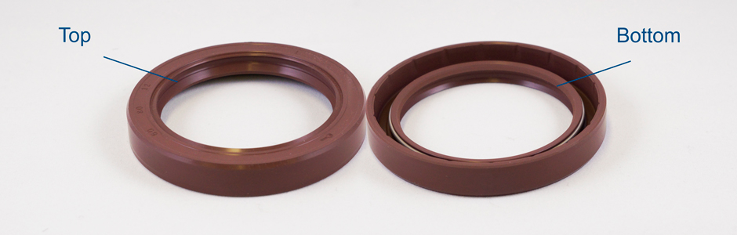

Single Lip Oil Seal vs a Double Lip Oils Seal

The single lip seal is classified as the inner diameter at the bottom of the component. The single lip is vital to the function of the seal by containing the oil, grease, or lubricant.
The only difference between a single and double lip is the additional rubber lip on the top of the oil seal which helps prevent dust or dirt from coming close to the shaft.
Identifying the oil seal lip can be misinterpreted with a visual inspection alone. For or this reason, you should press along the inner diameter at the top of the seal, if you feel a ridge with a slight movement or give it is highly likely you have a double lipped oil seal.
Suppliers use unique codes to identify oil seals worldwide. The most common lip style designations are 21 (single lip) and 23 (double lip).

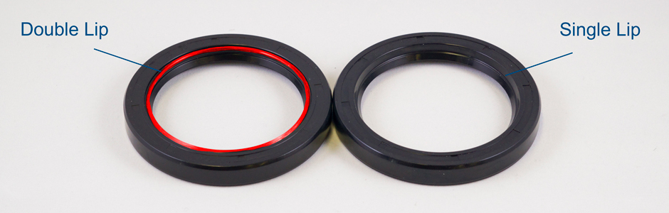

Identifying the Oil Seal Design

Type A - Rubber Covered Lip Seals

Fully covered outer diameter for excellent sealing. This oil seal is fully enclosed in a rubber material and is the most widely used type of oil seal. Great resistance to thermal cycling, temperatures, and different chemical resistance.
Type B - Metal Outer Diameter Oil Seals
Economic metal outer diameter for standard applications. This is an economical oil seal where the metal is exposed on one side and offers a closer fitting between the oil seal and housing or bore. Due to this, it has limited use with sealing thin liquids or gases.
Type C - Reinforced Metal Insert Oil Seals
The same design as type B with an additional inner case for greater structural rigidity. This type of oil seal is typically used in heavy-duty engineering machinery or large diameter sized seals
Type F - Stainless Steel Garter Spring
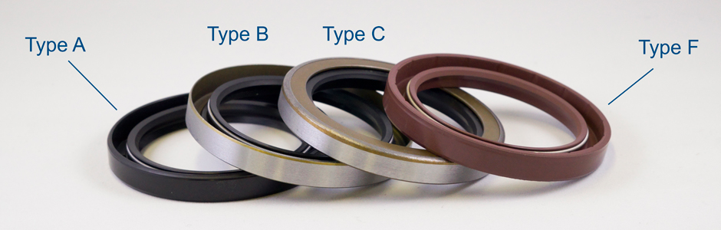
The same design as type A with corrosion protected metal case and stainless-steel garter spring. Suitable for use with a wide range of fuels and chemicals.

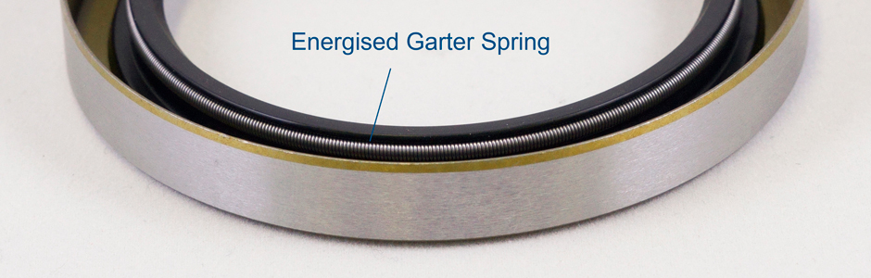

How to Identify Oil Seal Material

Nitrile or NBR is black in colour, whereas Viton or FKM is usually a brownish colour.

How to Measure Oil Seals

To measure METRIC oil seals
First: inner diameter (ID)
Second: outer diameter (OD)
Third: Width or Height

To measure IMPERIAL oil seals
First: Outer diameter (OD)
Second: Inner diameter (ID)
Third: Width or Height
