Elements 29.1 and 29.2: Assessment

Objective of this assessment: To assess your ability to produce a planned maintenance schedule.

Suggested Layout:

Title Page or Front Cover: to include your name, the project title, workplace, college name and the date to be completed (May 2014).
Acknowledgements: recognize any significant help that you have received from work colleagues, tutors etc.
Summary (sometimes called an abstract): This should be clear and concise, and should detail the aims of the specific and the main points undertaken. (this will probably be written last, but needs to be at the front of the report).
Contents: this should list the contents of the report with main headings, and possibly a very short description of the heading. It needs to clearly identify each section with page numbers.
Figures: make a list of any figures, diagrams, sketches or photographs that are in the report, include a very brief description (ie Figure 1- Lubrication layout of engine).
Tables: make a list of any tables that you have included, and a very brief description of what they include.
Nomenclature: make a list of any abbreviations or representatinv symbols that you have used in the report (eg PPM- planned preventative maintenance)
Introduction: this should introduce the project, it will include more general information than the summary, is usually longer, and should lead the reader (who may well know very little about the specifics of your project) from a general background to the specific requirements of your maintenance schedule. Here you should give some details of the equipment, and the specific maintenance task that you are going to undertake. Include your place of work using a location map or photographs.
General hints. Include plenty of ‘white space’, do not cram too much information on one page, it becomes very difficult to read. Remember the saying ‘a picture paints a 1000 words’, but ensure the picture is there for a reason and actually tells the reader something. Make the text size easy to read (11 or 12 from main body text), and space the lines (1.5 is good). Remember your lecturer is old and has failing eyesight! Remember the old adage in engineering….If it looks good, it probably is good. If your work is tatty and poorly laid out it will not attract a good mark. Your project will need to be about 2500 words.

Assessment details: You should base this work on your own workplace (or something you are doing at home or college if you are not in work). Produce a planned maintenance schedule to ensure a piece of equipment is available for operation, and then elaborate on one particular function (eg a schedule for a car, then explain in detail how to change the clutch plates). Identify the areas where condition monitoring could be utilised, stating your reasons for the choice of monitoring to be used. Demonstrate an understanding of the types of lubricants and lubrication systems used within the workplace (and in particular on the equipment you are maintaining), and the implications for the safe disposal of all waste materials.
You may like to use the information below as a checklist to ensure you include the required information.

1. Produce maintenance schedule
Obtain all the necessary specifications, documentation and information required for the planning of a maintenance schedule
Prepare your schedule to include:
  - Detailed list of all equipment and differing maintenance requirements
  - Risk assessment requirements
  - Tools and equipment required
  - Measuring systems and/or instruments required
  - Problem and fault diagnosis techniques to be used

Within this section you might like to consider and discuss how you would ensure the equipment you have chosen is available for operation when required. You will need to consider:
  - Type of industry
  - Process requirements
  - Business objectives
  - Performance
  - Cost
  - Downtime
  - Service life
  - Efficiency
  - Safety
  - Environmental impact

You should also indicate in your report how different maintenance functions can be split into categories such as:
  - The prevention of breakdown
  - Routine maintenance: Lubrication, Adjustment, and Cleaning
  - Planned maintenance: Major overhaul, Replacement of specific parts, Modifications
2. Carry out fault diagnosis and apply condition monitoring
  - Carry out a basic problem and fault diagnosis exercise on the equipment detailed in your report using appropriate methods and/or diagnostic aids
  - Detail you findings in a report and your conclusions as to the nature and cause of the faults
  - Detail in your report the action required to repair/prevent the fault
  - Use condition monitoring equipment in a practical situation
  - Suggest in your report where condition monitoring could be utilised as a fault diagnosis tool.

Within this section you might like to consider and discuss the following in relation to your chosen task.
Using Fault diagnosis systems such as:
  - Six point technique
  - Emergent problem sequence
  - Half split
  - Input to output technique

Using Fault finding aids such as:
  - Fault finding charts
  - Functional system charts
  - Algorithms
  - Maintenance records
  - Probability charts

Show an understanding of condition monitoring techniques and how they might be applied to your chosen task:
  - Thermal monitoring
  - Vibration monitoring
  - Noise monitoring
  - Temperature monitoring
  - Spectrographic oil analysis
  - Particle retrieval

3. Identify lubricants used in the workplace and means of disposal
  - Produce a detailed list of all lubricants used with the equipment detailed in your report
  - Give reasons for use of each
  - Using COSHH and manufacturers environmental information produce a report giving the disposal requirements for each lubricant listed

Within this section on lubrication you might like to consider and discuss the following in relation to your chosen task:
The principles of lubrication:
- Reduction of friction
- Reduction of wear
- Prevention of corrosion
- Sealing out of dirt.

Types of friction: friction force and effects of force.

Types of lubricants:
- Liquid lubricants, their characteristics and properties, grades and viscosity
- Semi-solid (Grease) or synthetic lubricants, their properties and applications
- Solid lubricants, graphite and molybdenum, their advantages/disadvantages

Additives, such as inhibitors and emulsifiers

Methods of application: manual, gravity, splash or pressure.

Disposal regulations, the requirements of BS EN 14001 and local authority environmental law.

Maintenance of a Small Piston Compressor.

Task: Checking the wear of pistons, cylinder bore and crankshaft ‘big end’ bearings.

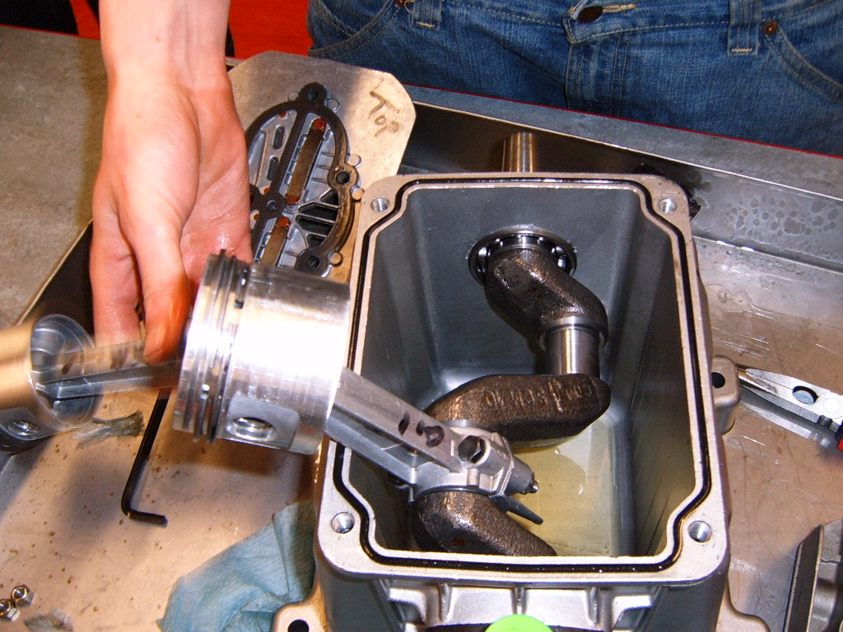
You are required to carry out checks for wear within the compressor:

To measure the clearance between the crankshaft and connecting rod shell bearings, and determine if they need to be replaced.

To measure the clearance between the piston and bore of the cylinder block, and determine if any repairs are required.

Some of the things that you need to include in your project are listed on the following pages. The actual maintenance task is highlighted, and in bold italics.

BE AWARE that you need to answer the questions posed in the project section above (summarized below):

1. Produce maintenance schedule
Obtain all the necessary specifications, documentation and information required for the planning of a maintenance schedule
Prepare your schedule to include:
  - Detailed list of all equipment and differing maintenance requirements
  - Risk assessment requirements
  - Tools and equipment required
  - Measuring systems and/or instruments required
  - Problem and fault diagnosis techniques to be used
A useful web page can be found here:
http://www.portlandcompressor.com/compressor/maintenance.aspx
You will also find useful information in the ‘Types of Maintenance’ section of the course notes on ‘Moodle’.

2. Carry out fault diagnosis and apply condition monitoring
  - Carry out a basic problem and fault diagnosis exercise on the equipment detailed in your report using appropriate methods and/or diagnostic aids
  - Detail you findings in a report and your conclusions as to the nature and cause of the faults
  - Detail in your report the action required to repair/prevent the fault
  - Use condition monitoring equipment in a practical situation
  - Suggest in your report where condition monitoring could be utilised as a fault diagnosis tool.
A useful web page can be found here:
http://www.portlandcompressor.com/compressor/trouble-shooting.aspx
You will also find useful information in the ‘Condition Monitoring and Fault Finding’ section of the course notes on ‘Moodle’.

3. Identify lubricants used in the workplace and means of disposal
  - Produce a detailed list of all lubricants used with the equipment detailed in your report
  - Give reasons for use of each
  - Using COSHH and manufacturers environmental information produce a report giving the disposal requirements for each lubricant listed
You will find the required information in the ‘Lubrication’ section of the course notes on ‘Moodle’.

After you have completed the above sections, the following questions should help you to produce the maintenance task part of your project. Make sure that you give full answers in complete sentences and not just one word answers. The questions are to be used as a guide only.

List the PPE will you be using, giving a reason why it is required:

ie Safety Glasses must be used to ensure no flying objects or swarf get into the eyes.

Make a list of the tools you will require.

Make a list of the parts you will need to replace during this exercise. Use the assembly drawing to identify the part numbers.

Before you start work on the compressor how do you ensure you are safe to strip out the machinery?

Before you disconnect the compressed air delivery pipes or hoses from the compressor, what must you do?

Why are you doing this?

How did you remove the flywheel? Describe it and illustrate with a sketch or image.

When using a ‘pullers’ on a tapered shaft comment on how you expect the flywheel to come off?

Sketch or find an image of the key used in the flywheel, and name it.

What size and grade of bolts are used to secure the cylinder head to the compressor block?

When you are replacing these bolts, it is important to tighten them to the required torque. Find out what the recommended torque is.

What tool will you use to ensure they are tightened correctly.

Why will you ensure the threads of the bolts, and the internal threads in the compressor block are clean, undamaged and lightly oiled before you tighten?

Describe in what order you will tighten the bolts, and state why?

It is important that the valve plate is installed the correct way around. Explain why?

Indicate on a sketch or include images to illustrate how the valves work.

When removing the bottom section of the bearing cap from the connecting rod, how are the bolt heads located to stop them from turning. Illustrate your answer with a sketch or image.

When replacing the nuts on these bolts, the maintenance manual advises using a product such as “studlock” on the threads before assembly. What is the purpose of this product?

Inspect the piston for wear (there will be marks on the sides). How is the gudgeon pin (10) held in the piston?

What type of tool is required to remove these retainers? Include a sketch or image of the tool and the retainers.

MAINTENANCE TASK: Once you have removed the connecting rod from the crankshaft, measure the outside diameter of the crankshaft. Use a vernier and a micrometer to compare results. Make sure you note down the readings.

Comment on how easy, or difficult it was to use the vernier and micrometer.

MAINTENANCE TASK: Measure the internal diameter of the shell bearing using both a vernier and a micrometer, again note down the readings.

Make a sketch, or use images to indicate how you were able to measure an internal diameter with the vernier and micrometer.

The rule of thumb clearance for a shell bearing is a maximum of 0.001 x Diameter of shaft. For example, for a 40mm diameter shaft the clearance should be a maximum of 0.04mm.
Look at your results and comment on the condition of the bearings.

How would you replace shell bearings?

If the crankshaft was worn, so that it was no longer properly round, briefly describe how you could repair it, and what you would have to do to the shell bearings.

MAINTENANCE TASK: Measure the bore of the cylinder block with a vernier gauge and make a note of it.

MAINTENANCE TASK: Measure the diameter of the piston with a vernier gauge and make a note of it.

Work out the clearance between the piston and the bore, and make a note of it.

By checking the manufacturer’s specification you find that the maximum clearance between the piston and bore is 0.045mm.
Look at your results and comment on the condition of the pistons and bore.

If the clearance was too large, briefly describe what you would need to do to repair the compressor.

Describe the purpose of the piston rings (part 18), and the oil wiper that are fitted to the piston.

When replacing the pistons into the bore, describe what action you need to take to ensure the piston fits into the compressor block without damaging the piston rings.

If you damage the large ‘O’ ring that acts as a seal between the crankcase and the compressor cylinder block (part 16), briefly describe how you could replace it if a proper spare was not available.

The gaskets (parts 5 and 7) between the valve plate (6) and the crankcase cover (4) and cylinder block (15) should always be renewed. If proper spares are not available suggest two ways of making new ones.

Once you have assembled the compressor, what action could you take to check that the compressor is sucking air into the air filter (26) and delivering it out of the delivery port.

What is the purpose of the thrust washer (41) located next to the connecting rod on the crankshaft?

When replacing the pipe or hose into the delivery port on the compressor, the maintenance manual suggests using PTFE tape of the threads. Briefly describe what function this tape has.

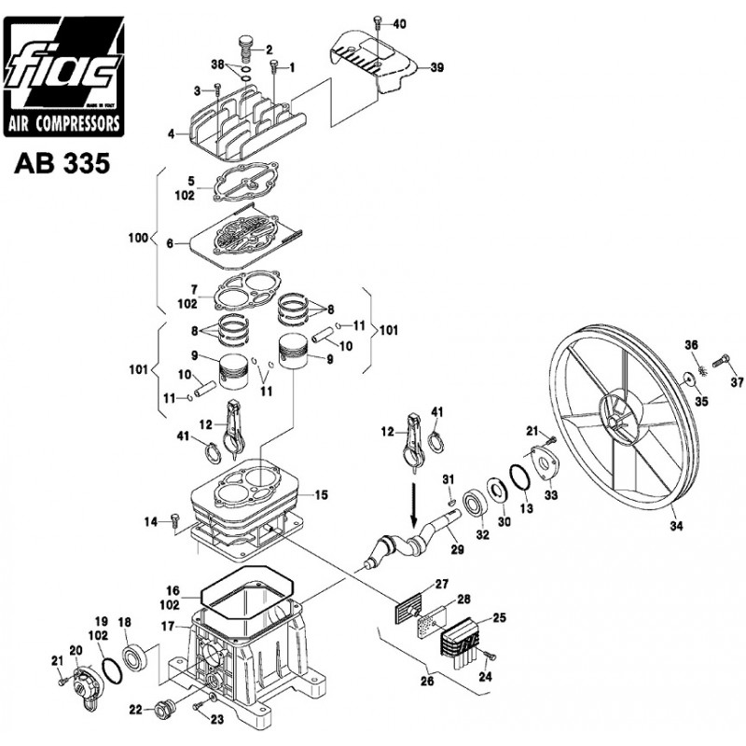
Parts List
- screw
- oil breather
- Screw
- crankcase cover
- gasket
- valve plate
- gasket
- piston ring set
- piston
- pin
- circlip
- piston rod
- gasket
- screw
- cylinder block
- O-ring 144
- Crank case
- Bearing 6203 17X40X12
- gasket
- back cover
- screw
- Oil level warning
- Screw M8X 25 UNI-8112
- screw M.4X45
- air filter cover
- air filter kit
- plate filter
- suction filter
- Crankshaft
- Oil seal 20x47x7
- woodruff key
- bearing 6204
- front cover
- flywheel
- washer
- washer
- screw
- gasket
- cover
- Screw
- thrust washer

