Maintenance of a Honda Varadero 125.
Neath, Port Talbot College.

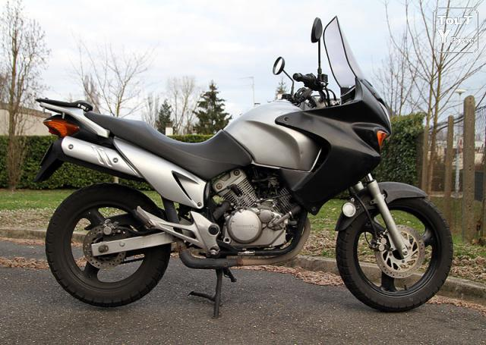

Acknowledgements:
I would like to thank my college maintenance lecture. Without Simons help I would not be able to complete this task as he gives me advice on what to do my project on and how to present it.
I would also like to thank my father without his help it would have been a lot harder to do the practical side of this assessment as he gave me advice as I was taking on this project.

Summary:
I have done my maintenance project of my Motorcycle which is a Honda Varadero 125. I have shown what I do before every ride and what I do every year to keep the bike maintain. In this project I also changed the front brake pads.

Contents:

- Acknowledgements
- Summary
- Contents
- Figures
- Tables
- Nomenclature
- Introduction
- Assessment details
- Produce maintenance schedule
-Before Every Ride
-Yearly Service
-Changing the front brake pads.
-Install New Front Brake Pads.
- Carry out fault diagnosis and apply condition monitoring.
- Breaking Failure.
-Unusual Noises.
-Lever Problems.
-Bad Vibrations.
- Handling Problems.
-Tyre Pressure.
-Front Forks.
- Identify lubricants used in the workplace and means of disposal.
- How to properly dispose oil.
- Appendix

Figures:
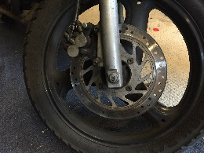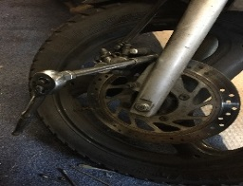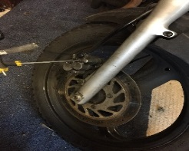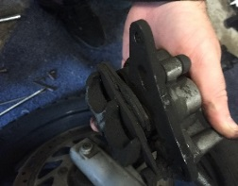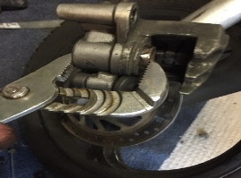
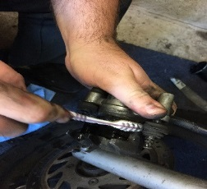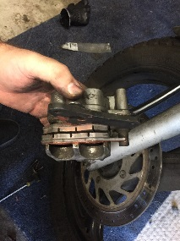

All these photo are me taking off the front calliper and changing the brake pads

Introduction:
I have done my maintenance project of my Motorcycle which is a Honda Varadero 125. I have shown what I do before every ride such as tire pressure, lights and brakes and also what I do every year to keep the bike maintain such as change the oil, air filter and if needed brake pads. By doing these check I notice I needed to change my brake pads I have shown how I had done this step by step.

HINT : Assessment details: change this to maintenance schedule and add brief descriptions of the three types of maintenance (see notes on moodle).

Before Every Ride:
- Check tire air pressure.
- Check brakes and cables.
- Check all light are working and horn.
- Check to see if you have got petrol.

Yearly Service
- Oil – Change oil & filter at recommended intervals
- Air filter – Clean or change when dirty
- Brake pads & rotors – Check for wear
- Chain & sprockets - Check for wear, kinks and tight spots
- Battery terminals & wires – Check for corrosion
- Cables – Lubricate and adjust if needed

Changing the front brake pads.

Hint: add a brief risk assessment here so that you do this safely, and make a list of the tools you will need.

Remove the Front Brake Callipers.
Step 1:

Remove the bolts holding the brake calliper in place. The calliper should slip off easily, as the brake hose is the only thing holding the calliper in place. Leave the hose attached, if possible. If you expect to leave the calliper loose for a long period of time, tie the calliper to the motorcycle to remove the weight from the hose.
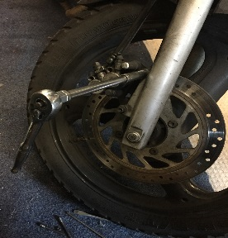

Step 2:

Remove the retaining pin that holds the pads in place. To do this, first remove the retaining clip, located on the inside of the calliper in a groove on the pin. Using a pair of needle nose pliers, remove the clip. The pin should slide out easily with the pliers.
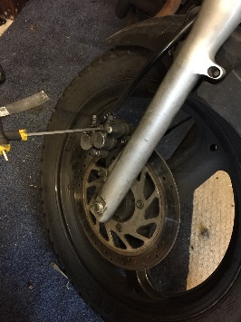
Step 3:

After removing the pin, the pads should easily slide out of the callipers. Inspect the pads for wear. If they show signs of uneven wear, then the callipers may also need replacing. Owners can accomplish this by removing the brake hose from the old calliper and then attaching a new calliper. Remember, the brake lines now require bleeding.

Step 4:

Inspect the brake discs. If the discs are scratched or gouged, bike owners need to remove them and take them to a machine shop for turning. In extreme cases, the disks may need replacement, especially if turning reduces them to below the minimum thickness. Do not turn them unless needed, as doing so reduces their life expectancy.
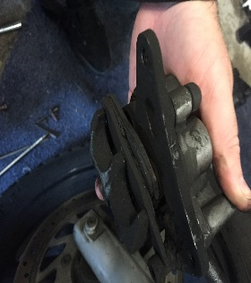

Step 5:

Clean the calliper using brake cleaner. Pay extra attention when cleaning the calliper's piston and be sure to clean it well. Use brake cleaner only, as other cleaners could leave an oily residue on the brake pads and make it harder to stop.
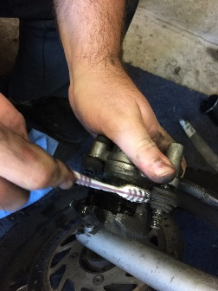

Step 6:

Compress the piston. Most people who replace their brake pads use a large C-clamp to accomplish this. Apply slow pressure on the piston to avoid pushing brake fluid out of the piston too quickly.
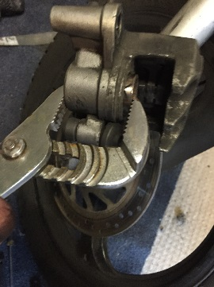

Install New Front Brake Pads.

Step 1:

Place the new brake pads into the callipers. They only go in one way, so placing them should not be a problem. Align the holes in the callipers with those on the pads and insert the pins. As long as the old retaining clip remains in good condition, it can be reused. Replace the retaining clip.

Step 2:

Replace the calliper over the brake disk, with the two brake pads positioned on either side of the disk. If for some reason the pads do not fit over the disk, the piston needs more compression. Owners should remove the new brake pads before compressing the piston again, as any pressure on the new pads can crack them. One way of fully compressing a piston involves putting the old pads back in and using a pry bar to separate them. Take care that the pry bar does not slip and damage any bike components.

Step 3:

Reinstall the two brake calliper mounting bolts and tighten them. Brake installers should torque the bolts to about 3.16 Nm using a torque wrench. Check the motorcycle's manual for more information and the exact specifications.

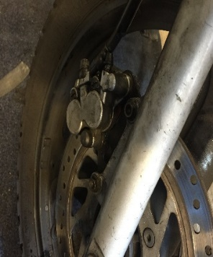

Step 4:

Test the brakes fully before taking the motorcycle out onto the open road. This requires riders to start and stop along short distances at very slow speeds to make sure they work properly. If the brakes need adjustment, do so before riding.

Carry out fault diagnosis and apply condition monitoring:
HINT: add brief descriptions of the types of fault diagnosis (see notes on moodle).

Breaking Failure.

Unusual Noises.
If you hear your brakes squeal or make a grinding noise when you use them, it’s a sign that they may need adjustment or replacement. Grinding noises are particularly serious, as they indicate that your brake pads are worn may need to be replaced.

Lever Problems.
If your brake lever feels “spongy” or hard to press down, it usually means that air has gotten into the brake lines. You may also be having an issue with low brake fluid. Be sure to check your master cylinder and your brake lines.

Bad Vibrations.
If your handle bars, break lever or entire bike shakes or vibrates when you apply the brakes, your brake rotors may be warped and need replacement.

Handling Problems.

Tyre Pressure.
It could be something simple as a low tyre pressure. But if you pump your tyre too much you could also damage the tyre and it could lead to a burst tyre. So when checking tyre pressure uses the recommendation pressure given by the manufacture.

Front Forks.
When riding if the bike pulls to one side and the handle bars are vibrating this could mean the forks are not right if this is the cause normally they will also leak.

HINT: add brief descriptions of the types of condition monitoring and suggest one to use for your bike (see notes on moodle).

Identify lubricants used in the workplace and means of disposal:

HINT add brief descriptions of the different types of lubricant (see notes on moodle).
For each of the below lubricants give a brief description of why it is used for the application (use the spec sheet for ideas, ie good at dispersing water, or excellent wear properties etc.)

Motul Chain Lube Factory Line:
This is the lubrication I use on my chain.
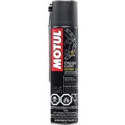
Castrol oil 10w30:
This is the lubrication I used in my engine.
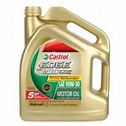
Motul Fork Oil medium 10w:
This is what I use in my forks.
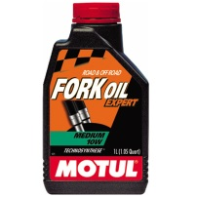
GT 85:
I use this to clean wires.
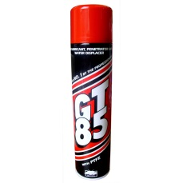

How to properly dispose oil:

If you are working on something in your garage you can take the oil to a license recycle centre. But if you owned a business you have to pay a license company to remove the oil and it’s still you’re responsibly to make sure it was done properly.

HINT What regulations apply to the safe disposal of oil?
Appendices.
-Castrol Safety Data Sheet.
-Castrol Oil specification
- Safe Storage Disposal

