UNIT REF: L1AM12 |  |  | LEARNER SUPPORT MATERIAL TASK SHEET:  UNIT TITLE: LIGHT VEHICLE BRAKING SYSTEMS COMPONENTS AND MAINTENANCE
Learner Name: |  |  |  |  | Date of Task:
KNOWLEDGE QUESTIONS
Question Number |  | Question |  |  |  | AC | Marks Awarded
1. |  | Identify and state the purpose of the following main components used in braking systems: (24 marks) |  |  |  | AC1.1-1.2
A. | 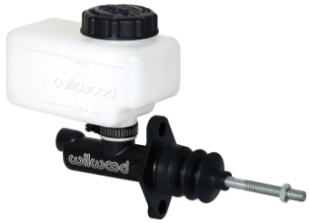 |  |  | Identify Part:
 |  |  |  | State purpose:
B. | 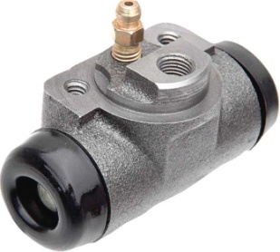 |  |  | Identify Part:
 |  |  |  | State purpose:
C. | 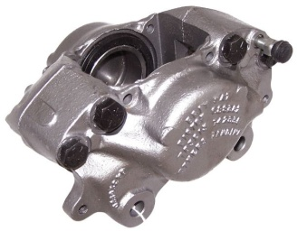 |  |  | Identify Part:
 |  |  |  | State purpose:
D. | 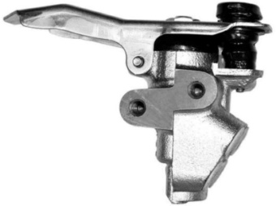 |  |  | Identify Part:
 |  |  |  | State purpose:
E. | 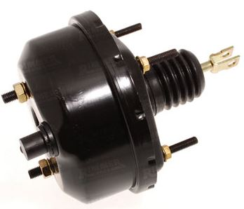 |  |  | Identify Part:
 |  |  |  | State purpose:
F. | 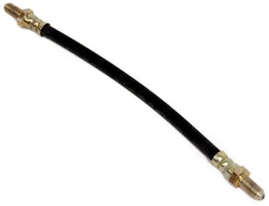 |  |  | Identify Part:
 |  |  |  | State purpose:

Question Number | Question | AC | Marks Awarded
2. | Draw two diagrams showing two different split braking systems:  (12 marks) | AC2.1
A.

Master Cylinder
B.
Master Cylinder
3. | During moderate braking, what is the approximate brake force distribution between the front brakes and rear brakes? (2 marks) | AC2.1-2.2
(Please circle the correct answer)

Front 20% Rear 80% Front 60% Rear 40% Front 80% Rear 20%

Question Number |  | Question | AC | Marks Awarded
4. |  | Approximately when should brake fluid be changed? (2marks) | AC2.2
5. | What does the term kinetic energy mean? (2 marks) |  | AC2.1-2.2
6. | What does the term coefficient of friction mean? (2 marks) |  | AC2.1-2.2
7. | State two advantages of a drum brake: (4 marks) |  | AC2.2
A
B
8. | State two advantages of a disc brake: (4marks) |  | AC2.2
A
B

