UNIT REF: L1AM03 |  | LEARNER SUPPORT MATERIAL TASK SHEET  UNIT TITLE: SPARK IGNITION ENGINE SYSTEMS COMPONENTS AND OPERATION
Learner Name: |  |  |  | Date of Task:
KNOWLEDGE QUESTIONS
Question Number | Question |  |  |  | AC | Marks Awarded
1. | Identify and State the purpose of the following main components used in petrol Spark Ignition (SI) engines: (32 marks) |  |  |  | AC1.1-1.2
A. | 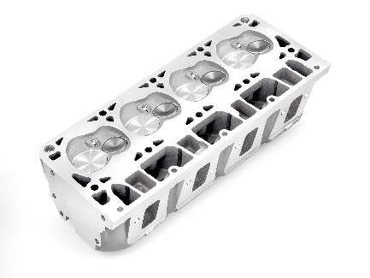 |  | Identify Part:
 |  |  | State purpose:
B. | 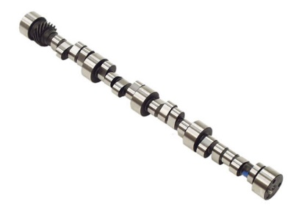 |  | Identify Part:
 |  |  | State purpose:
C. | 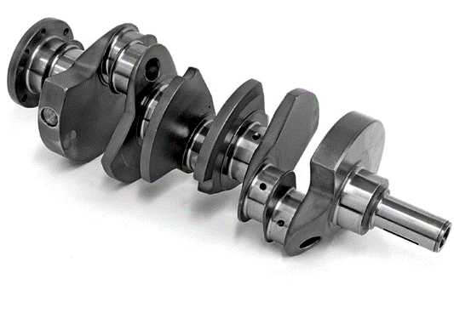 |  | Identify Part:
 |  |  | State purpose:
D. | 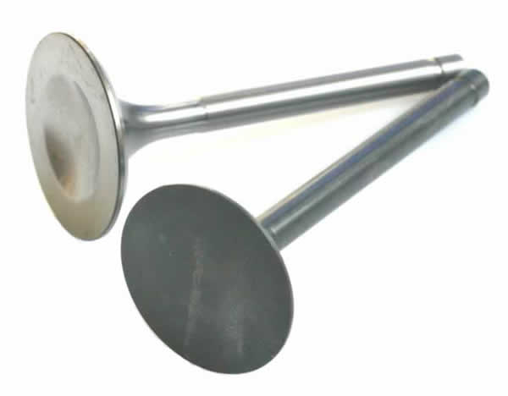 |  | Identify Part:
 |  |  | State purpose:

E. | 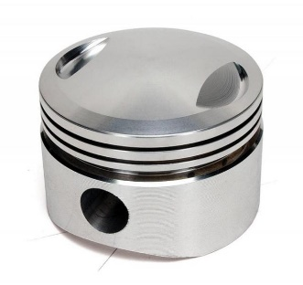 | Identify Part:
 |  | State purpose:
F. |  | Identify Part:
 |  | State purpose:
G. | 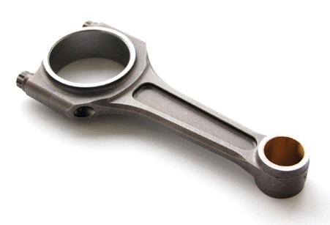 | Identify Part:
 |  | State purpose:
H. | 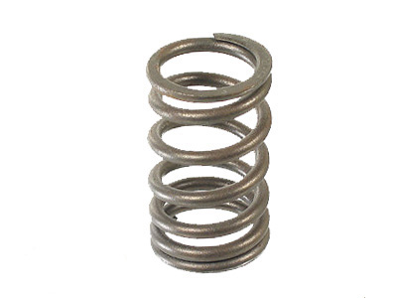 | Identify Part:
 |  | State purpose:
2. | Outline the main purpose for each of the following systems (8 marks) |  | AC1.3
A. | Cooling System –
B. | Lubrication System –
C. | Fuel System –

D. | Ignition System –
Question Number | Question | AC |  | Marks Awarded
3. | State the operating cycle of the 2 stroke petrol engine: (4 marks) | AC2.1
1.
2.
4. | State the operating cycle of the 4 – stroke petrol engine: (8 marks) | AC2.1
1. | Stroke:
2. | Stroke:
3. | Stroke:
4. | Stroke:
5. | Draw a circular diagram of the 4 stroke cycle indicating:  - Inlet valve opening and closing  - Exhaust valve opening and closing  - Top and bottom dead centres  - Typical ignition point  - Direction of rotation (16 marks) |  | AC2.2

Question Number | Question |  | AC | Marks Awarded
6. | Give examples of the correct type air / fuel ratios for each of the following:  (6 marks) |  | AC2.3
A. | Rich Mixture –
B. | Weak Mixture –
C. | Ideal Mixture–
7. | Identify the four main constituents of SI exhaust gas emissions and their effects on the environment: (16 marks) |  | AC2.4
Gas A: |  | Effects on health and the environment:
Gas B: |  | Effects on health and the environment:
Gas C: |  | Effects on health and the environment:
Gas D: |  | Effects on health and the environment:

