UNIT REF: L1AM06 |  | LEARNER SUPPORT MATERIAL TASK SHEET  UNIT TITLE: SPARK IGNITION SYSTEMS MAINTENANCE
Learner Name: |  |  |  | Date of Task:
KNOWLEDGE QUESTIONS
Question Number | Question |  |  |  | AC | Marks Awarded
1 | Name the following ignition system components. (10 marks) |  |  |  | AC2.1
A | 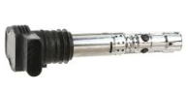 |  | Component –  Purpose -
B | 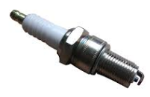 |  | Component –  Purpose -
C | 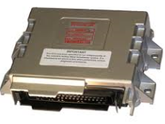 |  | Component –  Purpose -
D | 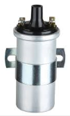 |  | Component –  Purpose -
E | 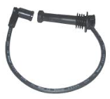 |  | Component –  Purpose -

Question Number | Question |  | AC | Marks Awarded
2. | State the name of the tools / equipment below, and give an example of where they would be used on a vehicles ignition system (10 marks) |  | AC2.2
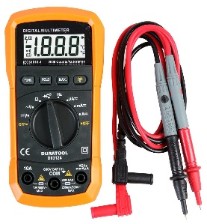  Above set on OHMs |  | Component –  Example of its use on an ignition system -
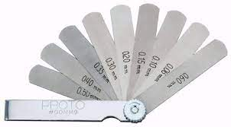 |  | Component –  Example of its use on an ignition system -
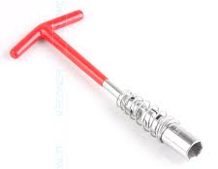 |  | Component –  Example of its use on an ignition system -
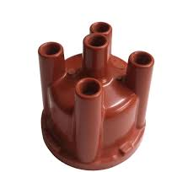 |  | Component –  Example of its use on an ignition system -

