UNIT REF: L1AM15 |  | LEARNER SUPPORT MATERIAL TASK SHEET:  UNIT TITLE: ELECTRICAL FOUNDATION SKILLS
Learner Name: |  |  |  | Date of Task:
KNOWLEDGE QUESTIONS
Question Number | Question |  |  |  | AC | Marks Awarded
1. | Identify the components in the images below, state their use and outline which electrical principle applies to each component. (24 marks) |  |  |  | AC1.1, 1.2
A  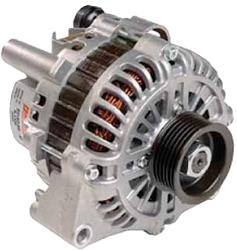 |  |  | Name:  Used to:  Component operating principles:
B  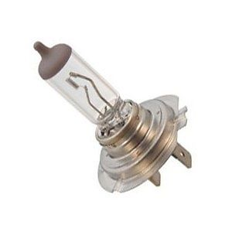 |  |  | Name:  Used to:  Component operating principles:
C  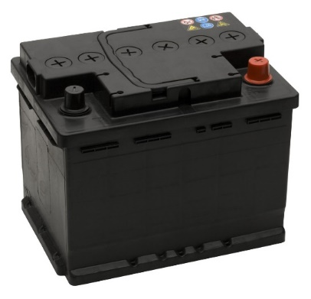 |  |  | Name:  Used to:  Component operating principles:
D  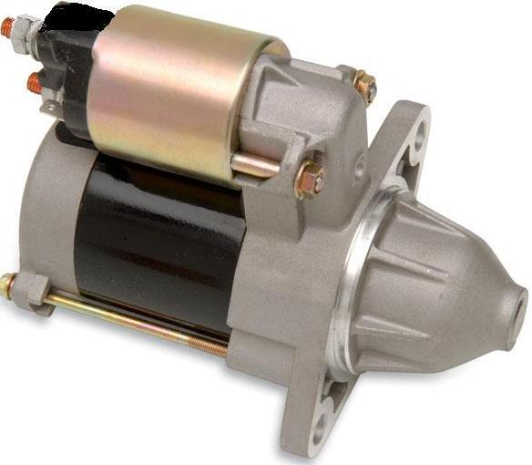 |  |  | Name:  Used to:  Component operating principles:

Question Number | Question |  | AC | Marks Awarded
2. | State 4 main electrical units of measurement (8 marks) |  | AC1.3
1.
2.
3.
4.
3. | Identify the two types of electrical circuits below (4 marks) |  | AC1.2
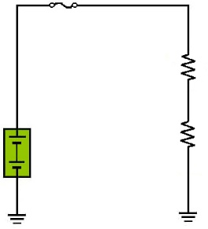 |  | 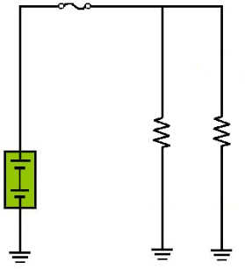
A. |  | B.
4. | Identify the electrical symbols in the images below (14 marks) |  | AC1.4
A
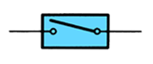
B
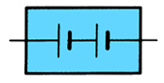
C
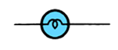
D
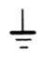
E
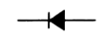

F
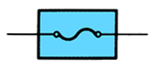
G

