UNIT REF:G0102K | WRITTEN ASSESSMENT  KNOWLEDGE OF HEALTH, SAFETY AND GOOD HOUSEKEEPING IN THE AUTOMOTIVE ENVIRONMENT

STUDENT NAME:

Pass mark 60%

1. An automotive technician wears overalls as part of their personal protective equipment (PPE). (10 marks)
Name an item of additional PPE required and state the task it would be used on to protect each of the following;
    - the head

    - the feet

    - the hands

    - the eyes

    - the ears

2. What item of PPE is it essential to wear in order to alert others of the presence of repair or recovery operations by the roadside?

3. Name THREE items of equipment used to protect customers’ transport when carrying out repairs, recovery or maintenance.

4. Many accidents in the automotive environment are caused by slips, trips and falls. List THREE different causes of these.

5. Name TWO utilities and THREE consumables used within the automotive environment that should not be wasted unnecessarily.

6. List the equipment and cleaning agent(s) which would be used when dealing with minor oil leaks / spillages in an automotive environment.

7. State ONE duty imposed on the employee by the Health & Safety at Work Act 1974.

8. State ONE duty imposed on the employer by the Health & Safety at Work Act 1974.

9. List TWO reasons for recycling waste materials where possible.

10. Describe the main potential hazard when using the equipment shown below.
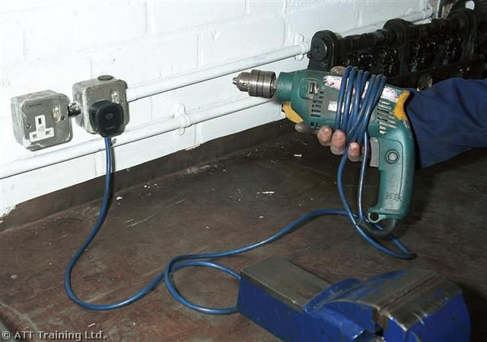

11. State a potential hazard when working in the area shown below.
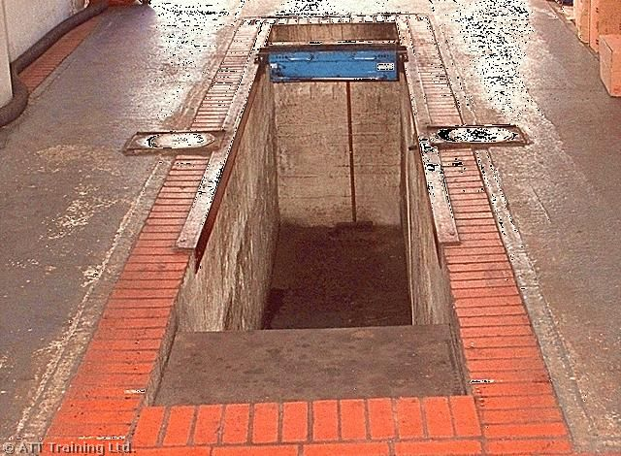

12. State where and why barrier cream would be used in an automotive environment.

13. State the name of the regulations that relate to the piece of equipment shown below, with regard to Health and Safety.
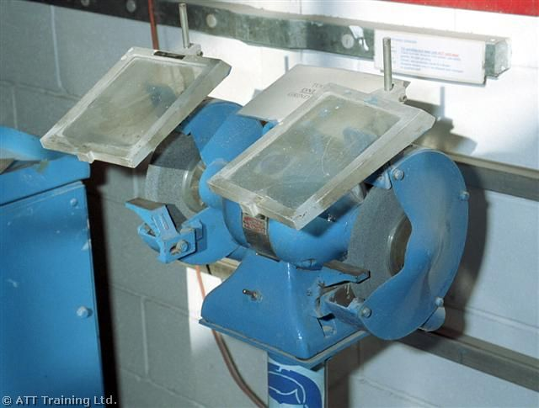

14. List FOUR things that an employer should provide in order to comply with modern safety legislation.

15. State TWO types of fire that it would be extremely dangerous to use the extinguisher A (Foam) on.




A B

16. State TWO types of fire that extinguisher B (Carbon Dioxide) should be used on.

17. State the TYPE of safety signs shown below.
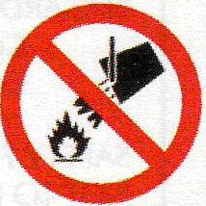

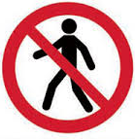
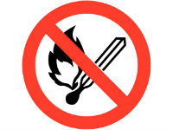

18. State the TYPE of sign shown and what each one means. (4 marks)

A B C
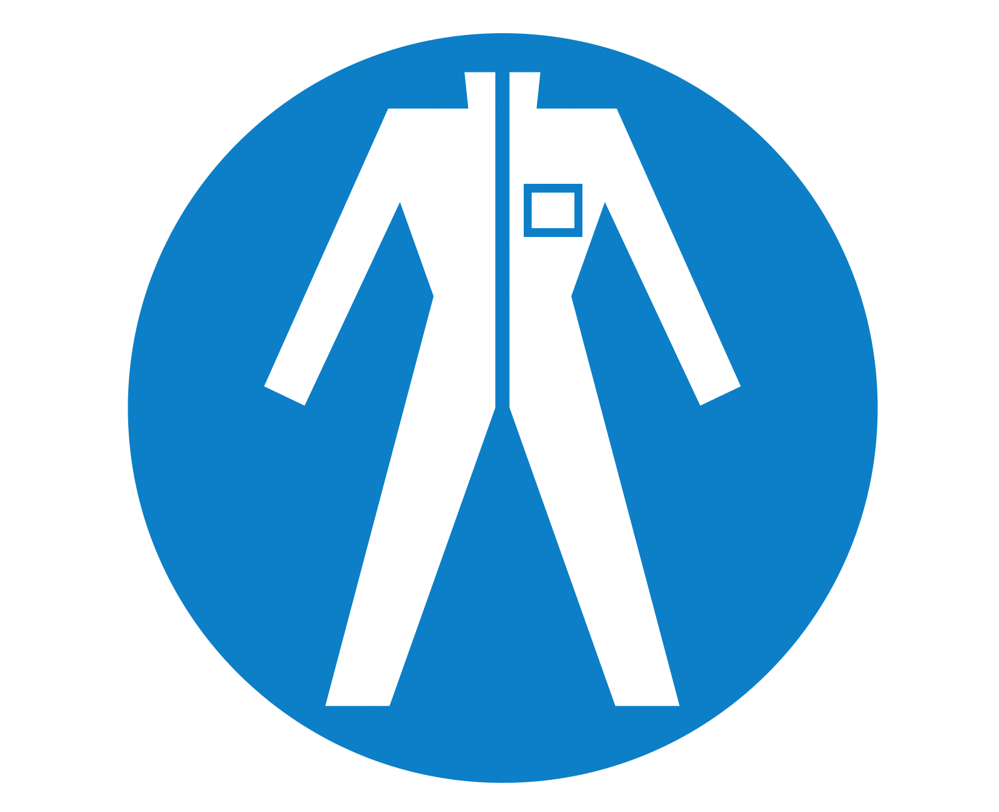
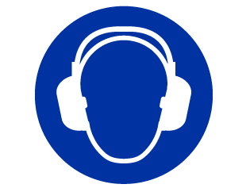


19. State the TYPE of sign shown and what it means. (4 marks)
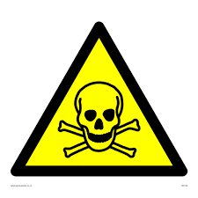
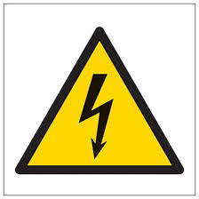
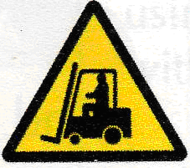

20. State the abbreviation PAT, and what is this test used for in Industry.

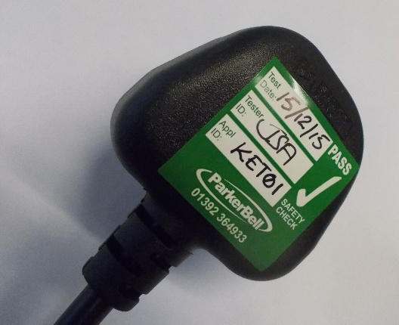

PAT = P A T

It is used to ensure what ?

