UNIT REF: L1AM02A |  | LEARNER SUPPORT MATERIAL TASK SHEET:  UNIT TITLE: KNOWLEDGE RELATING TO AUTOMOTIVE FOUNDATION SKILLS
Learner Name: |  |  |  | Date of Task:
KNOWLEDGE QUESTIONS
Question Number | Question |  |  |  |  | AC | Marks Awarded
1. | Identify and state the purpose of the following automotive measuring equipment: (36 marks) |  |  |  |  | AC1.11 1.2
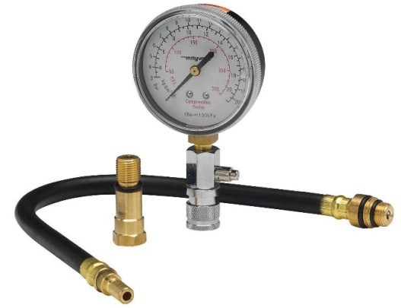  A |  |  | 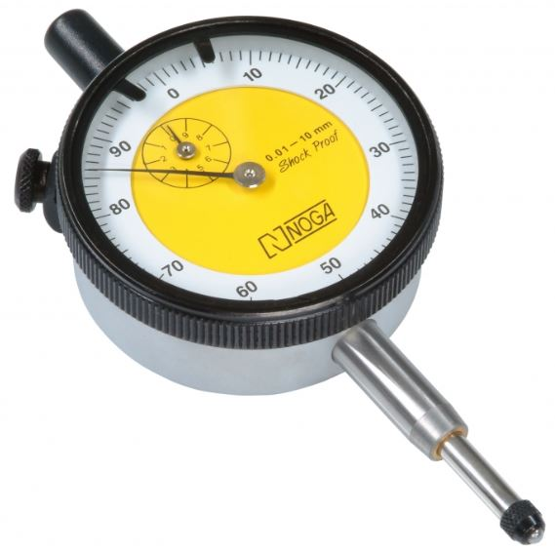  B |  | 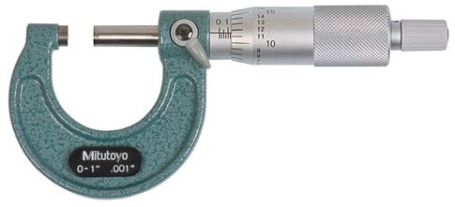  C
Name: |  |  | Name: |  | Name:
Purpose of tool: |  |  | Purpose of tool: |  | Purpose of tool:
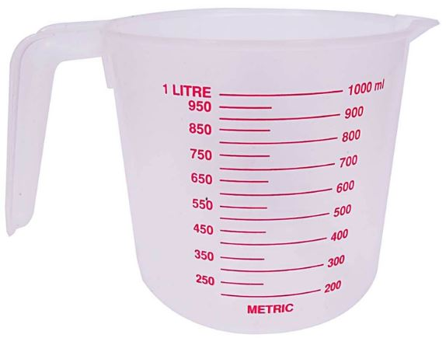  D |  |  | 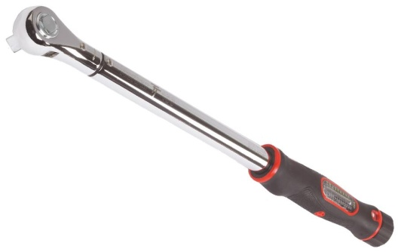  E |  | 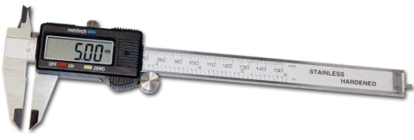  F
Name: |  |  | Name: |  | Name:
Purpose of tool: |  |  | Purpose of tool: |  | Purpose of tool:
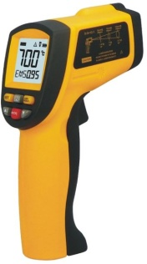  G |  |  | 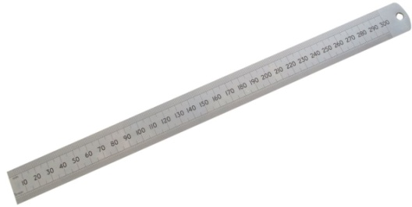  H |  | 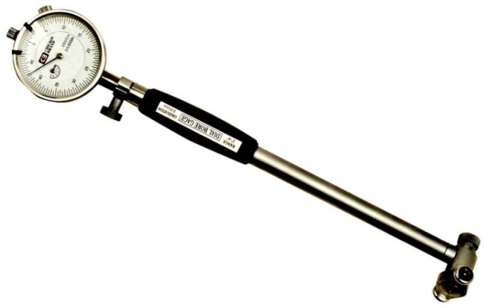  I
Name: |  |  | Name: |  | Name:
Purpose of tool: |  |  | Purpose of tool: |  | Purpose of tool:

Question Number | Question |  |  |  |  |  | AC |  | Marks Awarded
2 | Identify the type of automotive electrical circuits in the images below:  (6 marks) |  |  |  |  |  | AC1.3
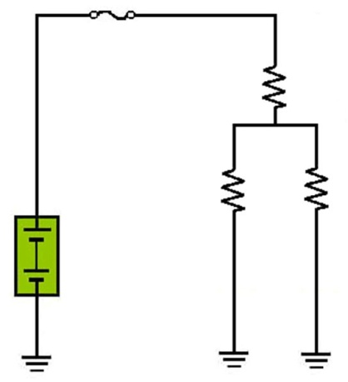  Circuit A: |  |  | 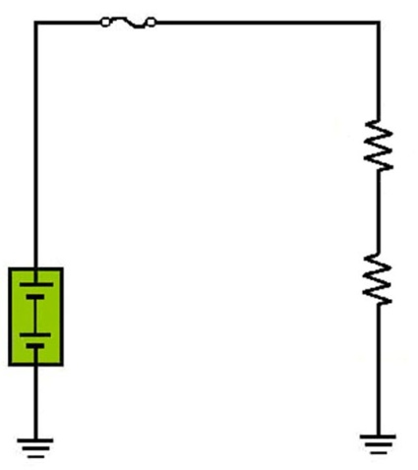  Circuit B: |  |  | 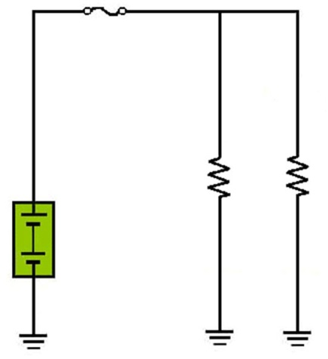  Circuit C:
3. | Identify the following electrical symbols commonly found on automotive electrical wiring schematic diagrams: (20 marks) |  |  |  |  |  | AC1.3
A |  | 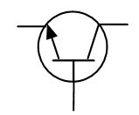  B |  | 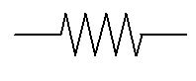  C | 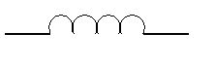  D |  |  | 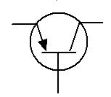  E
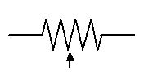  F |  | 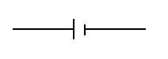  G |  | 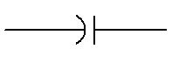  H | I |  |  | 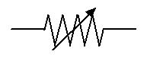  J

Question Number | Question |  |  |  | AC |  | Marks Awarded
4. | Identify the electrical units of measurement from the common automotive electrical test meter below: (12 marks) |  |  |  | AC1.4
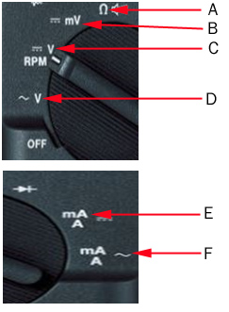 |  |  | A
 |  |  | B
 |  |  | C
 |  |  | D
 |  |  | E
 |  |  | F
5. | Identify the electrical measuring test being carried out in the images below: (6 marks) |  |  |  |  | 1.4
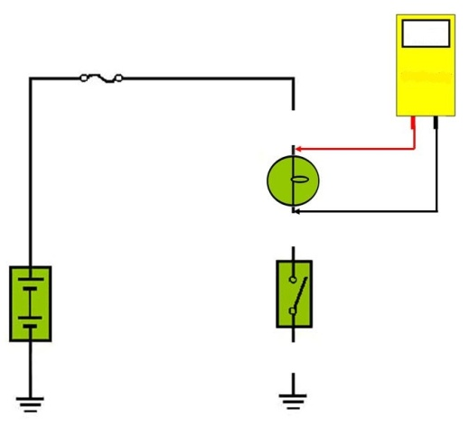  A |  | 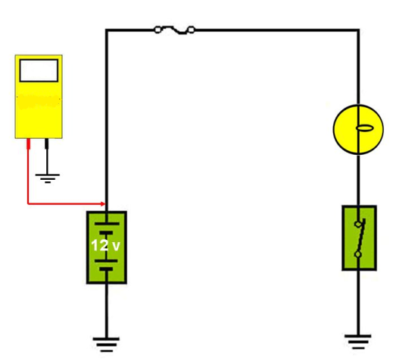  B |  | 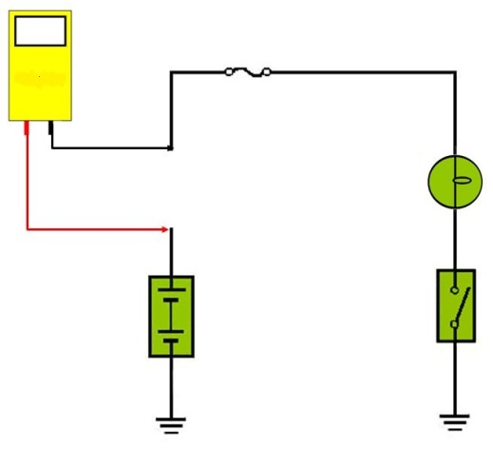  C

Question Number | Question |  |  | AC | Marks Awarded
6 | Identify the automotive locking and securing devices in the images below: (24 marks) |  |  | 1.5
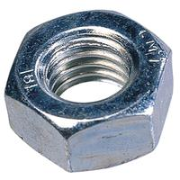  A |  | 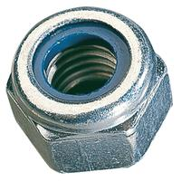  B | 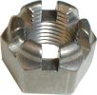  C
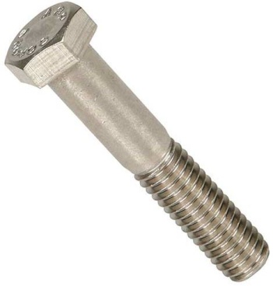  D |  | 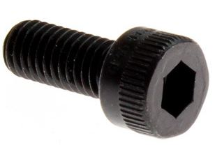  E | 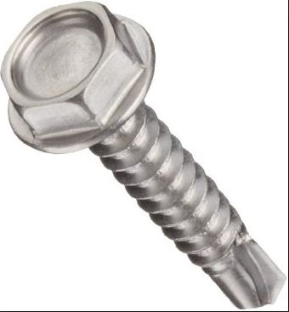  F
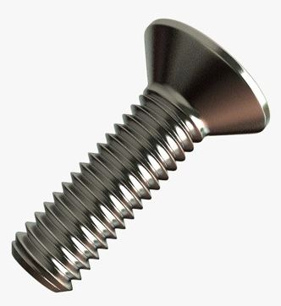  G |  | 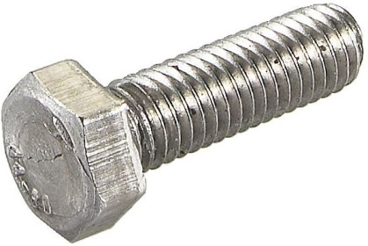  H | 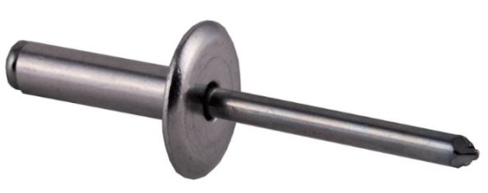  I
J |  | 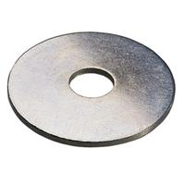  K | 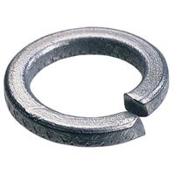  L

Question Number | Question |  |  | AC | Marks Awarded
7. | Identify the automotive locking and securing devices in the images below: (12 marks) |  |  | 1.5
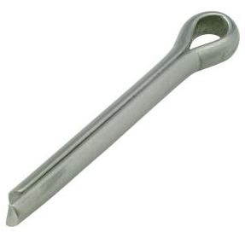  A |  | 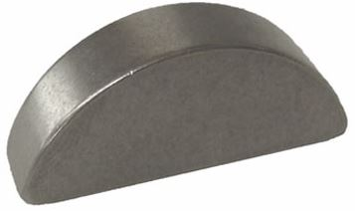  B | 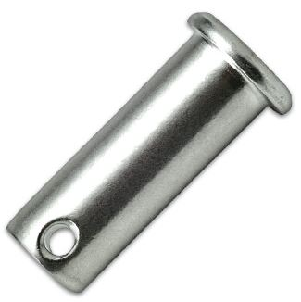  C
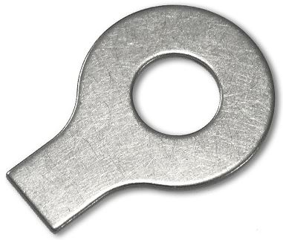  D |  | 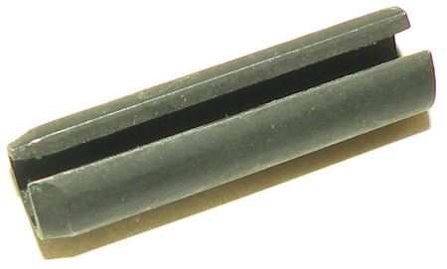  E | F
8. | Identify the common automotive hand tools in the images below:  (24 marks) |  |  | 1.6
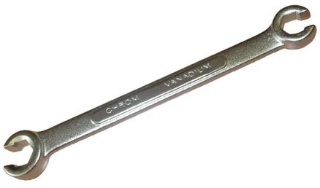  A |  | 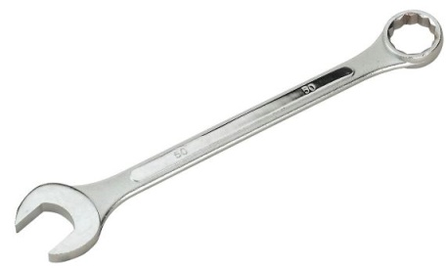  B | 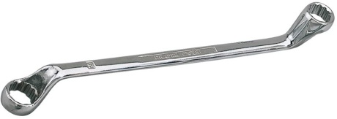  C
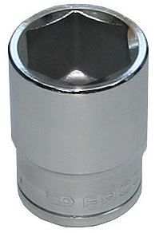  D |  | 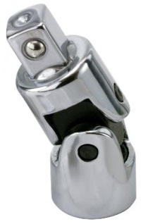  E | 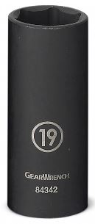  F

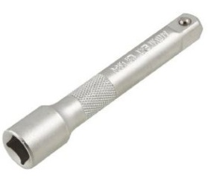  G |  | 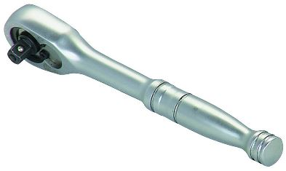  H | 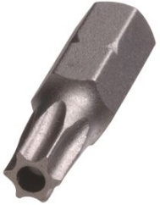  I
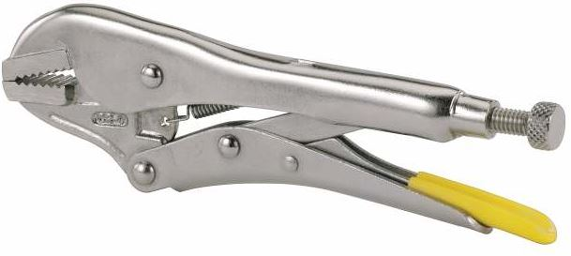  J |  | 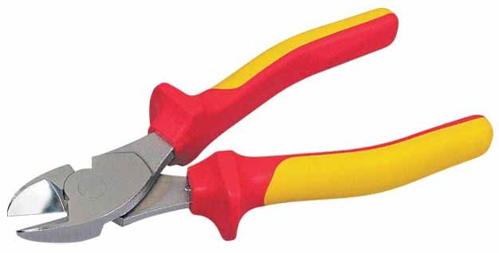  K | 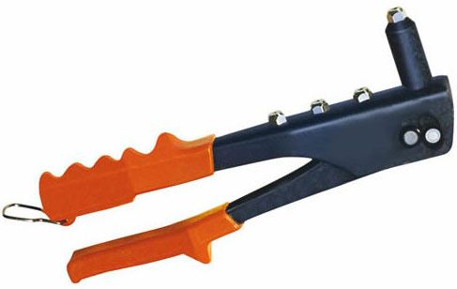  L
9. | Identify the common automotive workshop equipment in the images below: (18 marks) |  |  | 1.7
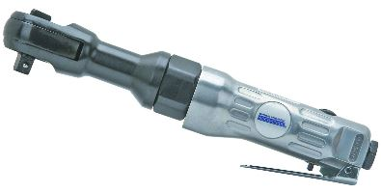  A |  | 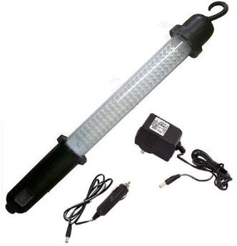  B | 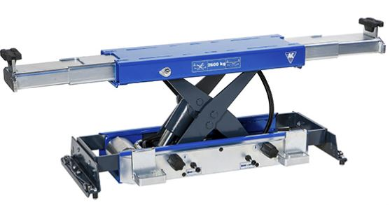  C
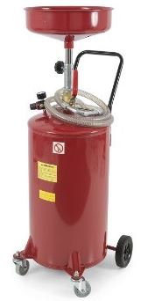  D |  | 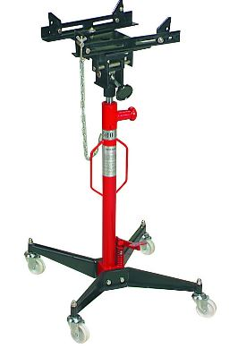  E | 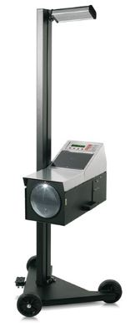  F

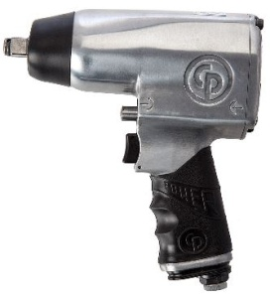  G |  |  |  |  | 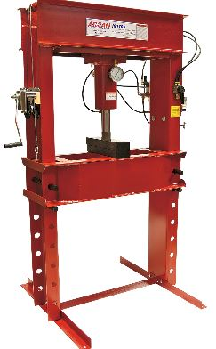  H |  | 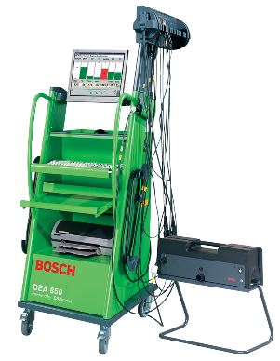  I
10. | Identify the material classification and where on a vehicle the following ferrous, non-ferrous and non-metallic materials would be used:  (44 marks) |  |  |  |  |  |  | AC2.1, 2.2
Material |  |  | Material classification:  Ferrous/Non-Ferrous/Non-metallic |  |  | Vehicle use:
Copper
Aluminum
Plastic
Cast iron
Mild and low carbon steel
High carbon steel
Lead
Brass
Glass
Rubber
Kevlar
11. |  | What is meant by the following terms when applied to materials used in vehicle materials and construction: (8 marks) |  |  |  |  |  |  | AC2.3
A. Tensile stress:
B. Compressive stress:
C. Yield stress:
D. Shear force:

UNIT REF:L1MV02A |  | SUPPORT MATERIAL ASSESSOR RECORD  UNIT TITLE: KNOWLEDGE RELATING TO AUTOMOTIVE FOUNDATION SKILLS
The section below is for use by the assessor :
Learning Outcomes |  |  |  |  |  |  |  |  |  |  | Passed (Tick )
1 | Know the basic tools, equipment and measuring devices used within a workplace environment
2 | Know the materials used in vehicle construction
Assessment Criteria
1.1 | State the main units of measurement related to automotive repair
1.2 | Identify the main measuring equipment used in an automotive environment
1.3 | State the basic principles of electrical circuits and components
1.4 | Identify electrical measurement equipment used in an automotive environment
1.5 | Identify locking and securing devices used in an automotive environment
1.6 | Identify common hand tools used in an automotive environment
1.7 | Identify common workshop equipment used in the automotive environment
2.1 | Identify the ferrous, non-ferrous and non-metallic materials used in vehicle construction
2.2 | Identify the applications of ferrous and non-ferrous materials used in vehicle construction
2.3 | State the common terms applied to the materials used in vehicle construction
Achievable Marks |  |  |  |  | Actual Marks |  |  |  | Actual Percentage (%)
210
Assessor Knowledge Decision |  |  |  | Tick () |  | Written feedback (with reference to assessment criteria) must be given when a learner is referred:
PASS (60% and above)
REFER (Less than 60%)
Assessor Decision: |  |  |  | Tick () |  | Written feedback (with reference to assessment criteria) must be given when a learner is referred:
PASS
I confirm that the learner’s work was to an acceptable standard and met the assessment criteria of the unit
REFER
The work carried out did not achieve the standards specified by the assessment criteria (written feedback to learner)
Assessor Name (Print): |  |  |  |  |  |  | Assessor PIN: |  |  | Date:
The section below is only to be completed once the assessor decision has been made and feedback given to learner:
The section below is to be completed by the learner :
I confirm that the work carried out was my own, and that I received feedback from the Assessor |  |  | Learner Name (Print): |  |  |  |  | Learner Signature: |  | Date:

