Servicing & Inspection of Light Vehicles
When we are discussing servicing of cars, it helps to take into account the different types of services that can be carried out. In general the chronological order of a cars service life is set out below:

PDI - Pre Delivery Inspection
This type of service is carried out on a brand new vehicle, prior to it being handed over to a customer. It ensures that all factory settings, levels and adjustments are all ok. It will usually take approx 1hr to complete.

1st Service
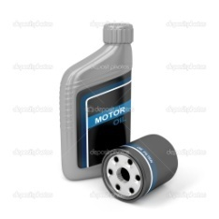
Usually carried out at 10,000 miles and or 1 year whichever comes first. This is described sometimes as a minor service. Generally this service is made up of an inspection of the vehicle and in most cases a lubrication service which involves replacing the engines oil and various filters.

Full service / Main service
This is the cars major service. Traditionally it is carried out every 10,000 miles or yearly, whichever comes first. Within this service, there would be extra items removed and replaced, such as the spark plugs, fuel filter as well as the oil and filters.

Traditionally after the full service is completed annually a lubrication service (covering items similar to the 1st service) is then carried out every 6 months.
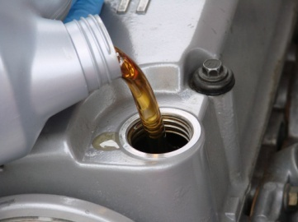
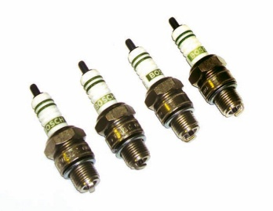
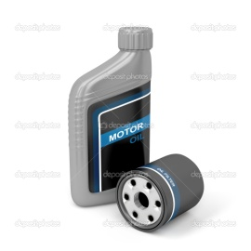
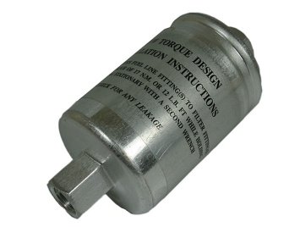
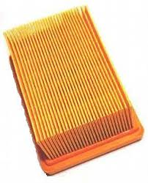

Spark plugs Air filter Fuel filter Oil & filter

A typical full service can be broken down into 3 simple steps. These steps are :-
The 3 R’s
Remove & Replace Components
Replenish & Adjustments
Report on Faults found
The service carried out could look something like this grid when completed.
Remove & replace components  - Spark plugs  - Oil & filter, sump washer  - Air filter  - Fuel filter  - Pollen filter (if app) | Report on faults found  The garage & customer will be entering what is commonly known as an agreement / contract. That agreement will be as follows. For a set amount of money they will expect the vehicle is serviced. The service will include the 3R’s  As part of the service, the customer will also receive a detailed diagnostic report of any other faults found.  You must have the customers permission to carry out any “extra work” , as this would then require a further agreement/ contract.  The Technician / Mechanics report should include the following areas.  - Engine & ancillary components  - Chassis systems, steering, brakes & suspension systems  - Transmission & final drive systems  - Electrical systems  NB  The vehicle should also have a pre service test drive and a post service test drive.
Replenish & adjustments

- Washer bottle fluid level

- Coolant level / antifreeze (if app)

- Brake / clutch fluid level

- Gearbox / transmission oil level

- Rear differential oil level

- Automatic gearbox oil (if app)

- Adjust clutch cable freeplay

- Rear brake shoes & handbrake

- Tapered wheel bearings

- Tyre pressures

Referencing Technical Information for Servicing
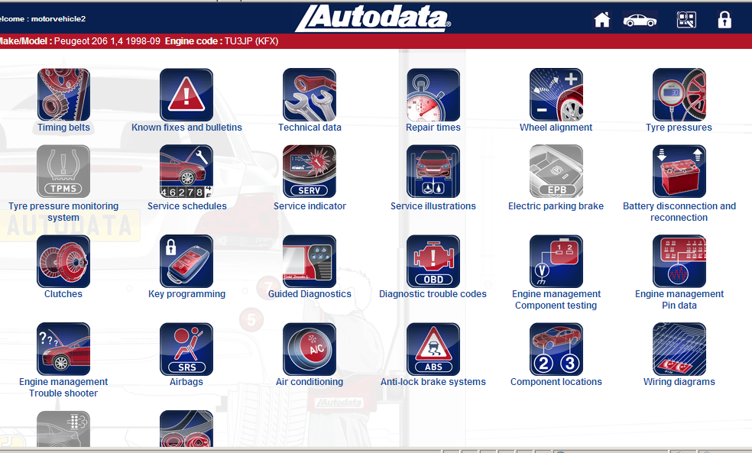

Technical
Data

Service
Schedules

Service
Illustrations

Service Illustrations
Technical Data Required for Servicing

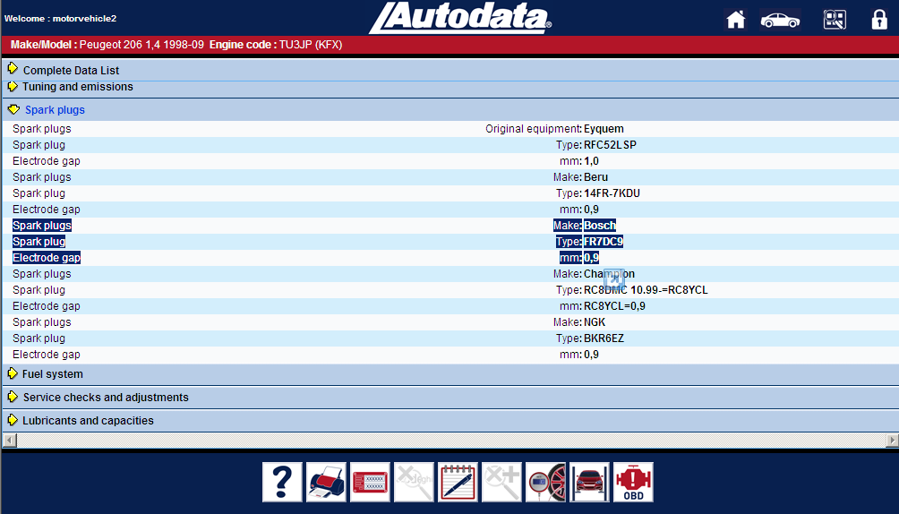
Spark plug information

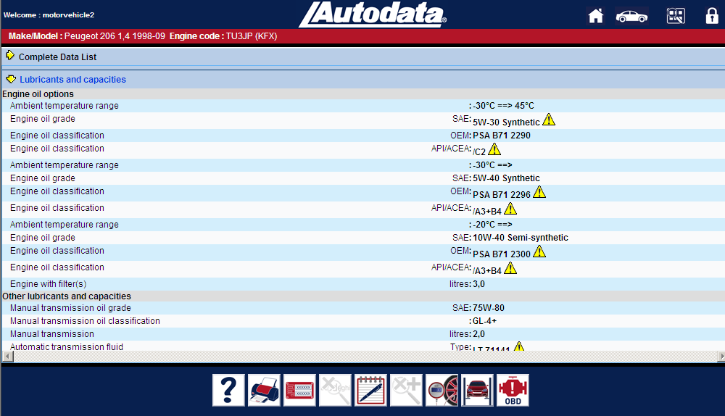
Oil & lubricants information

Selecting the correct service schedule

Selecting the service plan Position of Vehicle Type of check to
for a given mileage and item / area be carried out
and date. To be inspected e.g. Check/report
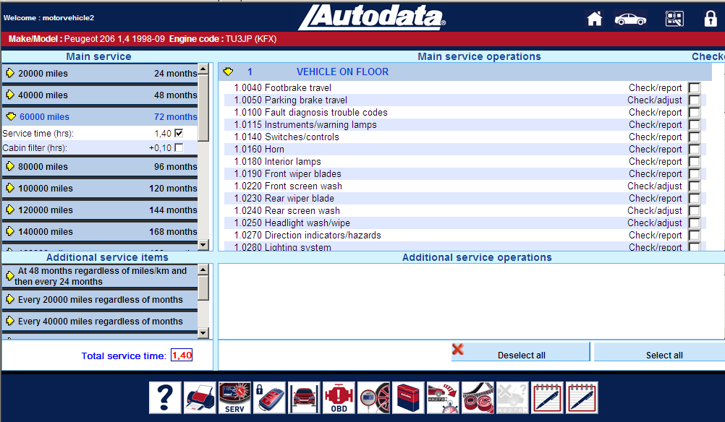
Remove /replace
Check/adjust

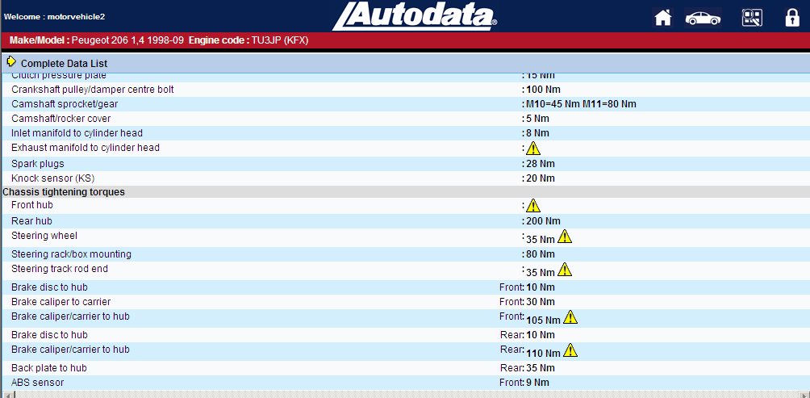
Tightening torques

Servicing Terminology
Routine servicing - The term given to the general tasks carried out as part of a
scheduled service

Non routine servicing - This is a term used to any extra work reported on a service
and completed at an extra cost with the customers approval

Time based servicing - This is a service carried out due to the next service coming
before the anticipated mileage.

Mileage based servicing - As above except that the vehicle has done the expected
Mileage, quicker than the anticipated date

e.g. - 10,000 miles OR 1 year whichever comes first

Preventive maintenance - This term is given to a situation where you carry out a repair
task which if not completed could result in further repairs and
cost if left for a later date.

Examples of “some” Preventive Maintenance
- Replacing a leaking wheel cylinder before it contaminated the brake shoes
- Replacing the timing belt at the recommended interval before it fails causing severe damage to the engine
- Regular oil & filter changes
- Checking antifreeze content before the winter cold weather strikes

F/S/H - Full Service History
F/D/S/H - Full Dealer Service History

Differing Stages of a Vehicle Service
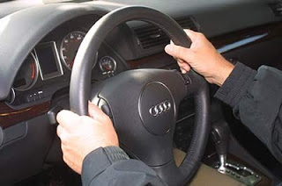
The pre service test drive
Checking for :
- General performance

- Knocks & sounds

- Steering pulling to either side

- Braking performance

- Interior function ( washers, horn, lights, seatbelts, dashboard warning lights, aircon…. etc

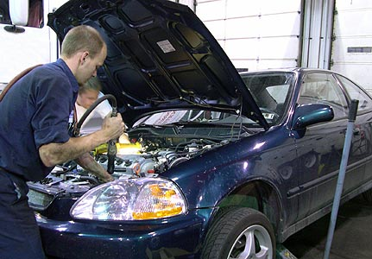
Vehicle on the floor
Tasks carried out:-
- Removing & replacing serviceable
components ( plugs, air filter …etc)

- Replenishing of fluids etc

- Adjustments of belts, freeplay of cables etc

- Refilling of new oil

Vehicle half way up
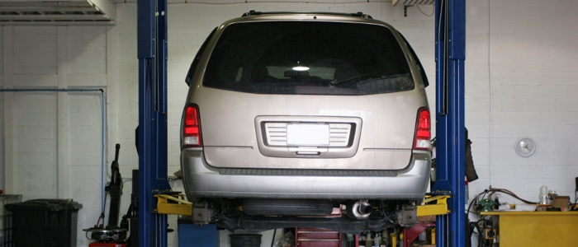
Tasks carried out:-
- Removal of wheels for inspection
of front and rear brakes.

- Inspection of steering, final drive,
suspension components.

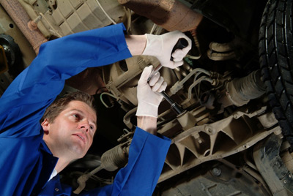
Vehicle fully raised
Tasks carried out:-
- Draining oil & replacing oil filter
Tip – Always drain the oil when the
engine is hot – the oil flows easier
this ensures the maximum oil leaves
the engine.

- Inspection of underside of vehicle
- Inspection of propshaft and final drive
(If appropriate)

Post service test drive
Checking for :
- Elimination of any original faults

- General driveability of vehicle

Finally the hand over to a satisfied customer

You will now be expected to pass a multi choice exam. Remember the 3r’s
- Remove & Replace
- Replenish & Adjust
- Report.
Phase Test Questions

- Which of the following is not a manufacturer-recommended scheduled service type?
A Pre-delivery service
B Fast service
C Distance-based service
D Time-based service

- What is being carried out in the image shown below?
A Tyre depth check
B Wheel condition check
C Tyre pressure check
D Wheel bearing run out

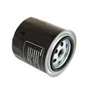
- The type of oil filter shown in the image below is as a replaceable?
A Canister
B Tin
C Element
D Centrifugal

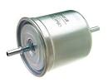
- What is the component shown in the image below?
A In-line fuel filter
B In –tank fuel filter
C Integrated fuel filter
D Fuel pump

- If the ABS light remains on, this warns the driver that the ABS system
A Is functioning correctly
B Has applied the brakes
C Is not functioning correctly
D Brake fluid requires changing

- Specific gravity of the cooling system antifreeze should be inspected using
A An ammeter
B A voltmeter
C A hygrometer
D A Hydrometer

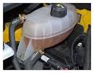
- What is the component shown in the image
A Expansion tank
B Contraction tank
C condenser tank
D Washer reservoir

- To set a spark plug gap, which of the following is the measuring tool used
A Depth gauge
B Micrometer
C Feeler gauge
D Dial test indicator

- Identify one component that may need adjusting as part of a scheduled service interval
A Hand brake
B Brake disc
C Wiper motor
D Seat belt

- The front wheel alignment of a vehicle is found to require adjustment. How should this adjustment be undertaken on a rack and pinion steering system
A By adjusting the track rod length
B By increasing the drop arm length
C By adding additional shims to the ball joint
D By moving the torsion bar to the nearside or offside of the vehicle

- Which of the following may need adjusting as part of a routine service
A Side lights
B Fog lights
C Head lights
D Brake lights

- Which one of the following may require adjusting as part of a routine service
A Spark plugs
B Spark leads
C Ignition coil
D Ignition switch

- Brake pads and discs would be inspected on a service interval for which one of the following
A Brake fluid leaks
B Wear
C Clearance
D Brake fluid level

- Checks are to be made for leaks on a fuel system. One method to do this is by using
A An emission tester
B A visual check
C Engine code reader
D Tread wear indicator

- When referring to tyre tread depth, what does the abbreviation TWI stand for
A Tyre width indicator
B Tyre wear indicator
C Tread wide indicator
D Tread wear indicator

- Brake linings and drums should be inspected on a service interval for which of the following
A Wear only
B Condition only
C Wear & condition
D Correct shoe alignment

- Drive belts should be inspected on a service interval for which of the following
A Wear only
B Condition only
C Wear & condition
D Wear, condition and clearance

- Which one of the following faults will not be indicated by a low brake fluid reservoir level
A Excessive worn brake pads
B Over adjusted hand brake
C External brake fluid leak
D Internal brake fluid leak
- A fully sealed expansion tank is used to do which of the following
A Check and drain a liquid cooling system
B Check and refill a cooling system
C Clean the coolant of a liquid cooling system
D check the temperature of the coolant

- Why is it important for a vehicle to be on a level surface when checking engine oil level
A Easy access to engine
B Dip stick may show a high reading
C Dip stick will show correct reading
D Dip stick may show a low reading

- Prior to carrying out work on a vehicle, the vehicle should be inspected for damage. What should happen if cosmetic damage is noticed
A Recorded on a scrap piece of paper
B Not recorded, as its not required
C recorded on a job card
D Highlighted on the vehicle

- Specifications for a vehicles maintenance system (ie oils types etc) would not be found in the
A Workshop manual
B Owners handbook
C Vehicle job card
D Specification sheet

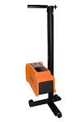
- The following equipment would be used to carry out the following task
A Wheel balance
B Confirm a new front end has been repaired correctly
C The headlight dip beam pattern is within tolerance
D Automatic wiper are working correctly

- The following equipment would be used to carry out the following task
A Brake test efficiency
B Brake horse power of a vehicle
C Steering vibrations
D Suspension Faults

- For warrant purposes, it is vital that a completed job card includes the following
A The work carried out and any change of customer details
B The work carried out, the vehicles mileage and date of when the work was completed
C The time of when the job was started and completed
D The colour and registration of the vehicle

- On removing the oil on a gearbox, it is found to contain metal fillings. The best course of action would be.
A Carry on with the task as the customer expects the car to be ready soon
B Report your findings to your supervisor immediately
C Ignore the fillings because it is going to be refilled with new oil

- The tool in the image would be used when carrying out which inspection on a vehicle
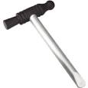
A MOT inspection
B First service
C PDI inspection
D Used vehicle inspection

- When inspecting a timing belt for tension, you would inspect for free play on the
A Shortest length
B Nearest point to the tensioner
C On its longest length
D Towards the camshaft

- What component in the image is being tested for its serviceability
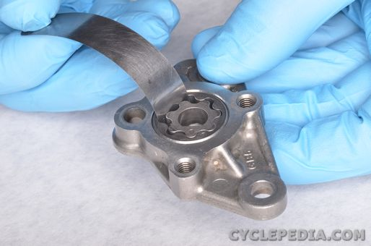
A Water pump
B Oil pump
C Differential
D Turbo

- The following item would be used to carry out what task
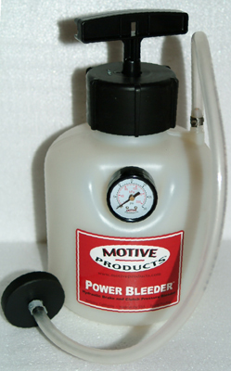
A Bleed brakes
B Drain coolant
C Top up hydraulic fluid
D Drain a gearbox of oil

