Level 3 Diploma in Work-based Land-based Engineering Operations

Unit 600 Task A: Use Calculations
(This task uses units of voltage, current, resistance, density, measuring and calculation)

PROFORMA 10 TITLE: ELECTRICAL PERFORMANCE

Introduction
In the presentation you were introduced to the term of electrical load and how electricity transmits current to that load in order to power it. In the workbook as well, you saw that the circuit produces a resistance to current flow which in turn affects the voltage.
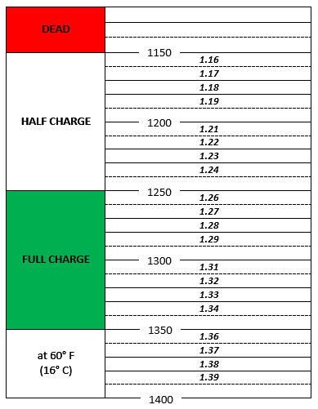
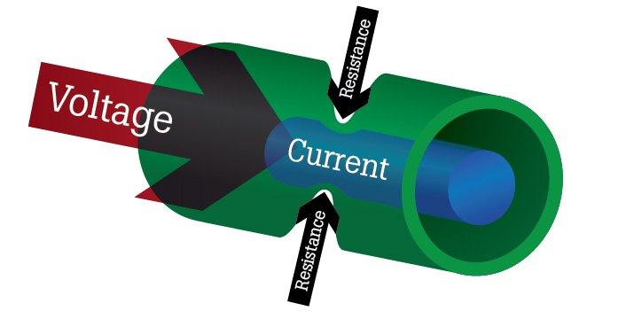
The heart of any electrical circuit is its power supply. In a land-based vehicle this is usually a battery and in order to do its job, the battery must be “in good heart”. Typically this means maintenance which requires taking a range of measurements.
This proforma is about measuring and calculating battery performance and other electrical circuit values.

TRAINEE:............................................................................... DATE: ……………………..

Task
- Complete the L3 Task Sheet 315/01: “Battery Servicing” and fill out the task sheet’s proforma. *
- Complete the L2 Task Sheet “Using an AVO meter & Multimeter”. *
- Complete the L3 Task Sheet 315/02: “Testing a Starter Circuit”. *
* Unless already completed

Attach the completed Task Sheets to this proforma.

