+
Level 3 Diploma in Work-based Land-based Engineering Operations

Unit 600 Task A: Use Calculations
(This task uses units of weights, volumes, flow rates and speed; measuring, calculation and conversion)

PROFORMA 11 TITLE: MACHINE CALIBRATION

Introduction
In this final task, you are required to calibrate a machine of your choice… typically a crop or knapsack sprayer; fertilizer distributor or seed drill. The procedure for calibration is usually explained in the machines operators’ handbook. An example is given below for a seed drill (Note: learners who have completed a Pesticide Applicators ticket PA2 will be evidence of this task on production of documentary evidence).
Calibrating an MF30 13 spout Combine Drill
Data: Application Rate of seed = refer to seed rate chart for seed chosen lbs/acre
Row width = 4³/₈“
1/10th acre = 41 turns.
Drive sprocket = 20T
Procedure:
- Place the calibration tray, buckets or other suitable receptacle e.g. foot bath under the first four spouts nearest the gearbox.
- Remove the ‘R’ clip connecting the drive to the fertilizer drive shaft and slide the drive shaft back to dis-engage (fig.13 below).
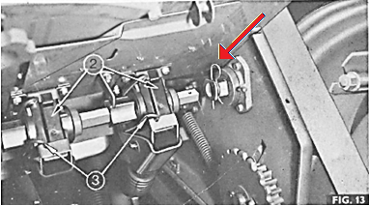
- Check the relevant seed flaps are adjusted appropriately for the particular seed (1, fig.9).
For cereals the flap should be set against the roll under light spring pressure.
The pressure can be altered by the lever 2 (fig.9)

- Blank off all other feeds with blanking plates (1, fig.12).

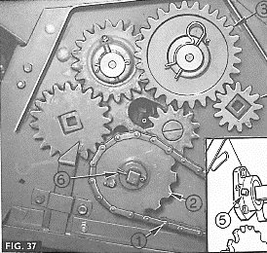
- Remove gearbox cover and check details of sprocket fitted (2, fig.37: 20T).
- Place an appropriate amount of seed into the hopper over the four feeds.
- Insert the calibration handle into the extension shaft and turn handle 41 times for 1/10th acre in an anti-clockwise direction, otherwise engage the land drive, jack up the drive wheel and turn the wheel instead.
- Weigh the seed collected as per below then calculate the application rate.
- Confirm results and adjust Regulator setting (fig.8) if necessary and repeat steps 6 – 8 as required.
The formula for calculating the Application Rate for this particular machine is as follows:
$$lbs per acre= \frac{Weight of seed collected (lbs)}{4 spouts }x number of spouts x 10 (acre)$$
Task
With the aid of the formula above:
- Calibrate the seed drill to produce the chosen application rate in lbs/acre.
- Write a summary of the process below stating the seed used and the recommended application rate and giving any adjustments made.
- Show the formula and all your calculations used.
- Finally convert your application rate into metric (kg/ha)
Note/ 1ha = 2.47 acres
1kg = 2.2 lbs.

TRAINEE:............................................................................... DATE: ……………………..

