Level 3 Diploma in Work-based Land-based Engineering Operations

Unit 600 Task A: Use Calculations
(This task uses ratios, areas & volumes)

ACTIVITY 3 TITLE: ENGINE DATA

Introduction
The engine cylinder below represents a piston at Bottom Dead Centre. The stroke is unknown. What is known is the area of the piston crown and the total volume of the cylinder. We can find the stroke of the piston by following the steps over the page.
Various standard formulae are used to work through the steps.
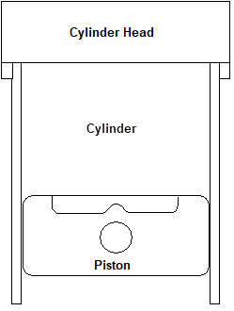
They are:-
$$CR= \frac{Vt}{Vc}$$
Where:
CR = compression ratio
V_{t} = total volume
V_{c} = clearance volume

$$Vt = Vc + Vs$$
Where:
V_{s} = swept volume
and:
V_{s} = Volume of a cylinder = area x height

Task
Selecting the most appropriate formula for each step, work through the steps over to find the stroke of the piston.

A. If the engine cylinder has a Compression Ratio of 12:1 and a Total Volume of 192 c.c., what is the cylinder's Clearance Volume?
B. With the Clearance Volume now established, calculate the Swept Volume.

C. With the Swept Volume now established, using the formula given what is the Stroke of the piston if the piston head has an area of 22cm²?

TRAINEE:............................................................................... DATE: ……………………..

