Level 3 Diploma in Work-based Land-based Engineering Operations

Unit 600 Task A: Use Calculations
(This task uses ratios, speed & conversion factors)

PROFORMA 4 TITLE: GEAR RATIOS

Introduction
A dumper has a conventional transmission consisting of a three-speed gearbox and a differential assembly.
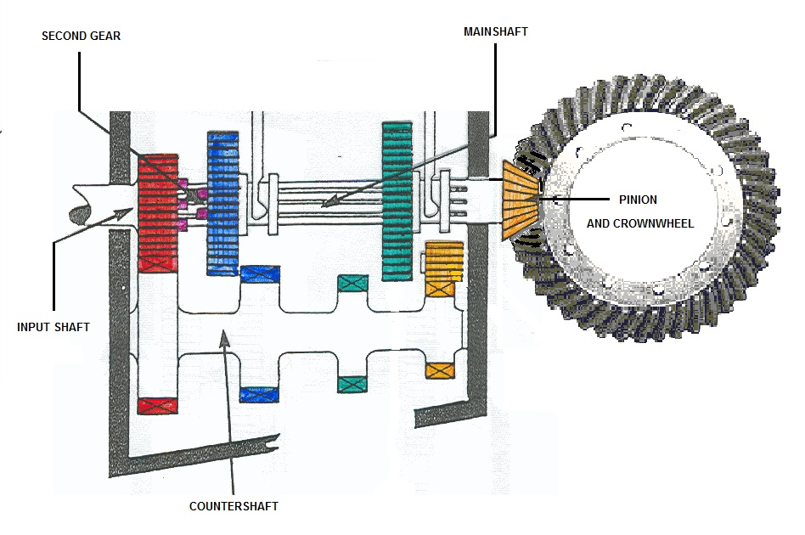

In the three speed gearbox, the input shaft gearwheel has 24 teeth and its corresponding constant mesh gear on the countershaft/layshaft has 52 teeth. With "second gear" selected, the driving gearwheel on the countershaft/layshaft has 27 teeth and the gearwheel in mesh with it on the mainshaft has 49 teeth.
Going into the differential assembly, the pinion on the end of the mainshaft has 10 teeth and meshes with the crown wheel which has 56 teeth. Halfshafts coming out of the differential drives the two front wheels.
The tyres on the driving axle are 600 x 16’s and have an overall diameter of 75cms currently.

TRAINEE:............................................................................... DATE: ……………………..

Task
A. Draw a simple sketch showing the layout of the transmission with the number of teeth labelled on their respective gears.
B. Calculate what speed the wheels turn if the engine runs at 1800 rpm.
C. If the engine was running at 1800 rpm in second gear, what speed was the dumper travelling at in m.p.h.?
Note 1: there are 1609.3 metres in a mile
Note 2: circumference of a circle = 2πr
Note 3: π = 3.1416

