Level 3 Diploma in Work-based Land-based Engineering Operations

Unit 600 Task A: Use Calculations
(This task uses areas, weights, volumes, angles, flow rates, speed, trigonometry & scaling)

PROFORMA 5 TITLE: HYDRAULICS

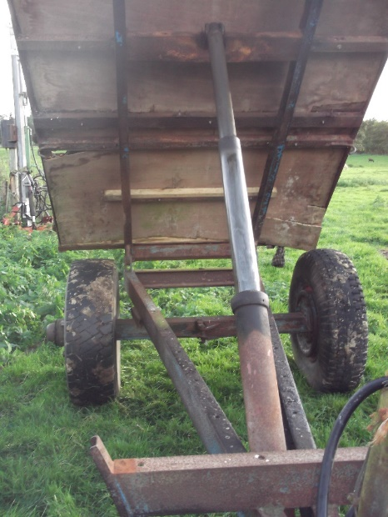
Introduction
A tipping trailer has a two stage ram. The first stage has a cylinder diameter of 85mm and a stroke of 660mm.

The second stage has its cylinder diameter 65mm and a stroke of 620mm.

When the trailer was lowered, it took 30 seconds to retract the second stage and 50 seconds to retract the first stage.

At full tip height, a plumbline was dropped from the top of the second stage cylinder pivot pin under the bed and a mark was placed on the chassis giving a perpendicular measurement of 1.8m. The mark was measured to be 1.5m from the trailer bed pivot at the rear.

Task
A. Calculate the volume of oil needed to raise the first stage of the ram and the volume of oil needed for the second.
B. Calculate the average flow rate of the returning oil to the tractor from the ram when the trailer bed is lowered (both the first and second stage) in litres per minute.
C. Decide on what trigonometric ratio you need to use and calculate the tip angle of the trailer bed at full tip height.*
D. On a sheet of A4 paper, draw a diagram to a suitable scale and use a protractor to measure the tip angle. Explain possible reasons for any discrepancies between the results you have calculated and those obtained from your diagram.

Note/
* When calculating angles, trigonometry is used. Depending on what data is given, provided two values are known, the value of the third unknown can be calculated using a simple equation. The value calculated can then be determined from the respective tables, either being a sine, cosine or tangent.

The three simple equations are: $sin=\frac{side opposite}{hypotenuse}$ $cos=\frac{side adjacent}{hypotenuse}$ $tan=\frac{side opposite}{adjacent}$
TRAINEE:............................................................................... DATE: ……………………..

