Level 3 Diploma in Work-based Land-based Engineering Operations

Unit 600 Task A: Use Calculations
(This task uses algebra, areas, pressures, loads, force, and conversions)

PROFORMA 6 TITLE: HYDRAULICS II
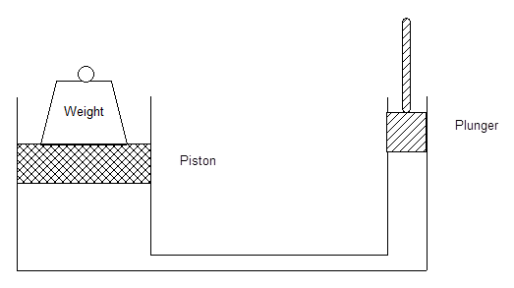
Introduction

The diagram above represents a hydraulic press. In conventional hydraulic theory:
- The maximum load lifted is directly proportional to the area of the face of the piston i.e. the larger the piston face area, the greater the load that can be lifted.
- The maximum load lifted is determined by the maximum hydraulic pressure that can be exerted against the face if the piston.
- The load lifted is the product of $Pressure x Area$, and you’ll remember from your Workbook…
$Pressure (or Thrust)=\frac{Force}{ Area}$

Task
A. Calculate the area of the piston if the load it has to lift is 25lbs, the area of the plunger is 1in² and the force applied to the plunger is 5lbs.
B. With the area of the piston now established, work out what the system pressure would have to be to lift a 1 cwt (hundredweight) load. *
C. Now find out what the maximum load is that can be lifted before the PRV blows at 1000 psi.
D. Now convert your three answers into SI units.

*Note: there are 112 lbs in a hundredweight and 20cwt in a ton.
TRAINEE:............................................................................... DATE: ……………………..

