Level 3 Diploma in Work-based Land-based Engineering Operations

Unit 600 Task A: Use Calculations
(This task uses areas, volumes & conversions)

PROFORMA 8 TITLE: WORKSHOP FLOOR

Introduction
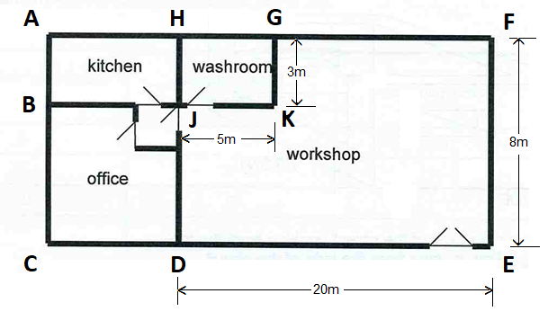
The drawing above represents the plan of a workshop. The workshop floor needs to be repainted and the area known to calculate the volume of paint.
In working out how much paint you will need, you’ll need to work out the total area of the workshop floor then source an appropriate paint, calculate how many tins are required after establishing the paints’ coverage, and then arrive at a total cost.

Task
A. Calculate the floor area that needs painting.
B. Research on-line for a suitable paint product and calculate how many tins would be required.
C. Print out the web-page (or screenshot) sourced from your research which gives the essential information.
D. Work out the overall cost of the job and how much paint would be left over to the nearest litre.
TRAINEE:............................................................................... DATE: ……………………..

