Level 3 Diploma in Work-based Land-based Engineering Operations

Unit 600 Task A: Use Calculations
(This task uses load, force & friction)

PROFORMA 9 TITLE: COEFFICIENT OF FRICTION

Introduction
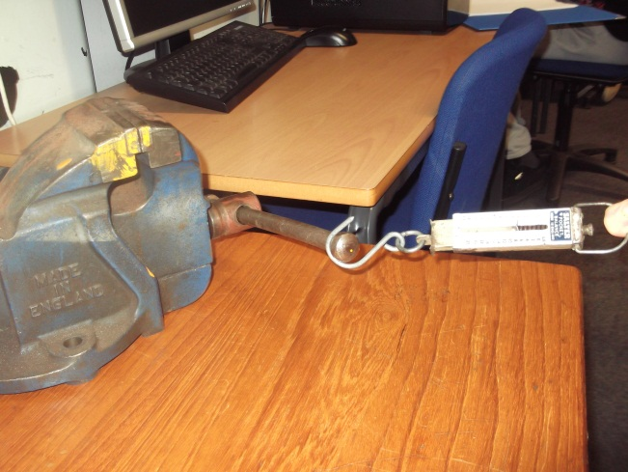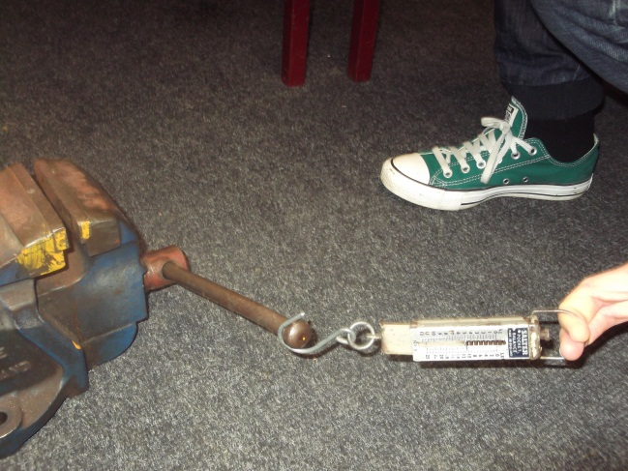
The pictures above show a spring balance being used to measure the force required to pull a known weight (vice) over two different surfaces.
The formula used to calculate the coefficient of friction was demonstrated during the presentation (p26) and is reproduced here:
$$µ=\frac{F}{W}$$

Task
With the supplied weight and spring balance…
A. Place the weight on a workbench and measure the pulling force required to drag the weight at a constant speed over the surface.
B. Now place the weight on the wooden ramp and measure the pulling force required to drag the weight at a constant speed along the surface.
C. Finally place the weight on the concrete floor and again measure the pulling force required to drag the weight at a constant speed over the surface.

Record your readings over.

D. From the measurements taken, calculate the coefficient of friction (µ) of each of the three surfaces.
TRAINEE:............................................................................... DATE: ……………………..

- Workbench
Weight (kg): | Constant pulling force (kg):

- Wooden ramp
Weight (kg): | Constant pulling force (kg):

- Shop floor
Weight (kg): | Constant pulling force (kg):

