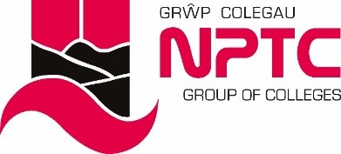

School of Hairdressing and Applied Therapies

NVQ Level 2 Diploma in Beauty Therapy

Evidence Workbook on the Muscular System

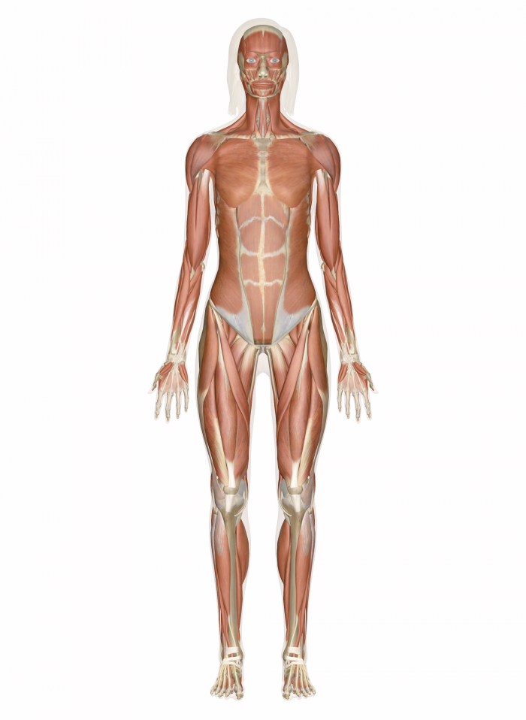

Student Name:
Question | √ or X | Competent/  Not yet  competent
Q1
Q2
Q3
Q4
Q5
Q6
Q7
Q8
Q9

Tutor Signature & Comments:

Date of competence:

- List the functions of the muscular system.

- Name and briefly describe the three main types of muscle tissue.

- Complete the table below.
Muscle | Action(s)
 | Closes the mouth and puckers the lips.
 | Retracts the angle of the mouth to produce a smile.
Frontalis
 | Smiling and laughing.
 | Raises mandible. Elevates and retracts the lower jaw.
 | Pulls back the angle of the mouth and flattens the cheek area, aiding chewing. Sucking and blowing.
Levator Labitis
Masseter
Corrugator

 | Wrinkling of the chin, as used in expressions of doubt or displeasure.
Orbicularis Oculi
Depressor Labii
Sternocleidomastoid
Wrinkling of the skin in the neck.
Depresses the lower jaw.
Draws down the lower lip and angle of the mouth as in yawning.

- List the bones of the appendicular skeleton.

- Label the diagram below of the facial muscles.

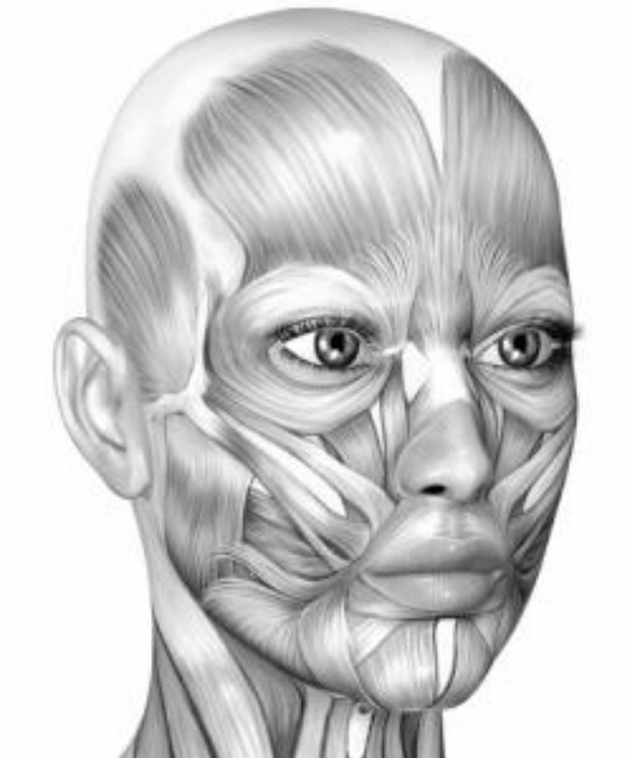

- Label the diagram below.

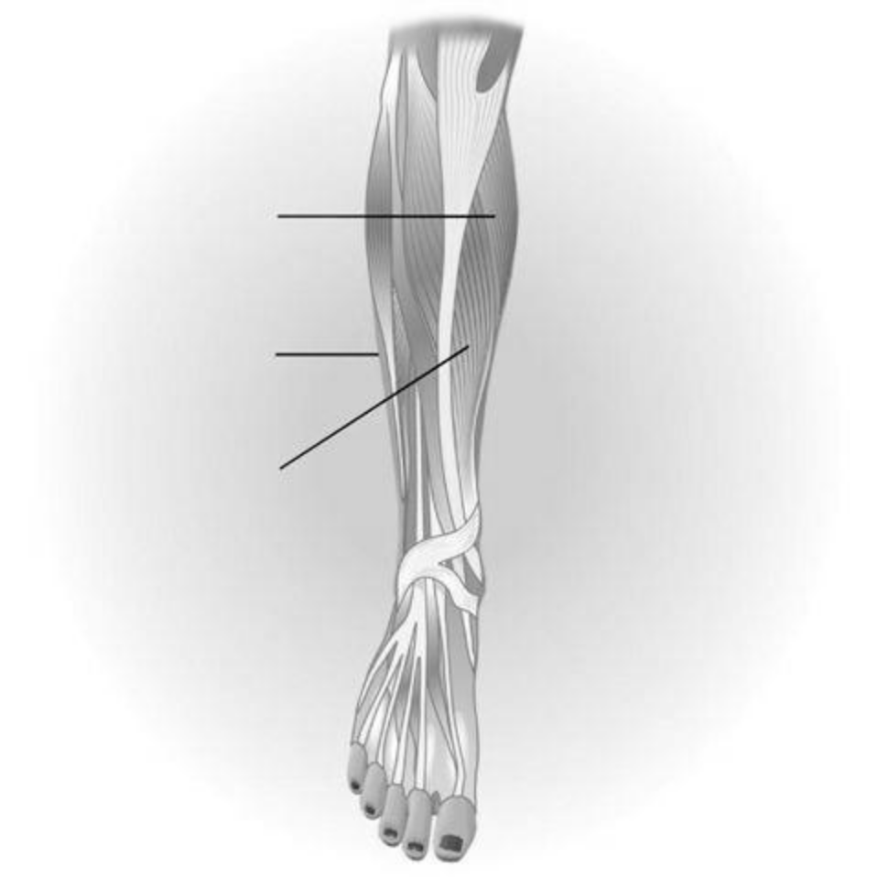

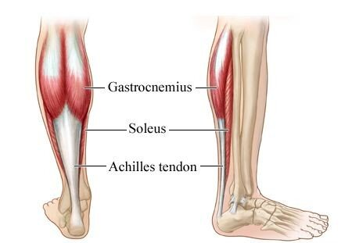

- Label the diagram below.

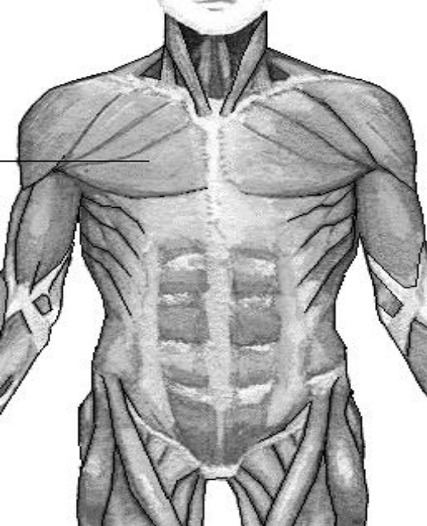

- Label the diagram below.

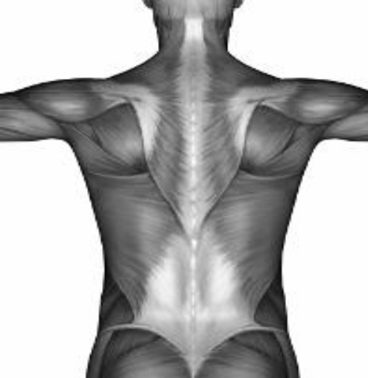

- Complete the table below on the function(s) of muscles in the lower leg.

Muscle | Function(s)
Peroneus brevis
Gastrocnemius
Soleus
Tibialis anterior

- Complete the table below on the function(s) of the muscles in the upper body.

Muscle | Function(s)
Deltoid

Pectoralis
Trapezius

Latissimus Dorsi

