Exhaust Systems & Requirements and Components

System Requirements: The exhaust system has to carry the exhaust gases out of the engine to a safe position on the vehicle, silence the exhaust sound and cool the exhaust gases. It also has to match the engine gas flow, resist internal corrosion from the exhaust gas and resist external corrosion from water and road salt.

System Components:
The exhaust system consists of the exhaust manifold, silencers, mufflers, expansion boxes and resonators. It also has down or front pipes, intermediate and tail pipes, heat shields and mountings. Also included are one or more catalytic converters, one or two lambda sensors and an outlet for the exhaust gas recirculation system.
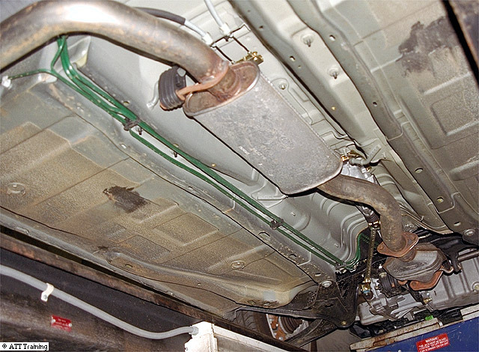

High Temperatures: The exhaust gases are at a very high temperature when they leave the combustion chambers and pass through the exhaust ports. The exhaust manifold is made from cast iron in order to cope with the high temperature. The remainder of the exhaust system is made from steel, which is alloyed and treated to resist corrosion.

Down Pipe or Front Pipe:
The down pipe or front pipe is attached to the manifold with a flat or ball flange. This joint is subject to bending stresses with the movement of the engine in the vehicle. To accommodate the movement, and reduce stress fractures, many flange connections have a flexible coupling made from a ball flange joint and compression springs on the mounting studs.

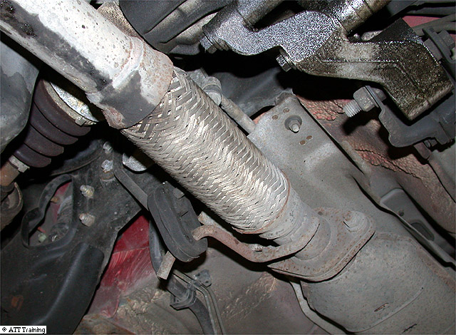
Exhaust Movement:
Another system to accommodate movement is a flexible pipe constructed from interlocking stainless-steel coils, or rings. Where a flexible joint is not required, the front pipe may be supported by a bracket welded to the pipe which is bolted to a convenient position on the engine or gearbox. Where a catalytic converter is used, it is fitted to the front pipe so that the exhaust heat is used to aid the chemical reactions taking place within the catalytic converter. The front pipe connects to an expansion box or silencer. The exhaust gases are allowed to expand into this box and begin to cool. They contract on cooling and slow down in speed.

Exhaust Cutting Tools

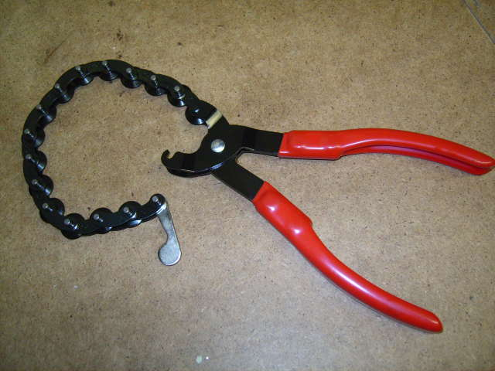
Exhaust Cutting Tool

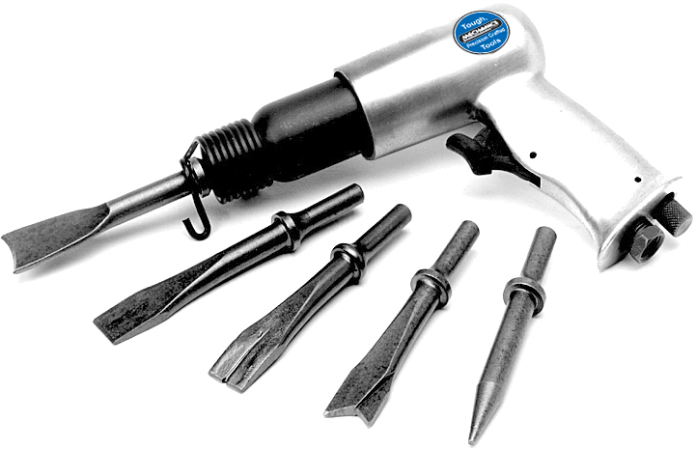
Air Chisel

Silencers or Mufflers:
Silencers are constructed as single- or twin-skin boxes, and there are two main types: The absorption type, which uses glass fibre or steel wool to absorb the sound; and the baffle type, which uses a series of baffles to create chambers. In the baffle type, the exhaust gases are transferred from a perforated inlet pipe to a similarly perforated outlet pipe. These silencers have a large external surface area so that heat is radiated to the atmosphere. Additional pipes and silencers carry the exhaust gas to the rear of the vehicle.

Baffle Type
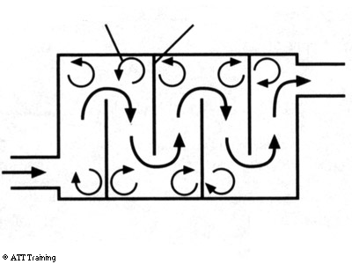
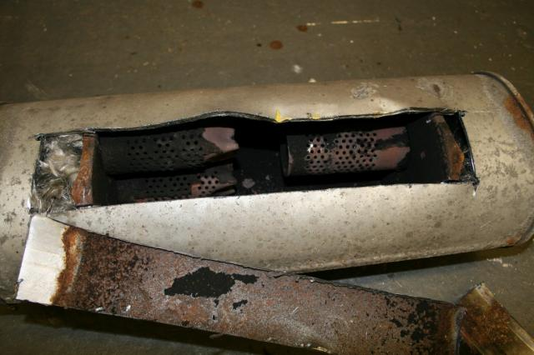

Absorption Type
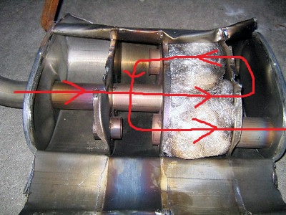
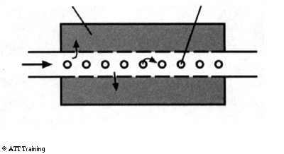
Joints & Sealing
Pipes are joined together by a flange, or clamp, fitting. Flange connections have a heat-resistant gasket and through-bolts to hold the flange together. Clamp fittings are used where pipes fit into each other. The larger pipe is toward the front and the smaller pipe fits inside. A ring clamp, or ‘U’ bolt and saddle, are tightened around the pipes to give a gas-tight seal. An exhaust paste is usually applied to improve the seal of the joint. The exhaust system must be sealed to prevent toxic exhaust gases from entering the passenger compartment.
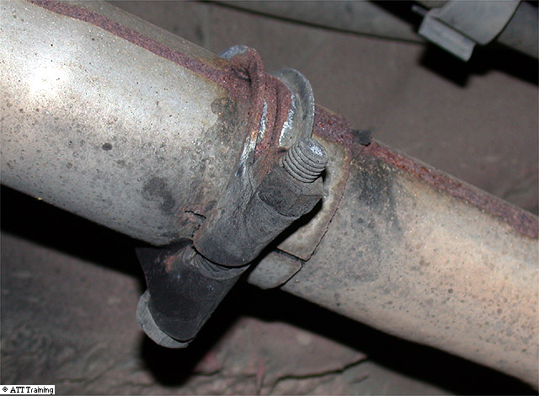

Sleeve Type Joint

Flange Type Fitting

Exhaust Mountings:
A small water-drain hole may be used on the underside of some silencers. This is to reduce internal corrosion from standing water in the silencer body forming on short-journey usage.
The exhaust is held underneath the vehicle body on flexible mountings. These are usually made from a rubber compound and many are formed as a large ring that fits on hooks on the vehicle and the exhaust-pipe brackets. Other mountings are bonded-rubber blocks on two steel plates.
The reasons for the exhaust being mounted on rubber mountings are to allow the exhaust to have movement relative to the engine movement.
If this was not the case the thin exhaust pipe would if held rigid fatigue and crack from the strain
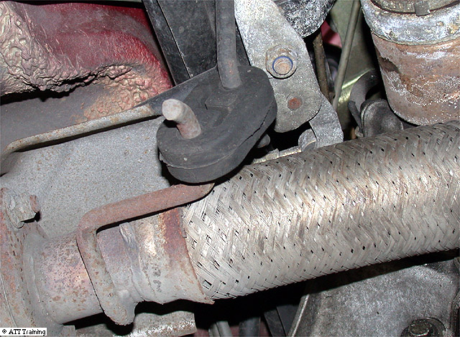

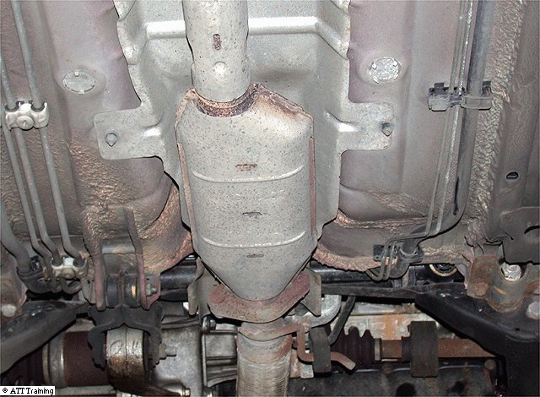
Heat Shields:
Heat shields are fitted to the exhaust, or to the vehicle floor, to prevent the ignition of sound-deadening and anti-corrosion materials. Catalytic converters become very hot during operation. It is important, therefore, that all heat shields are correctly fitted and positioned to insulate the vehicle from the high temperature of the catalytic converter.

Exhaust Gas Recirculation Valve – EGR Valve:
An important exhaust gas recirculation component is the EGR valve. This valve opens to allow exhaust gases to flow from the exhaust manifold into the inlet manifold.
When nitrogen is burnt with fuel at high temperatures, it gives of oxides of nitrogen. To lower this gas product, a valve is fitted and operated by the ECU to allow a small percentage of exhaust gas back into the combustion chamber. The gases are inert (will not burn) and as such will lower the temperature of the combustion in the chamber. This action lowers the oxide of nitrogen gas.
Many EGR valves are operated by vacuum motors. The vacuum feed from the inlet manifold is switched by an electrical solenoid valve. This valve is energised from a relay on signals from the electronic control unit.

Lambda Sensor:
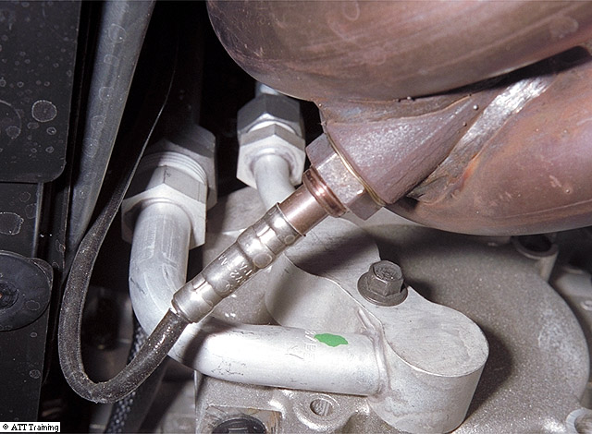
The Lambda sensor is a device fitted to a vehicle which runs on a closed loop system. The function of the Lambda sensor is to measure the content of oxygen that is present in the exhaust gases leaving the engine.
The amount of oxygen detected will allow the ECU to send a signal to the fuel system and it will either richen or weaken the fuel content entering the cylinders.

Catalytic Converter & Engine Exhaust Gas Pollutants
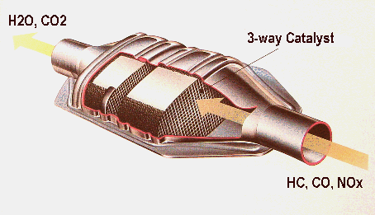

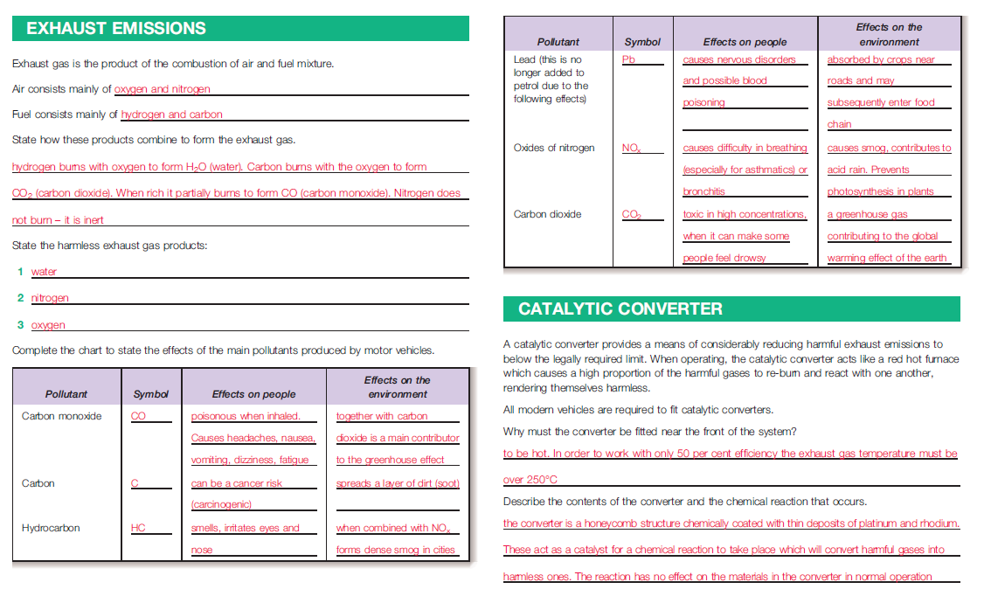

Catalytic Converter - Gas conversion

Diesel Engine – Particulate Diesel Filter

WHAT IS A DPF?

A Diesel Particulate Filter (DPF) is a 'Filter' mounted in the exhaust of your vehicle.
It is designed to catch the soot particles that come from your engine, reducing the soot emissions by up to 80%.

DPFs were introduced following the introduction of the Euro 5 emission standards and are required to ensure your vehicle meets the emission specification it was designed to by the manufacturer.

The filter is designed to STOP the very fine, harmful particles entering the atmosphere and prevent our children, friends and family from breathing them in.
The DPF is structured like a series of honeycomb filters that stop the soot passing all the way through the filter, therefore reducing emissions
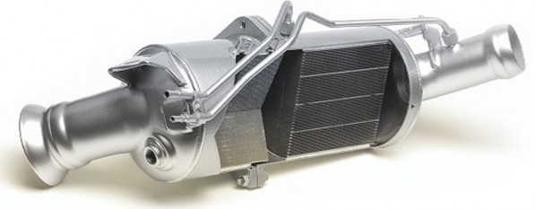
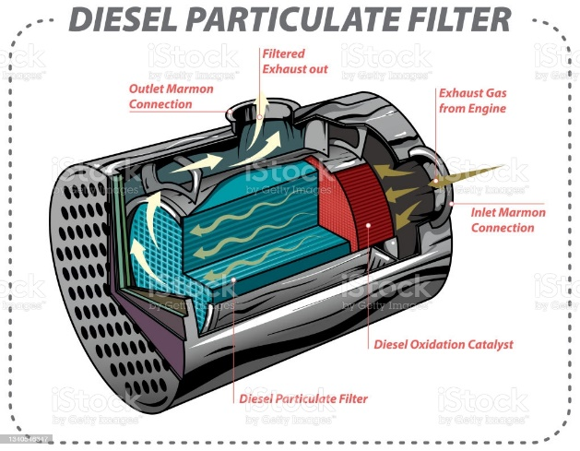
Other DPF Images
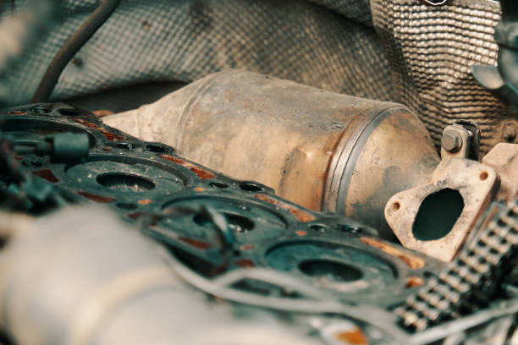

Vehicle dashboard warning sign for a faulty DPF

Exhaust Questions
These questions are typical of exam you will need to answer to complete the end test. To take away the guessing factor, they are not multi choice. Careful revision of your notes will allow you to give full and accurate answers to the questions. Each question will have 4 marks giving a total of 100 marks. You should be aiming for a mark no less than 75% to be in a good position to pass the end exam.

- Name 2 Health & Safety requirements to consider when working on exhaust systems

- Why is an exhaust manifold generally made for heavy cast iron.

- What type of driving can cause premature or shortening of the expected life span of an exhaust system. What causes this fact to shorten the life span of the exhaust.

- Name 2 types of design used to connect two sections of the exhaust together.

- Why is exhaust paste sometimes used in the jointing process.

- Why is it necessary to allow the exhaust to move relative to the rest of the vehicle, how is this achieved.

- What is the role of a heat shield in regards to the exhaust system.

- Describe how the “Baffle” type of silencer works.

- Describe the principle of how the “Absorption” type of silencer works.

- What does the abbreviation EGR stand for in exhaust systems.

- What is the function and how does the EGR valve operate.

- What is the function of the following components found in exhaust systems

  - Lambda Sensor
  - Particulate Diesel Filter (PDF)

- Why are some vehicles fitted with two Lambda sensors, what is the function of the second Lambda sensor.

- What does the term “closed loop” mean in regards to engine management systems.

- What is the function of the Catalytic converter found on modern vehicles.

- Why is the Catylitic converter found close to the front of the exhaust system.

- State what the internal honeycomb structure is coated in to be able to complete its operation.

- What temperature must a converter get to be only 50% efficient

- Air consists mainly of what two gases.

- In a three way catalytic converter name the gases entering the Catalytic converter and the gases leaving the converter.

- Name 3 pollutant gases and the effect they have on both people and the environment.

- How can a faulty spark plug cause damage to a Catalytic converter.

- Name 3 precautions that can be taken to ensure a long life span of a Catalytic converter.

- Name a precaution to be taken when you are removing a catalytic converter from a car that you will be refitting at a later time.

- By what means should old exhausts be correctly disposed of.

