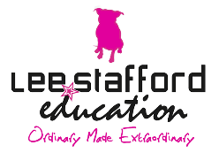

School of Hairdressing and Applied Therapies

Level 1 Diploma in an Introduction to the Hair & Beauty Sector

UV10343: Introduction to the hair and beauty sector
UV10344: Presenting a professional image in a salon
UV30341: Hair plaiting
UV30336: Shampoo and conditioning
UV30335: Skin care
UV30340: Themed face painting
UV30338: Styling women’s hair
UV30339: Basic make-up application
UV30333: Nail art application
UV10479: Create a hair and beauty image
UV10416: Providing basic manicure treatment
UV20400: Head massage
UV10480: Colour hair using temporary colour

