Shampoo and conditioning
VRQ
UV30336
L/502/3753
Learner name:
Learner number:

VTCT is the specialist awarding body for the Hairdressing, Beauty Therapy, Complementary Therapy and Sport and Active Leisure sectors, with over 45 years of experience.
VTCT is an awarding body regulated by national organisations including Ofqual, SQA, DCELLS and CCEA.
Assessor name | Assessor signature | Assessors  initials | Assessor number  (optional)
Hannah Pritchard | HP | H. P
VTCT is a registered charity investing in education and skills but also giving to good causes in the area of facial disfigurement.

Statement of unit achievement
By signing this statement of unit achievement you are confirming that all learning outcomes, assessment criteria and range statements have been achieved under specified conditions and that the evidence gathered is authentic.
This statement of unit achievement table must be completed prior to claiming certification.
Unit code | Date achieved | Learner signature | Assessor  initials | IV signature  (if sampled)
UV30336

Assessor tracking table
All assessors using this Record of Assessment book must complete this table. This is required for verification purposes.
UV30336
Shampoo and conditioning
Through this unit you will develop the skill of shampooing
and conditioning hair using a variety of products and
massage techniques.
You will work under the direct supervision of a stylist paying
close attention to manufacturers’ instructions for products,
timing and safety whist working.
This unit is suitable for hairdressers and barbers.
UV30336_v6
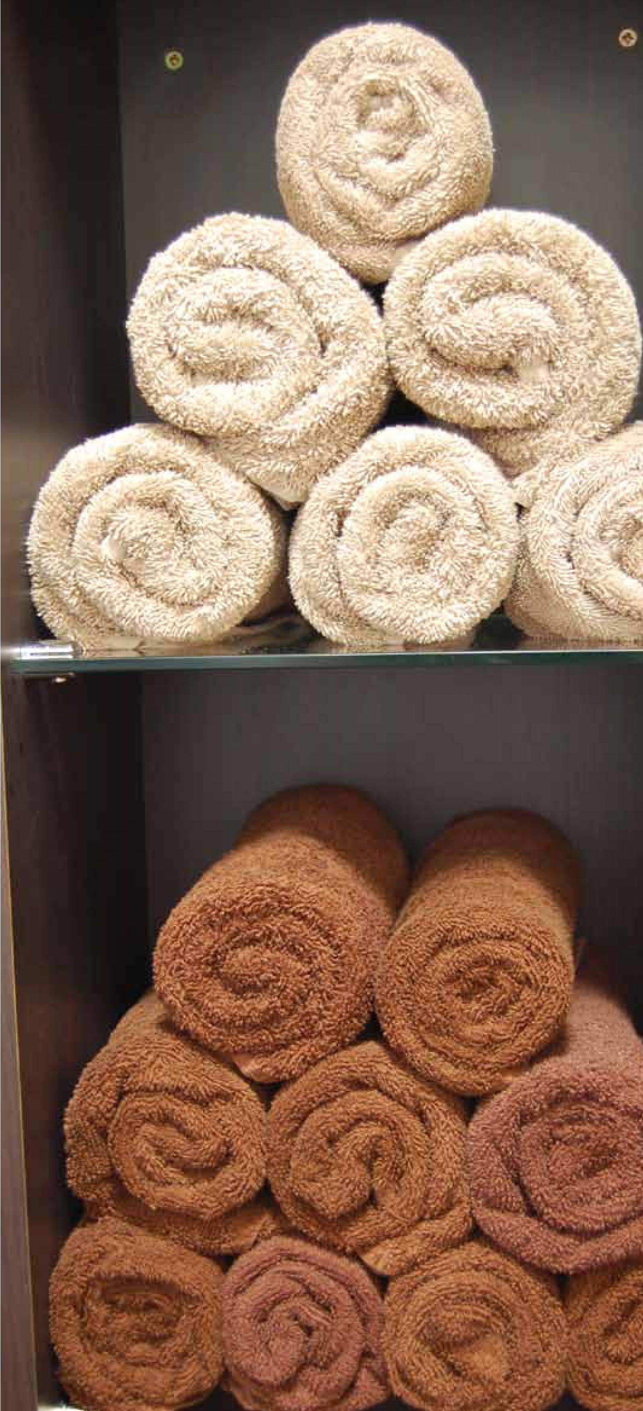
GLH
Credit value
Level
Observation(s)
External paper(s)
30
3
E3
3
0
© Habia

Shampoo and conditioning

Learning outcomes
On completion of this unit you will: 1. Be able to prepare for shampoo and conditioning 2. Be able to shampoo, condition and towel dry hair

Evidence requirements
- Environment
Evidence for this unit must be gathered in a real or realistic working environment.
- Simulation
Simulation is allowed for ‘Observation’ outcomes in this unit.
- Observation outcomes Competent performance of ‘Observation’ outcomes must be demonstrated to your assessor on at least three occasions.
- Range
All ranges must be practically demonstrated or other forms of evidence produced to show they have been covered. 5. Knowledge outcomes There must be evidence that you possess all the knowledge and understanding listed in the ‘Knowledge’ section of this unit. This evidence may include projects, assignments, case studies, reflective accounts, oral/written questioning and/or other forms of evidence.
- Tutor/Assessor guidance You will be guided by your tutor/assessor on how to achieve learning outcomes and ranges in this unit. All outcomes and ranges must be achieved.
- External paper There is no external paper requirement for this unit.

Achieving observation outcomes
Your assessor will observe your performance of practical tasks. The minimum number of observations required is indicated in the evidence requirements section of this unit.
Criteria may not always naturally occur during a practical observation. In such instances you will be asked questions to demonstrate your competence in this area. Your assessor will document the criteria that have been achieved through oral questioning.
Your assessor will sign off an outcome when all criteria have been competently achieved in a single client service.
Achieving observations
and range

Achieving range
The range section indicates what must be covered. Ranges should be practically demonstrated as part of an observation. Where this is not possible other forms of evidence may be produced. All ranges must be covered.
Your assessor will document the portfolio reference once a range has been competently achieved.

Maximum service times
There are no maximum service times that apply to this unit.

Observations
Outcome 1

Be able to prepare for shampoo and conditioning
You can:
- Prepare the client for shampooing and conditioning

Observation | 1 | 2 | 3
Date achieved
Criteria questioned orally
Portfolio reference
Assessor initials
Learner signature

*May be assessed through oral questioning.
Outcome 2

Be able to shampoo, condition and towel dry hair
You can:
- Shampoo and condition hair
- Towel dry and detangle hair
- Follow safe and hygienic working practices
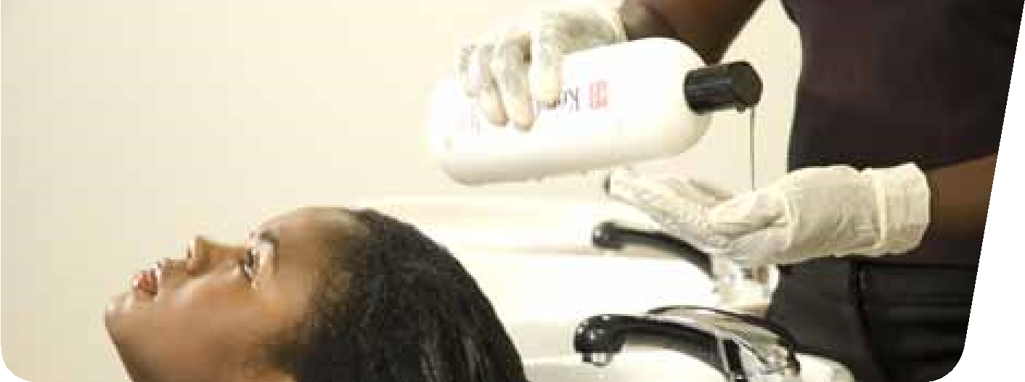
- Communicate and behave in a professional manner
© Habia
*May be assessed through oral questioning.

Observation | 1 | 2 | 3
Date achieved
Criteria questioned orally
Portfolio reference
Assessor initials
Learner signature

Range
*You must practically demonstrate that you have:
Shampooed a minimum of 1 of the hair lengths | Portfolio reference
Above shoulder length hair
Below shoulder length hair
Used all the massage techniques | Portfolio reference
Effleurage
Rotary
Petrissage
Used a minimum of 2 conditioning products | Portfolio reference
Surface
Penetrating
Treatment
*It is strongly recommended that all range items are practically demonstrated. Where this is not possible, other forms of evidence may be produced to demonstrate competence.

Achieving knowledge outcomes
You will be guided by your tutor and assessor Where possible your assessor will integrate on the evidence that needs to be produced. knowledge outcomes into practical observations Your knowledge and understanding will be through oral questioning. assessed using the assessment methods listed below:
Developing knowledge
- Observed work
- Witness statements
- Audio-visual media
- Evidence of prior learning or attainment
- Written questions
- Oral questions
- Assignments
- Case studies

Knowledge
Outcome 1

Be able to prepare for shampoo and conditioning
You can: | Portfolio reference /  Assessor initials*
b. State the procedure for client preparation | UV30336 Workbook
*Assessor initials to be inserted if orally questioned.

Requirements highlighted in white are assessed in the external paper.
Outcome 2

Be able to shampoo, condition and towel dry hair
© Habia
You can: | Portfolio reference /  Assessor initials*
e. State the effects of shampooing and conditioning on the hair | UV30336 Workbook
f. State the basic structure of the hair | UV30336 Workbook
*Assessor initials to be inserted if orally questioned.

Requirements highlighted in white are assessed in the external paper.

Unit content
This section provides guidance on the recommended knowledge and skills required to enable you to achieve each of the learning outcomes in this unit. Your tutor/assessor will ensure you have the opportunity to cover all of the unit content.

Outcome 1: Be able to prepare for shampoo and conditioning
Preparation of client: Remove client’s outer clothing, protect against damage, ensure client relaxed and comfortable (posture, aids service), remove excessive jewellery (avoid damage to jewellery and skin), gown, towel, plastic cape, barrier cream, ensure client comfort, record card.

Outcome 2: Be able to shampoo, condition and towel dry hair

Shampoo hair: Wet hair, apply shampoo (effleurage), massage scalp (rotary), rinse, repeat if necessary.
Conditioners:
Surface – pre-shampooed, apply (effleurage), massage product into hair (petrissage), comb, rinse.
Leave-in – pre-shampooed, towel dry, apply (effleurage), comb, do not rinse.
Penetrating – pre-shampooed hair, towel dry, hot cross bun section, bowl and brush application, roots to ends, wide tooth comb, massage into hair and scalp (petrissage), heat, emulsify, rinse.
Scalp tonic – pre-shampooed, towel dry, small section application, direct to scalp, ensure complete coverage, massage into scalp, do not rinse.
Towel dry hair: After shampooing whilst client still at basin gently squeeze hair, remove excess water, wrap towel around the head, gently blot/squeeze the hair.
Disentangle hair: Seat client at workstation, remove towel, use large tooth comb, work from ends to roots, methodical working, small sections, avoid damage to cuticle, tugging, pain, further knots.
The effects of shampooing and conditioning products on the hair:
Shampoos – detergent, cleans hair, remove dirt/grease/styling products, opens cuticles.
Conditioners – emulsion, smoothes and closes cuticle, easy to work with, adds moisture to hair, makes hair shine, repairs hair, restores to natural pH.
pH scale: Acid - 0/6.9 (close cuticle), neutral - 7, alkaline - 7.1/14 (open cuticle).
pH of shampoo and conditioner: Shampoos (alkaline), conditioners (acid).
The basic structure of the hair: Cuticle, cortex medulla.
© Habia
Outcome 2: Be able to shampoo, condition and towel dry hair (continued)
How to follow safe and hygienic working practices:
Maintaining a safe salon – clean, tidy, safe standards of working, remove spillages, report slippery surfaces, remove/ report obstacles, clear access to trolleys and equipment, clean/sterilise/disinfect (tools, equipment, work surfaces), no smoking, eating, drinking or drugs in salon, professional personal hygiene.
Personal protective equipment – wear protective equipment, avoid latex, powdered gloves, apron.
Electricity at work – visual check of equipment, no trailing wires, portable appliance testing.
Manual handling – moving stock safely, lifting, working heights, unpacking.
Towels – wash regularly, clean for every client, place dirty towels in covered bin.
Reporting of injuries diseases and dangerous occurrences – accident book, reporting diseases, log accidents.
Control of substances hazardous to health – store, handle, use, disposal, replace lids, ventilation for vapour and dust, avoid over exposure to chemicals, use manufacturers instructions for use.
Disposal of waste – sharps box, closed top bin, dilute chemicals with running water, environmental protection, salon policies for hazardous waste, single use items, empties (recycle).
Product storage – check end date/ packaging, store away from heat/damp/ direct sunlight, empties avoid theft.
Professional communication in a salon environment: Try to avoid technical language, always respond, consider clients confidentiality.
Verbal – speaking (tone of voice, the language you use, how quickly and clearly), questioning (open, closed, probing).
Non-verbal – body language, positive attitude (posture, facial expressions, hand gestures, the distance you stand), listening (be patient), try to understand.
Written – visual aids, magazines, client records.
Behave professionally in a salon environment: Follow health and safety practice and procedures, salon code of conduct, respect others, value client(s), co-operate with others (be sympathetic, fair, not aggressive), use appropriate language, avoid gossip, maintain confidentiality, polite, cheerful and friendly manner (friendly facial expressions, open body language, positive attitude), eye contact, sensible behaviour, team work, pride in work, punctuality, employer and client loyalty.

