Styling
VRQ
women’s hair
UV30338
F/502/3796
Learner name:
Learner number:

VTCT is the specialist awarding body for the Hairdressing, Beauty Therapy, Complementary Therapy and Sport and Active Leisure sectors, with over 45 years of experience.
VTCT is an awarding body regulated by national organisations including Ofqual, SQA, DCELLS and CCEA.
Assessor name | Assessor signature | Assessors  initials | Assessor number  (optional)
Hannah Pritchard | HP | HP
VTCT is a registered charity investing in education and skills but also giving to good causes in the area of facial disfigurement.

Statement of unit achievement
By signing this statement of unit achievement you are confirming that all learning outcomes, assessment criteria and range statements have been achieved under specified conditions and that the evidence gathered is authentic.
This statement of unit achievement table must be completed prior to claiming certification.
Unit code | Date achieved | Learner signature | Assessor  initials | IV signature  (if sampled)
UV30338

Assessor tracking table
All assessors using this Record of Assessment book must complete this table. This is required for verification purposes.
UV30338
Styling women’s hair
Through this unit you will develop the skill of blow drying,
finger drying and finishing techniques on a variety of hair
types and lengths.
You will work under the direction of a stylist who will help
you to identify the capability of your client’s hair so that you
can choose from a range of products, tools and equipment
to complete the look. You will need to demonstrate the
ability to use heated styling equipment to finish the service.
Part of this service is to provide your client with good
aftercare advice.
UV30338_v8
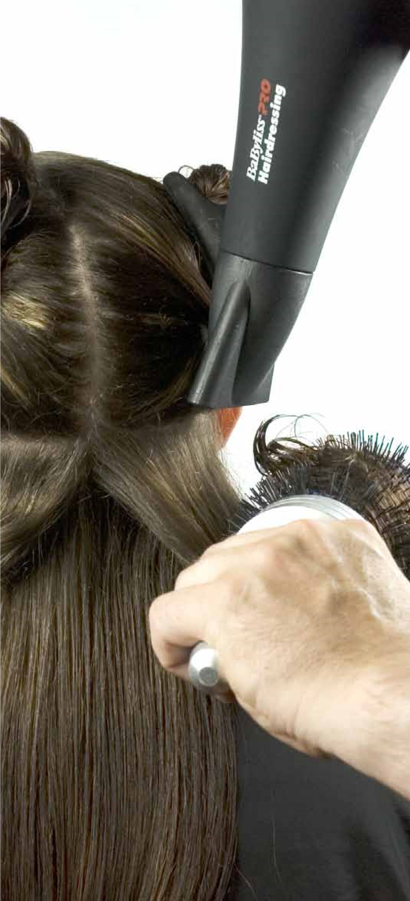
GLH
Credit value
Level
Observation(s)
External paper(s)
30
3
1
3
0
© Habia

Styling women’s hair

Learning outcomes
On completion of this unit you will:
- Be able to prepare for styling women’s hair
- Be able to style women’s hair

Evidence requirements
- Environment
Evidence for this unit must be gathered in a real or realistic working environment.
- Simulation
Simulation is allowed for ‘Observation’ outcomes in this unit.
- Observation outcomes Competent performance of ‘Observation’ outcomes must be demonstrated to your assessor on at least three occasions.
- Range
All ranges must be practically demonstrated or other forms of evidence produced to show they have been covered. 5. Knowledge outcomes There must be evidence that you possess all the knowledge and understanding listed in the ‘Knowledge’ section of this unit. This evidence may include projects, assignments, case studies, reflective accounts, oral/written questioning and/or other forms of evidence.
- Tutor/Assessor guidance You will be guided by your tutor/assessor on how to achieve learning outcomes and ranges in this unit. All outcomes and ranges must be achieved.
- External paper There is no external paper requirement for this unit.
UV30338﻿

Achieving observation outcomes
Your assessor will observe your performance of practical tasks. The minimum number of observations required is indicated in the evidence requirements section of this unit.
Criteria may not always naturally occur during a practical observation. In such instances you will be asked questions to demonstrate your competence in this area. Your assessor will document the criteria that have been achieved through oral questioning.
Your assessor will sign off an outcome when all criteria have been competently achieved in a single client service.
Achieving observations
and range

Achieving range
The range section indicates what must be covered. Ranges should be practically demonstrated as part of an observation. Where this is not possible other forms of evidence may be produced. All ranges must be covered.
Your assessor will document the portfolio reference once a range has been competently achieved.

Maximum service times
There are no maximum service times that apply to this unit.

Observations
Outcome 1

Be able to prepare for styling women’s hair
You can:
a. Prepare for styling women’s hair
*May be assessed through oral questioning.
Outcome 2

Observation | 1 | 2 | 3
Date achieved
Criteria questioned orally
Portfolio reference
Assessor initials
Learner signature

Be able to style women’s hair
You can:
- Select appropriate products, tools and equipment
- Style women’s hair using basic techniques
- Follow safe and hygienic working practices
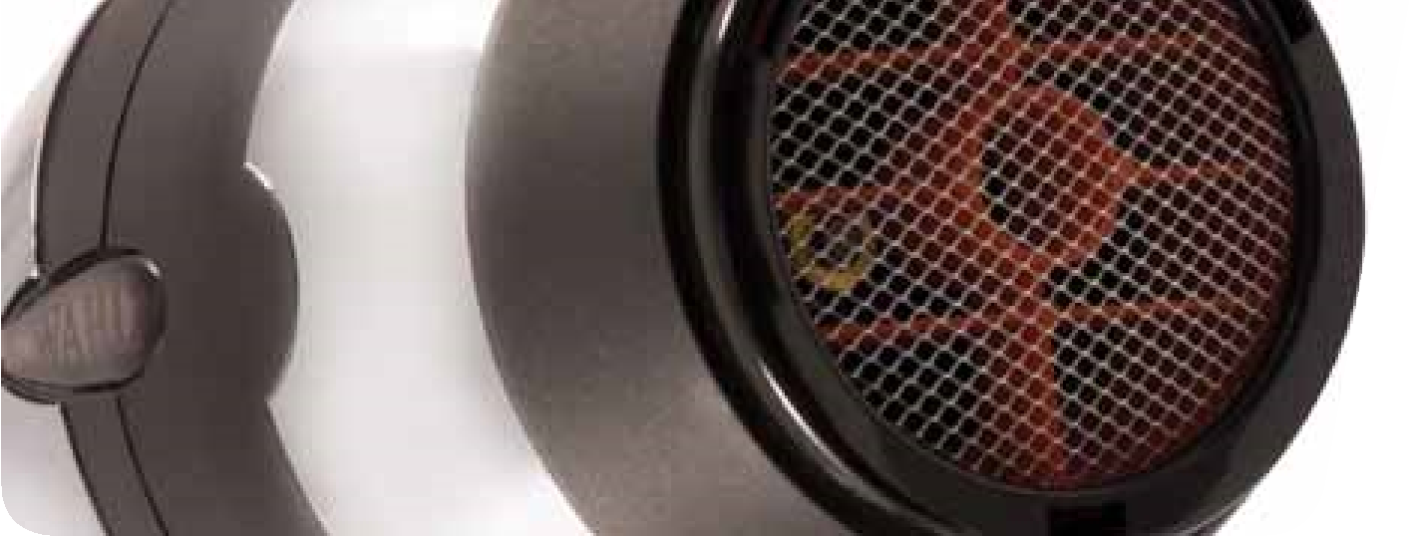
- Communicate and behave in a professional manner
Photo courtesy of Wahl (UK) Ltd.
*May be assessed through oral questioning.

Observation | 1 | 2 | 3
Date achieved
Criteria questioned orally
Portfolio reference
Assessor initials
Learner signature

Range
*You must practically demonstrate that you have:
Used a minimum of 4 blow drying and finishing techniques | Portfolio reference
On face
Off face
Straightening
Smoothing
Curling
Finger drying
Application of product
Finishing
Used a minimum of 3 products | Portfolio reference
Mousse
Gel
Lotion
Spray
Moisturiser
Wax
Heat protector
*It is strongly recommended that all range items are practically demonstrated. Where this is not possible, other forms of evidence may be produced to demonstrate competence.
*You must practically demonstrate that you have:
Photo courtesy of Wahl (UK) Ltd.
Used all types of equipment | Portfolio reference
Combs
Brushes
Dryers
Electrical equipment
Considered all factors | Portfolio reference
Face shape
Adverse skin
Scalp and hair conditions
Hair growth patterns
Hair length
Hair type
Hair condition
Hair texture
Elasticity
Density
*It is strongly recommended that all range items are practically demonstrated. Where this is not possible, other forms of evidence may be produced to demonstrate competence.

Developing knowledge

Achieving knowledge outcomes
You will be guided by your tutor and assessor Where possible your assessor will integrate on the evidence that needs to be produced. knowledge outcomes into practical observations Your knowledge and understanding will be through oral questioning. assessed using the assessment methods listed below:
- Observed work
- Witness statements
- Audio-visual media
- Evidence of prior learning or attainment
- Written questions
- Oral questions
- Assignments
- Case studies

Knowledge
Outcome 1

Be able to prepare for styling women’s hair
Portfolio reference / You can:
Assessor initials*
b. Identify basic techniques for styling women’s hair | UV30338 Evidence Workbook
c. State the factors that influence the choice of hair styling techniques for women | UV30338 Evidence Workbook
d. State the importance of the preparation procedures for styling women’s hair | UV30338 Evidence Workbook
*Assessor initials to be inserted if orally questioned.

Requirements highlighted in white are assessed in the external paper.
© Habia
Outcome 2

Be able to style women’s hair
You can: | Portfolio reference /  Assessor initials*
e. State the purpose of hair styling and finishing products, tools and equipment | UV30338 Evidence Workbook
*Assessor initials to be inserted if orally questioned.

Requirements highlighted in white are assessed in the external paper.

Unit content
This section provides guidance on the recommended knowledge and skills required to enable you to achieve each of the learning outcomes in this unit. Your tutor/assessor will ensure you have the opportunity to cover all of the unit content.

Outcome 1: Be able to prepare for styling women’s hair

Basic styling techniques for women’s hair: Blow drying (flat, root lift, movement), straightening, smoothing, curling (waves, curls), finger drying (natural look, spiky effect), hair up (plait, pleat, rolls, curls).
Factors that influence styling: Previous chemical services, percentage of grey, client requirements, tools and equipment, presence of added hair, maintenance of style suitability.
Hair condition – dry, greasy, normal, virgin, chemically treated, elasticity (strength of hair), porosity (damage to cuticle layer, the ability to absorb moisture).
Hair cut/style – uniform layer, one length, short graduation, long graduation.
Temperature – body heat, salon temperature, added heat.
Texture – fine, medium, coarse.
Length – short, medium, long.
Density – fine, medium, thick.
Growth patterns – cowlick, widow’s peak, nape whorl, double crown, male pattern baldness.
Skin tone – fair, medium, olive, dark.
Face shape – oval, round, square, oblong, heart, pear.
Head size – large, medium, small.
Existing curl – tight, soft, wave.
Lifestyle – job, family, financial, time.
Test results – good, bad, caution, positive, negative.
The importance of the preparation procedures for styling women’s hair: Health and safety, client comfort, avoid cross infection, professional image, avoid damage to clothes, looks professional, saves time, return business, prevent legal action.
Preparation of self: Clothes (salon requirements for uniform, clean/ironed clothes, non-restrictive, closed in low heel shoes), hair (clean, healthy, manageable, off face), personal hygiene (clean body, clean teeth, fresh breath, workable length clean nails, deodorant, no overpowering perfume/aftershave), personal protective equipment (gloves, apron), prevent dermatitis, minimal jewellery, positive attitude, ready to greet.
Preparation of client: Remove outer client clothing, protect against damage, ensure client relaxed and comfortable (posture aids service), remove excessive jewellery (to avoid damage to jewellery and skin), gown, towel, plastic cape, barrier cream, record card.
© Habia
Outcome 1: Be able to prepare for styling women’s hair (continued)
equipment, visual check on large and small equipment, electrical equipment checked, portable appliance test, select height of chair/basin.
Outcome 2: Be able to style women’s hair
Preparation of work area: Chair, trolley, work station, equipment cleaned, appropriate sterilisation (barbicide, autoclave, UV, sterilising spray), complete destruction of all living organisms on tools and equipment, disinfection (remove contamination from hard surfaces, large work areas, floors and work surfaces), heat or chemical methods, use of trolley, safe professional presentation of tools and The purpose of hair styling and finishing products, tools and equipment: Correct tools/equipment/ styling/finishing products means hair is easier to control, hair protected, style lasts longer, defines style.
Range of styling products and when to use them:
Gel – wet look, ideal for spiky styles, apply to wet hair.
Mousse – gives hold/body, various hold strengths, apply to wet hair.
Blow dry lotions – protects hair from heat/ humidity, apply to wet hair.
Moisturiser/oils – African type hair, conditioning, adds moisture, adds shine, use on dry hair.
Activators – activated by the use of heat, defines curl, adds moisture, shine, hold, ideal for dry sets, can use on wet or dry hair.
Heat protectors – coats hair, protective layer, gives shine/definition, apply prior to the use of all electrical equipment.
Serum – gives shine, adds moisture, ideal on chemically treated hair, can use on wet or dry hair.
Range of tools and equipment and the effects achieved:
Round brushes (various diameters) –
gives curl (smaller diameter = tighter curl), body, movement, volume.
Flat brushes – paddle, Denman, gives smooth, straight finish.
Bristle brushes – remove roller marks, dressing hair, smoothes, give shine, good for fine hair.
Vent brush – produces a soft causal broken up effect, ideal on short hair.
Dressing comb – back-comb/tease
the hair into style, used for all dressing techniques.
Straighteners – smoothes/flattens the cuticles, straightens hair.
Curling tongs – various sizes, produces lift, waves, curl.
Hand dryer – removes moisture from the hair.
Diffuser – diffuses the flow of air, allowing hair to dry naturally, increases natural curl, adds volume, movement, body.
Heated rollers – used on dry hair, various sizes of rollers, lift, curl, bounce.
Photo courtesy of Wahl (UK) Ltd.
Outcome 2: Be able to style women’s hair (continued)
Style women’s hair using basic styling techniques:
Straightening – section hair, work methodically, direct airflow away from root, stretch hair, round brush, smooth cuticle, no root lift, fully dry each section, allow to fix in new shape.
Smoothing – section hair, work methodically, direct airflow away from root, smooth cuticle, flat brush, no root lift, fully dry each section.
Curling – section hair, work methodically, round brush to create curl, large diameter = large curl, small diameter = small curl, direct airflow away from root, smooth cuticle, allow to fix in new shape.
Hair up:
Plait – individual, whole head, across front, half head.
Pleat – cone shape in nape of neck.
Rolls – large section of hair, backcombed, wound into roll, pinned.
Curls – individual curls placed, pinned.
Spiral curls – tendrils, whole pony tail, trailing.
Finger drying – use fingers/diffuser, low power, lift section of hair to dry, circulate air, direct airflow in direction hair to be worn.
Finishing – vent brush to create lift, brush/ comb to flatten style, fingers to define style, backcombing (create root lift/create shape), back brushing (create volume/shape), apply finishing product appropriate to style.
How to follow safe and hygienic working practices:
Maintaining a safe salon – clean, tidy, safe standards of working, remove spillages, report slippery surfaces, remove/ report obstacles, clear access to trolleys and equipment, clean/sterilise/disinfect tools, equipment and work surfaces, no smoking, eating, drinking or drugs in the salon, professional personal hygiene.
Personal protective equipment – wear protective equipment, avoid latex, powdered gloves, apron.
Electricity at work – visual check of equipment, no trailing wires, portable appliance testing.
Manual handling – moving stock safely, lifting, working heights, unpacking.
Towels – wash regularly, clean for every client, place dirty towels in covered bin.
Reporting of injuries, diseases and dangerous occurrences – accident book, reporting diseases, log accidents.
Control of substances hazardous to health – store, handle, use, disposal, replace lids, ventilation for vapour and dust, avoid over exposure to chemicals, use manufacturers’ instructions for use.
Disposal of waste – sharps box, dilute chemicals, contaminated/hazardous waste, closed top bin, empties (recycle).
Product storage – check end date/ packaging, store away from heat/damp/ direct sunlight, empties avoid theft.

© Habia

Outcome 2: Be able to style women’s hair (continued)
Professional communication in a salon environment: Try to avoid technical language, always respond, consider clients’ confidentiality.
Verbal – speaking (tone of voice, the language you use, how quickly and clearly), questioning (open, closed, probing).
Non-verbal – body language, positive attitude (posture, facial expressions, hand gestures, the distance you stand), listening (be patient, try to understand).
Written – visual aids, magazines, client records.
Behave professionally in a salon environment: Follow health and safety practices and procedures, salon code of conduct, respect others, value client(s), co-operate with others (be sympathetic, fair, not aggressive), use appropriate language, avoid gossip, maintain confidentiality, polite/cheerful and friendly manner (friendly facial expressions, open body language, positive attitude, eye contact), sensible behaviour, team work, pride in work, punctuality, employer and client loyalty.
Notes
Use this area for notes and diagrams

