Create a hair and beauty image
VRQ
UV10479
Y/600/4875
Learner name:
Learner number:

VTCT is the specialist awarding body for the Hairdressing, Beauty Therapy, Complementary Therapy and Sport and Active Leisure sectors, with over 45 years of experience.
VTCT is an awarding body regulated by national organisations including Ofqual, SQA, DCELLS and CCEA.
Assessor name | Assessor signature | Assessors  initials | Assessor number  (optional)
Hannah Pritchard | HP | HP
VTCT is a registered charity investing in education and skills but also giving to good causes in the area of facial disfigurement.

Statement of unit achievement
By signing this statement of unit achievement you are confirming that all learning outcomes, assessment criteria and range statements have been achieved under specified conditions and that the evidence gathered is authentic.
This statement of unit achievement table must be completed prior to claiming certification.
Unit code | Date achieved | Learner signature | Assessor  initials | IV signature  (if sampled)
UV10479

Assessor tracking table
All assessors using this Record of Assessment book must complete this table. This is required for verification purposes.
UV10479
Create a hair and beauty image
Through this unit you will develop the creative skill of using
both hairdressing and beauty techniques to create an
image.
You will plan, research and develop your ideas and then
present your image to an audience. You must pay close
attention to manufacturers’ instructions for products, timing,
and safety whilst working.
This unit is suitable for hairdressers, barbers and beauty
therapists.
UV10479_v8
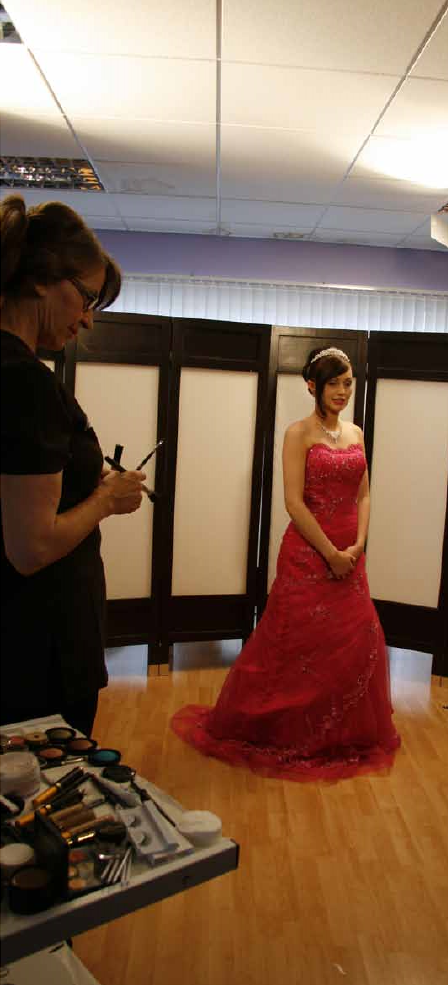
GLH
Credit value
Level
Observation(s)
External paper(s)
30
3
1
1
0
© Habia

Create a hair and beauty image
Learning outcomes | Evidence requirements
On completion of this unit you will: 1. Environment
Evidence for this unit must be gathered in a
- Be able to create an image real or realistic working environment.
- Be able to plan an image
  - Simulation Simulation is not allowed in this unit.
  - Observation outcomes Competent performance of ‘Observation’ outcomes must be demonstrated to your assessor on at least one occasion.
  - Knowledge outcomes There must be evidence that you possess all the knowledge and understanding listed in the ‘Knowledge’ section of this unit. This evidence may include projects, assignments, case studies, reflective accounts, oral/written questioning and/or other forms of evidence.
  - Tutor/Assessor guidance You will be guided by your tutor/assessor on how to achieve learning outcomes in this unit. All outcomes must be achieved.
  - External paper There is no external paper requirement for this unit.
Achieving observations

and range

Achieving observation outcomes
Your assessor will observe your performance of practical tasks. The minimum number of observations required is indicated in the evidence requirements section of this unit.
Criteria may not always naturally occur during a practical observation. In such instances you will be asked questions to demonstrate your competence in this area. Your assessor will document the criteria that have been achieved through oral questioning.
Your assessor will sign off an outcome when all criteria have been competently achieved in a single client service.

Achieving range
There are no range statements that apply to this unit.

Maximum service times
There are no maximum service times that apply to this unit.

Observations
Outcome 1

Be able to create an image
You can:
- Produce and present the final image
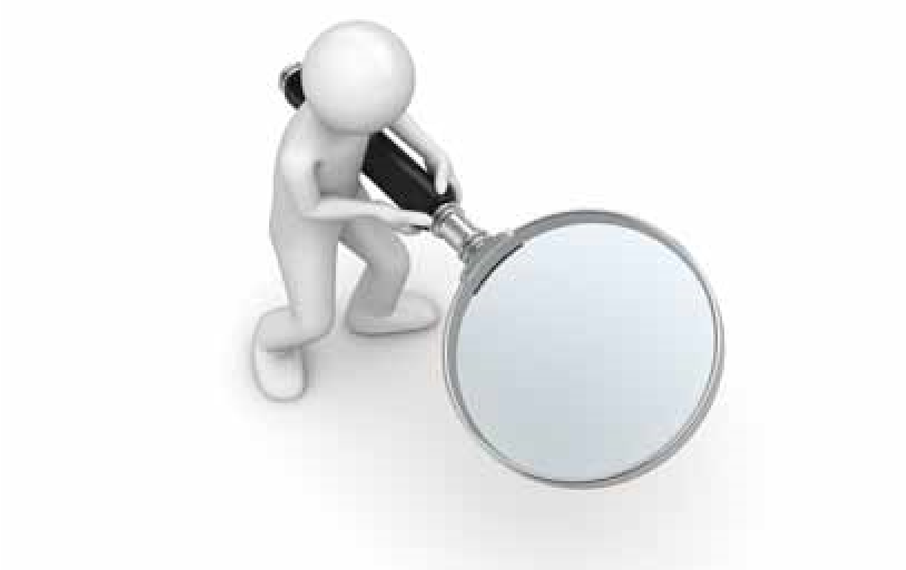
- Follow safe working practices

Observation | 1 | 2 | 3
Date achieved
Criteria questioned orally
Portfolio reference | CS | CS | CS
Assessor initials
Learner signature

*May be assessed through oral questioning.

Developing knowledge

Achieving knowledge outcomes
You will be guided by your tutor and assessor Where possible your assessor will integrate on the evidence that needs to be produced. knowledge outcomes into practical observations Your knowledge and understanding will be through oral questioning. assessed using the assessment methods listed below:
- Observed work
- Witness statements
- Audio-visual media
- Evidence of prior learning or attainment
- Written questions
- Oral questions
- Assignments
- Case studies

Knowledge
Outcome 1

Be able to create an image
You can: | Portfolio reference /  Assessor initials*
c. Develop the image | UV10479 Evidence workbook
d. State the importance of developing an image | UV10479 Evidence workbook
- Describe ways of effectively presenting a created image  - Outline the safety considerations that must be taken into account | UV10479 Evidence workbook
*Assessor initials to be inserted if orally questioned.

Requirements highlighted in white are assessed in the external paper.
© Habia
Outcome 2

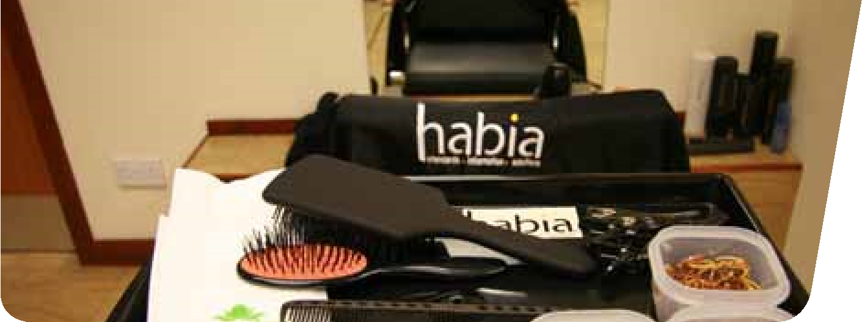
Be able to plan an image
You can: | Portfolio reference /  Assessor initials*
a. Access sources of information for creating an image | UV10479 Evidence workbook
- Identify sources of information for creating an image  - State the importance of researching when developing a plan for creating an image | UV10479 Evidence workbook
d. Prepare and develop a plan for creating an image | UV10479 Evidence workbook
e. Describe how to develop a plan for creating a range of images | UV10479 Evidence workbook
*Assessor initials to be inserted if orally questioned.

Requirements highlighted in white are assessed in the external paper.

Unit content
This section provides guidance on the recommended knowledge and skills required to enable you to achieve each of the learning outcomes in this unit. Your tutor/assessor will ensure you have the opportunity to cover all of the unit content.

Outcome 1: Be able to create an image

Develop an image: Starting point, develop creative skills, total image, plan of action (saves time, looks professional), organise event.
Create – make, produce, construct, build.
Image – likeness, copy, picture, representation.
Occasions for presenting an image:
Formal/informal presentation – catwalk/ fashion show, competition, wedding, prom, photo shoot, parade, posed stance, photographic evidence, film footage, target audience.
Audience – dignitaries, centre/workplace management team, teachers, lecturers, tutors, peers, colleagues, employers, prospective employers, photographers, television/news crew.
Effective presentation methods: Prepared speech/prompt cards, practice speech, professionalism, varied communication skills (body language, tone, clarity, projection of voice), practice walk/ stance.
How to follow safe and hygienic working practices:
Maintaining a safe salon – clean, tidy, safe standards of working, remove spillages, report slippery surfaces, remove/ report obstacles, clear access to trolleys and equipment, clean/sterilise/disinfect tools, equipment and work surfaces, no smoking, eating, drinking or drugs in the salon, professional personal hygiene.
Personal protective equipment – wear protective equipment, avoid latex, powdered gloves, apron.
Electricity at work – visual check of equipment, no trailing wires, portable appliance testing.
Manual handling – move stock safely, lifting, working heights, unpacking.
Towels – wash regularly, clean for every client, place dirty towels in covered bin.
Reporting of injuries, diseases and dangerous occurrences – accident book, reporting diseases, log accidents.
Control of substances hazardous to health – store, handle, use, disposal, replace lids, ventilation for vapour and dust, avoid over exposure to chemicals, use manufacturers’ instructions for use.
Disposal of waste – sharps box, dilute chemicals, contaminated/hazardous waste, closed top bin, empties (recycle).
Product storage – check end date/ packaging, store away from heat/damp/ direct sunlight, empties avoid theft.
Safety considerations: Consultation (use of products), personal protective equipment, client comfort/safety, maintain posture of self and client to minimise fatigue and injury.

© Habia

Outcome 2: Be able to plan an image
Accessing sources of information: Library (hair and beauty publications), computer (search engine), news agent (hair and beauty related articles), art gallery (paintings/photos), cinema (films).
make-up, painting of nails.
Beauty products
– foundation make-up,
eye shadow, mascara, lip colour, nail
varnish.
Beauty tools and equipment
– make-up,
applicator brushes, foam pads, cotton wool,
hair restraint.
Clothes
– vintage, clients, hired, borrowed,
themed.
Accessories
– hair extensions, false nails,
material swatches, feathers, flowers, glitter,
ribbons.
How to research when developing an
image:
Start with a basic idea, gather
information from all sources, ensure your
plan will work, create a lasting impression.
Your attention to detail will be good and
you will be able to re-create the idea.
Sources of information for creating an image: Images from the internet, newspapers, books, magazines, television, films, photographs, paintings.
How to develop a plan for creating images: Create a mood board (used to display ideas), poster, collection of ideas, the thought process, story behind an image, (can include images, pictures, text, objects, materials, accessories).
Find a theme for your image: Decision making, ideas for image (avant-garde, catwalk, wedding/prom hair, historical ideas, famous people, fantasy, futuristic, Disney characters, make-believe, current fashion), identify look (hairstyle, make-up, clothes, accessories).
Preparation for creating an image: Be organised, think ahead, plan for everything.
Model – client, peer, training head.
Hairdressing techniques – blow drying, setting (wet/dry), finishing techniques (curling/straightening), hair-up (rolls, curls, plaits).
Hair products – temporary colour (setting lotions, coloured mousses, coloured hair spray), setting and finishing products.
Hairdressing tools and equipment – brushes, combs, rollers, hairdryer, pins/ grips.
Beauty techniques – application of

