Hair plaiting
VRQ
Learner name:
Learner number:
UV30341
R/502/3804

VTCT is the specialist awarding body for the Hairdressing, Beauty Therapy, Complementary Therapy and Sport and Active Leisure sectors, with over 45 years of experience.
VTCT is an awarding body regulated by national organisations including Ofqual, SQA, DCELLS and CCEA.
Assessor name | Assessor signature | Assessors  initials | Assessor number  (optional)
Hannah Pritchard | HP | HP
VTCT is a registered charity investing in education and skills but also giving to good causes in the area of facial disfigurement.

Statement of unit achievement
By signing this statement of unit achievement you are confirming that all learning outcomes, assessment criteria and range statements have been achieved under specified conditions and that the evidence gathered is authentic.
This statement of unit achievement table must be completed prior to claiming certification.
Unit code | Date achieved | Learner signature | Assessor  initials | IV signature  (if sampled)

Assessor tracking table
All assessors using this Record of Assessment book must complete this table. This is required for verification purposes.
UV30341
Hair plaiting
Through this unit you will be introduced to the intricate skill
of plaiting hair.
You will learn how to communicate with your client in a
professional manner, prepare your client and their hair for
plaiting services, and ensure that you follow salon health
and safety practices throughout.
You will demonstrate that you can provide both on the scalp
and off the scalp plaits.
This unit is suitable for hairdressers and barbers.
UV30341_v8
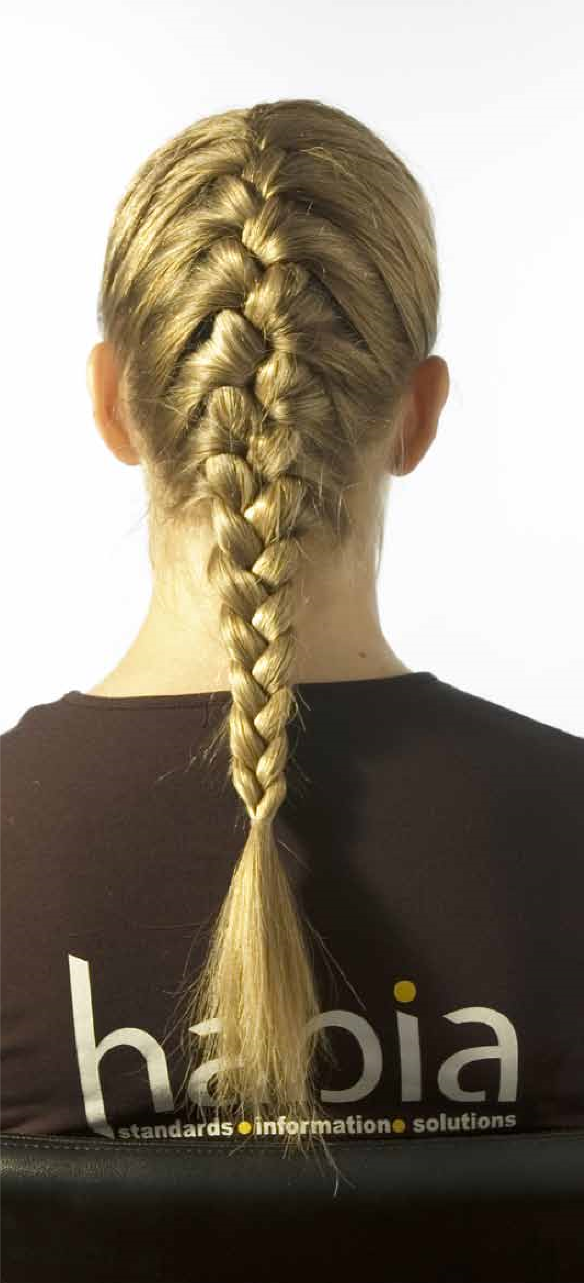
GLH
Credit value
Level
Observation(s)
External paper(s)
30
3
E3
2
0

Hair plaiting
Learning outcomes
On completion of this unit you will:
- Be able to prepare for basic hair plaiting
- Be able to carry out basic hair plaiting techniques

Evidence requirements
- Environment
Evidence for this unit must be gathered in a real or realistic working environment.
- Simulation
Simulation is allowed for ‘Observation’ outcomes in this unit.
- Observation outcomes Competent performance of ‘Observation’ outcomes must be demonstrated to your assessor on at least two occasions.
- Range
All ranges must be practically demonstrated or other forms of evidence produced to show they have been covered. 5. Knowledge outcomes There must be evidence that you possess all the knowledge and understanding listed in the ‘Knowledge’ section of this unit. This evidence may include projects, assignments, case studies, reflective accounts, oral/written questioning and/or other forms of evidence.
- Tutor/Assessor guidance You will be guided by your tutor/assessor on how to achieve learning outcomes and ranges in this unit. All outcomes and ranges must be achieved.
- External paper There is no external paper requirement for this unit.

Achieving observation outcomes
Your assessor will observe your performance of practical tasks. The minimum number of observations required is indicated in the evidence requirements section of this unit.
Criteria may not always naturally occur during a practical observation. In such instances you will be asked questions to demonstrate your competence in this area. Your assessor will document the criteria that have been achieved through oral questioning.
Your assessor will sign off an outcome when all criteria have been competently achieved in a single client service.
Achieving observations
and range

Achieving range
The range section indicates what must be covered. Ranges should be practically demonstrated as part of an observation. Where this is not possible other forms of evidence may be produced. All ranges must be be covered.
Your assessor will document the portfolio reference once a range has been competently achieved.

Maximum service times
There are no maximum service times that apply to this unit.

Observations
Outcome 1

Be able to prepare for basic hair plaiting
You can:
- Prepare for hair plaiting service
- Select products and tools for
- plaiting
*May be assessed through oral questioning.
Observation | 1 | 2 | 3
Date achieved
Criteria questioned orally
Portfolio reference
Assessor initials
Learner signature
Outcome 2

Be able to carry out basic hair plaiting techniques
You can:
- Carry out a plaiting technique
- Follow safe and hygienic working practices
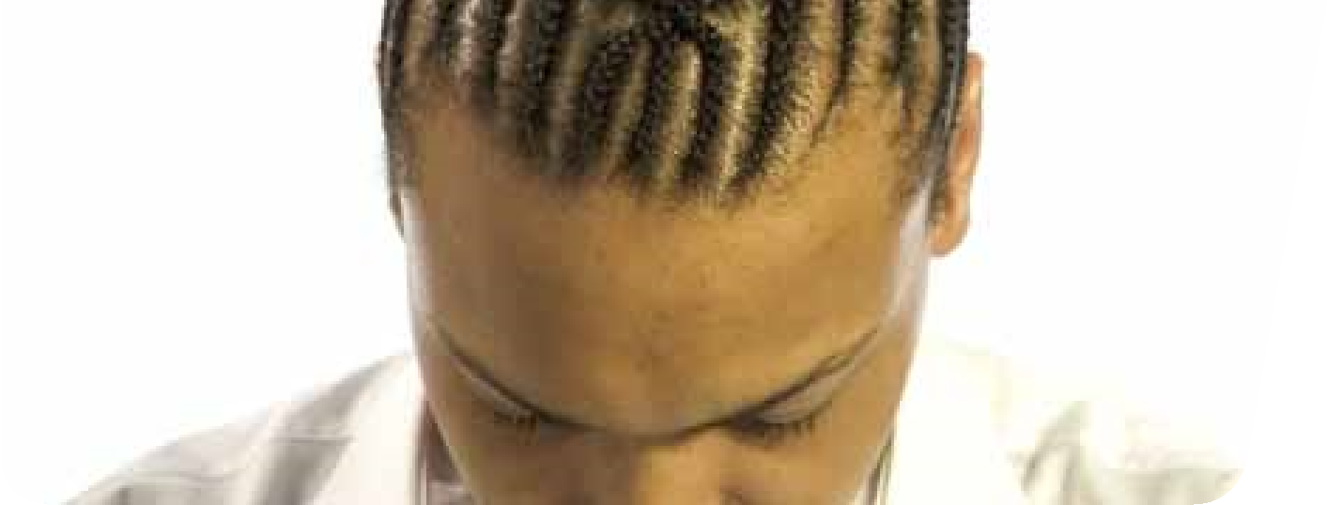
- Communicate and behave in a professional manner
© Habia
*May be assessed through oral questioning.
Observation | 1 | 2 | Optional
Date achieved
Criteria questioned orally
Portfolio reference
Assessor initials
Learner signature

Range
*You must practically demonstrate that you have:
Used all of the plaiting techniques | Portfolio reference
On the scalp plaits
Off the scalp plaits
*It is strongly recommended that all range items are practically demonstrated. Where this is not possible, other forms of evidence may be produced to demonstrate competence.

Achieving knowledge outcomes
You will be guided by your tutor and assessor Where possible your assessor will integrate on the evidence that needs to be produced. knowledge outcomes into practical observations Your knowledge and understanding will be through oral questioning. assessed using the assessment methods listed below:
Developing knowledge
- Observed work
- Witness statements
- Audio-visual media
- Evidence of prior learning or attainment
- Written questions
- Oral questions
- Assignments
- Case studies

Knowledge
Outcome 1
Be able to prepare for basic hair plaiting
You can: | Portfolio reference /  Assessor initials*
c. State the procedure for client preparation
* Assessor initials to be inserted if orally questioned.

Requirements highlighted in white are assessed in the external paper.
Outcome 2

Be able to carry out basic hair plaiting techniques
© Habia
You can: | Portfolio reference /  Assessor initials*
d. State when and how to use products, tools and equipment
* Assessor initials to be inserted if orally questioned.

Requirements highlighted in white are assessed in the external paper.

Unit content
This section provides guidance on the recommended knowledge and skills required to enable you to achieve each of the learning outcomes in this unit. Your tutor/assessor will ensure you have the opportunity to cover all of the unit content.

Outcome 1: Be able to prepare for basic hair plaiting
Preparation of self:
Clothes (salon
requirements for uniform, clean/ironed
clothes, non-restrictive, closed in low heel
shoes), hair (clean, healthy, manageable,
off face), personal hygiene (clean body,
teeth, workable length clean nails,
deodorant, no overpowering perfume/
aftershave), personal protective equipment
gloves, apron, prevent dermatitis), minimal
(
jewellery, positive attitude, ready to greet.
Preparation of client:

Remove client’s
outer clothing, protect against damage,
ensure client relaxed and comfortable
(
posture, aids service), remove excessive
jewellery (to avoid damage to jewellery and
skin), gown, towel, plastic cape, barrier
cream, ensure client comfort, record card.
Preparation of work area:

Chair,
trolley, work station, equipment cleaned,
appropriate sterilisation (barbicide,
autoclave, UV, sterilising spray), complete
destruction of all living organisms on tools
and equipment, disinfection (remove
contamination from hard surfaces, large
work areas, floors and work surfaces), heat
or chemical methods, use of trolley with
full access around trolley, safe professional
presentation tools and equipment, visual
check electrical equipment, select height of
chair.
Select products and tools for basic
plaiting:

Products
–

Hair spray, dressing cream, oil,
wax, gel, moisturiser.
Tools
– Denman brush (flat brush), wide
tooth comb, tail comb, section clips, bands,
pins, ornamentation, water spray.

Outcome 2: Be able to carry out basic hair plaiting techniques

Application of finishing products: Follow manufacturer’s instructions for each product, defines, adds shine, holds, separates hair, spikes, protects, moisturises.
Range of finishing products:
Wax – removes static/frizz, gives definition, adds moisture, shine/lustre.
Sprays – holds style in place, repels moisture, longevity, adds shine.
Dressing creams – defines style, adds gloss/shine/lustre, tames dry hair.
Gel – wet look effect, spike hair, sleek hair.
Serum – adds shine, reduces frizz/static.
Plaiting techniques: Off scalp, on scalp plaits, 3 stem plait from ponytail, braiding/ cane row/corn row, fish tail plait, rope plait, French plait.
Follow safe and hygienic working practices:
Maintaining a safe salon – clean, tidy, safe standards of working, remove spillages, report slippery surfaces, remove/ report obstacles, clear access to trolleys and equipment, clean/sterilise/disinfect (tools, equipment, work surfaces), no smoking, eating, drinking or drugs in salon, professional personal hygiene.
Personal protective equipment – wear protective equipment, avoid latex, powdered gloves, apron.
Electricity at work – visual check of equipment, no trailing wires, portable appliance testing.
Manual handling – moving stock safely, lifting, working heights, unpacking.
© Habia
Towels – wash regularly, clean for every client, place dirty towels in covered bin.
Reporting of injuries, diseases and dangerous occurrences – accident book, reporting diseases, log accidents.
Control of substances hazardous to health – store, handle, use, disposal, replace lids, ventilation for vapour and dust, avoid overexposure to chemicals, use manufacturers’ instructions for use.
Disposal of waste – sharps box, closed top bin, dilute chemicals with running water, environmental protection, salon policies for hazardous waste, single use items, empties (recycle).
Product storage – check end date/ packaging, store away from heat/damp/ direct sunlight, empties avoid theft.
How to maintain personal hygiene: Clothes/uniform (washed/ironed daily, comfortable clean shoes), hair (clean, healthy, manageable, off face), personal hygiene (shower daily, deodorant, clean teeth, fresh breath), nails (workable length, clean), avoid overpowering perfume/ aftershave, minimal jewellery, light fresh make-up, wash hands between clients, cover cuts and wounds with plaster, personal protective equipment (gloves, apron, prevent dermatitis).
Professional communication in a salon environment: Try to avoid technical language, always respond, consider clients confidentiality.
Verbal – speaking (tone of voice, the language you use, how quickly and

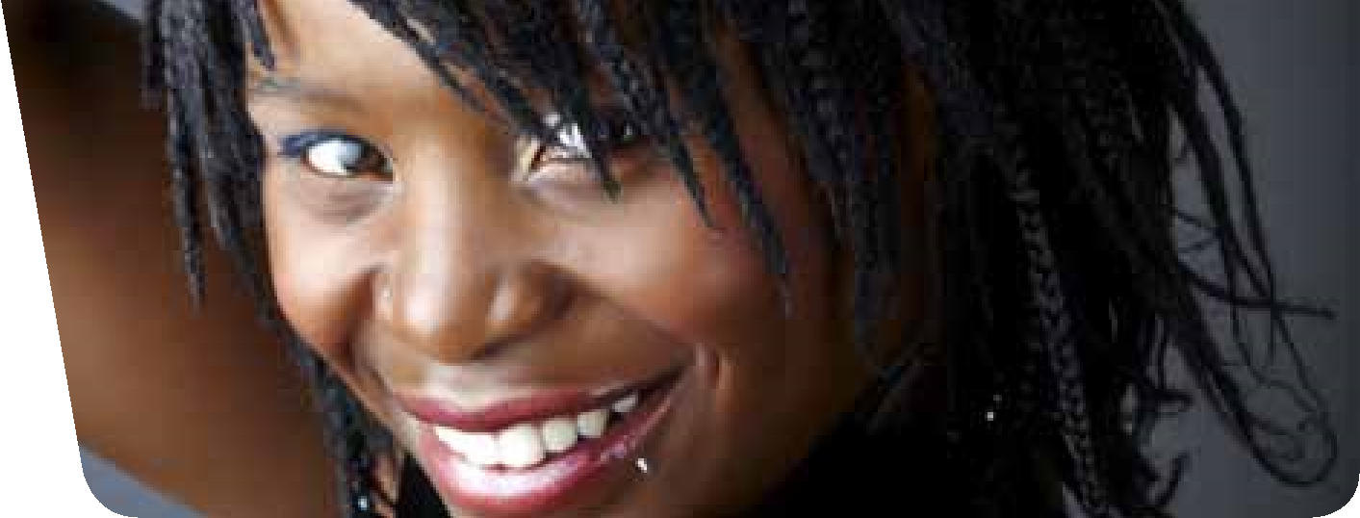
Outcome 2: Be able to carry out basic hair plaiting techniques (continued)
© Habia
clearly), questioning (open, closed,
probing).

Non-verbal
– body language, positive
attitude (posture, facial expressions, hand
gestures, the distance you stand), listening
(
be patient, try to understand
).
Written
– visual aids, magazines, client
records.
Behave professionally in a salon
environment:

Follow health and safety
practices and procedures, salon code of
conduct, respect others, value client(s),
co-operate with others (sympathy,
accepting, fair, not aggressive), appropriate
language, avoid gossip, maintain
confidentiality, polite, cheerful and friendly
manner (friendly facial expressions, open
body language, positive attitude, eye
contact), sensible behaviour, team work,
pride in work, punctuality, employer and
client loyalty.
Use this area for making notes and drawing diagrams
Notes

