

Lee Stafford Academy
of
Hairdressing, Barbering and Applied Therapies

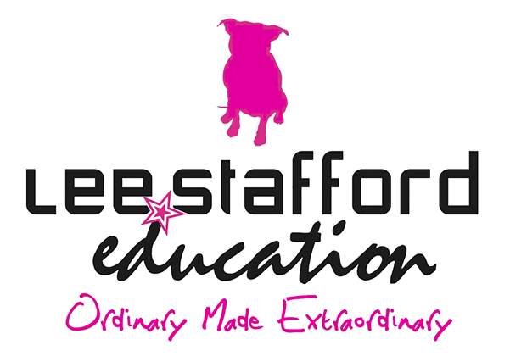

VTCT Level 1 Diploma in an Introduction to the Hair and Beauty Sector.

LIST OF UNITS:

- UV10343: Introduction to the Hair and Beauty Sector.

- UV10344: Presenting a professional image in the salon.

- UV30341: Hair Plaiting.

- UV30336: Shampoo and conditioning.

- UV30339: Basic make-up application.

- UV30333: Nail art application.

- UV10479: Create a hair and beauty image.

- UV10480: Colour hair using temporary colour.

- UV10416: Providing basic manicure treatment.

11. UV10417: Providing basic pedicure treatment.

12. UV1030338: Styling women’s hair

13. UV30335: Skin care

