School of Hairdressing and Applied Therapies

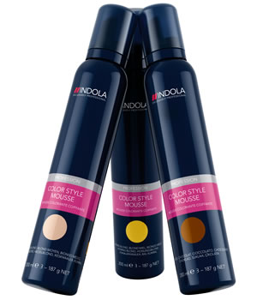
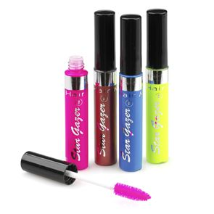
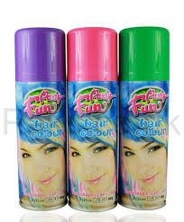

Level 1 Diploma in Hairdressing

UV10480 Colour Hair Using Temporary Colour

Course Notes

What is a Temporary colour

Temporary hair colour is a type of hair colour that does not deliver permanent results. Most temporary hair dyes wash out after one shampoo. Temporary hair colour is a fun way to instantly change your hair colour for an event or holiday or just to experiment with colour without committing to a permanent change.

How does Temporary colour work on the Hair Structure?

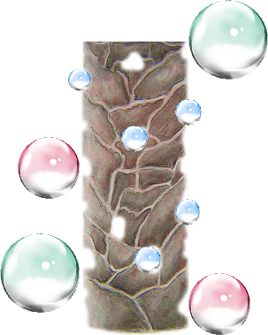
Temporary hair colour contains large colour molecules which attach themselves to the cuticle scales. This is because the molecules are large preventing penetration into the hair shaft.

Principles of temporary colours

- Some temporary colours applied to dry hair will last until they are brushed out.
- Temporary colours applied to towel dried hair will last until the hair is shampooed.
- On porous hair the colour will be more vibrant and harder to remove.
- Can be used for introducing hair colour to a client
- Gives instant shine
- Used for darkening hair or adding tone
- Removes unwanted tones
- Will not lighten hair
- Refresh colour fade
- Skin test is not required prior to application
- Blends in minimal white hair
- No commitment

Types of temporary colouring products:

- Colour rinse
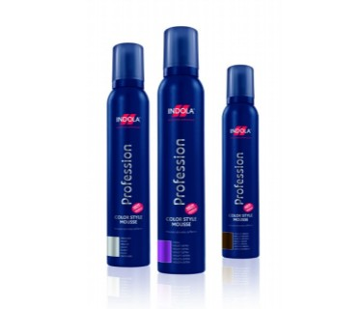
- Hair mascara
- Coloured mousse
- Coloured setting lotions
- Colour creams
- Colour sprays
- Colour shampoos

How to select temporary colour:

Choose the appropriate product for the client and selected service.

Colour rinse – will add colour, can apply styling product on top, good to blow dry, non-sticky result.

Hair mascara – will achieve vivid colours, strand effect, sticky result.
Coloured mousse – will add colour, no setting properties, sticky result.

Coloured setting lotions – will add colour, setting properties, sticky result.

Colour creams – will add colour, no setting properties, non-sticky result.

Colour hairsprays – will add colour, wide spread application, sticky result brushes out.

Colour shampoos – will add colour, can apply styling product on top, good to blow dry, non‑sticky result.

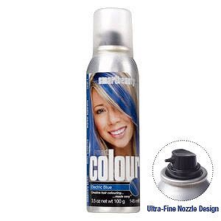
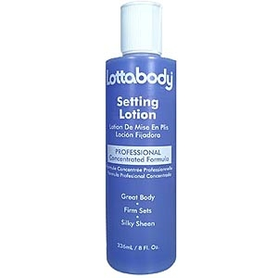
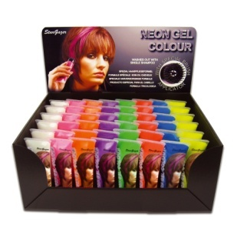

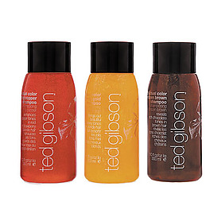

The purpose of hair colouring products:

Temporary
- introduce client to colour
- refresh colour fade
- quick fashion effects
- cancel out unwanted tones
- darken natural hair
- blend in minimal white hair
- instant colour change
- no commitment

Factors that influence the choice of temporary colour:

Hair condition –

- dry
- greasy
- normal
- virgin ( hair that has not been chemically treated)
- chemically treated
- elasticity (strength of hair)
- porosity (damage to cuticle layer, the ability to absorb moisture).
- Existing colour of hair light, dark, warm tone, cool tone.
- Hair cut/style – uniform layer, one length, short graduation, long graduation.
- Temperature – body heat, salon temperature, added heat.
- Texture – fine, medium, coarse.
- Length – short, medium, long.
- Density – fine, medium, thick.
- Test results – good, bad, caution, positive, negative
- Skin tone – fair, medium, olive, dark.

Other factors to consider:

- Client occupation
- Finances
- Family commitments
- Time factors
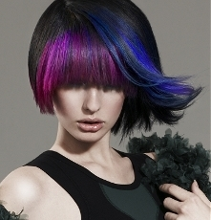

The importance of preparation procedures for temporary colour:

- Ensures the salon and the stylist present a professional image, saves time.
Preparation of self:

Clothes (salon requirements for uniform, clean/ironed clothes, non-restrictive, closed-in low heeled shoes), hair (clean, healthy, manageable, off face), personal hygiene (clean body, teeth, workable length clean nails, deodorant, no overpowering perfume/
aftershave), personal protective equipment (gloves, apron, prevent dermatitis), minimal jewellery, positive attitude, ready to greet.
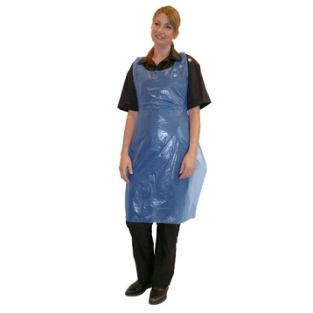

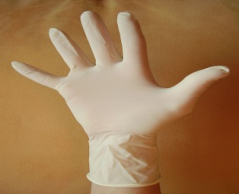

Preparation of client:

- Remove client’s outer clothing, to protect against damage
- Ensure client is relaxed and comfortable (posture, aids service)
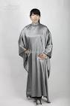
- Remove excessive jewellery (avoid damage to jewellery and skin)
- Gown, towel, plastic cape, barrier cream
- Complete client record card.

Preparation of work area:

- Chair, trolley, work station, must be clean
- Equipment, appropriate sterilisation (barbicide, autoclave, UV, sterilising spray), complete destruction of all living organisms on tools and equipment.
- Disinfection (remove contamination from hard surfaces, large work areas, floors and work surfaces, heat or chemical methods).
- Use of trolley, safe professional presentation tools and equipment, visual check on large and small equipment, electrical equipment checked,
- Portable appliance test.
- Select height of chair/basin.

Hair sectioning techniques:

- Hot cross bun – section head into four equal parts.
- Half head – section head from temple, around back of head (occipital bone) to temple.
- Placed application – select size of section/strand, isolate section from rest of hair.
- Placed application – select size of section/strand, isolate section from rest of hair.

Following manufacturers’ instructions:
- Can be found on bottle, packaging, leaflet, colour chart,
- Ensures successful service
- Correct storage (temperature, location, and light)
- Handling (PPE)
- Correct mixing, use (application, removal),
- Disposal (dilution-products, bagged bin‑empties),
- Following instructions can prevent mistakes and legal action.

Apply temporary colouring products:

Prior to the application of temporary colour it is important to carry out a strand test to determine correct colour choice and product.
Temporary colour can be applied to shampooed, towel dried hair or dry hair, and personal protective equipment should always be used. Always follow manufacturers’ instructions for individual selected product, and use appropriate equipment.

Bowl and brush – decant product into bowl, spread evenly with wide tooth comb (mousse, creams, setting lotion).

Direct from product – bottle (sprinkle onto wet hair before styling), can (spray onto dry hair), mascara wand (comb onto dry hair).

Shampoo/conditioner – wet hair, apply, allow to stain hair, rinse.

How to follow safe and hygienic working practices:

Maintaining a safe salon – clean, tidy, safe standards of working, remove spillages, report slippery surfaces, remove/ report obstacles, clear access to trolleys and equipment, clean/sterilise/disinfect
tools, equipment and work surfaces, no smoking, eating, drinking or drugs in salon, professional personal hygiene.

Personal protective equipment –wear protective equipment, avoid latex, powdered gloves, apron.
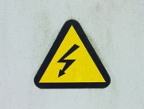
Electricity at work – visual check of equipment, no trailing wires, portable appliance testing.
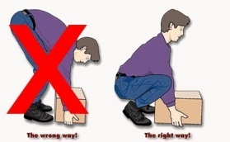
Manual handling – moving stock safely, lifting, working heights, unpacking.

Towels – wash regularly, clean for every client, place dirty towels in covered bin.

Reporting of injuries, diseases and dangerous occurrences – accident book, reporting diseases, log accidents.

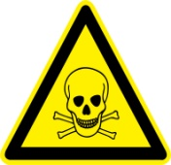
Control of substances hazardous to health – store, handle, use, disposal, replace lids, ventilation for vapour and dust, avoid over exposure to chemicals, use manufacturers’ instructions for use.

Disposal of waste – sharps box, dilute chemicals, contaminated/hazardous waste, closed top bin, recycle empties.

Product storage – check end date/packaging, store away from heat/damp/ direct sunlight, empties, avoid theft.

Professional communication in a salon environment:

Try to avoid technical language, always respond, and consider client confidentiality.

Verbal – speaking (tone of voice, the language you use, how quickly and clearly), questioning (open, closed, probing)
Non-verbal – body language, positive attitude (your posture, facial expressions, hand gestures), proximity (the distance you stand), listening (be patient, try to understand).

Written – visual aids, magazines, client records.

Behave professionally in a salon environment:

- Follow health and safety practice and procedures
- Salon code of conduct, respect others, value client(s), co‑operate with others (be sympathetic and fair, not aggressive).
- Use appropriate language, always avoid gossip and maintain confidentiality.
- Be polite/cheerful using a friendly manner (friendly facial expressions, open body language, positive attitude, eye contact).
- Sensible behaviour (team work, pride in work, punctuality, employer and client loyalty).

How to remove colouring products from the hair:

- Brushing
- shampooing
- Clarifying shampoo for build-up of product.

Basic hair structure:

- Cuticle
- Cortex
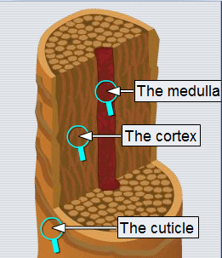
- Medulla

