School of Hairdressing and Applied Therapies
Question | √ or X | Competent/Not yet  competent
Q1
Q2
Q3
Q4
1
2
3
4
5
6
7
8
9
10
11
12
Q5
1
2
3
4
5
6
7
8
Q6
Q7
Q8

Level 1 Diploma in Hairdressing
Unit: UV10480
Colour Hair using Temporary Colour

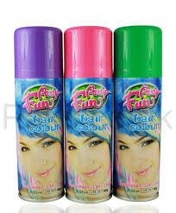
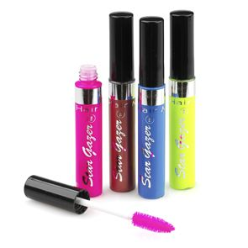
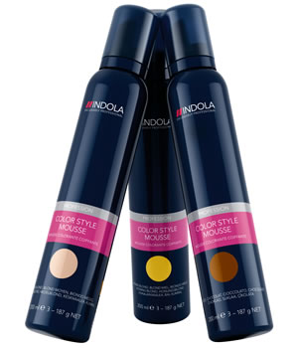

Student Name:

Tutor Signature & Comments:
Literacy Alert:

Date issued:
Date handed in for marking:
Date of competence:

Colour Hair using Temporary Colour

- Explain the importance of the preparation procedures for temporary colouring

- Is temporary hair colour permanent?

- How does temporary hair colour work on the hair structure?

4. List the principles of temporary hair colour
1.
2.
3.
4.
5.
6.
7.
8.
9.
10.
11.
12.

5. State the purpose to why we use temporary hair colour
1.
2.
3.
4.
5.
6.
7.
8.

6. Outline procedures for temporary hair colour.

7. List the factors that would influence the choice of temporary colour.

8. Why is it important to always follow manufacturer’s instructions?

Please use the grid below to correct any spelling mistakes identified within this workbook

Spelling mistake | Spelling correction

Please use the grid below to correct any grammar issues identified within this workbook

Grammar mistake | Grammar correction

