Temporary Colour Revision

What is a temporary Colour?

Temporary hair colour is a type of hair colour that does not deliver permanent results. Temporary hair colour is a fun way to instantly change your hair colour for an event or holiday or just to experiment with colour without committing to a permanent change.

How long a temporary colour will last?

- One shampoo.

How long a semi permanent colour will last?

- Six shampoos/washes

How long a quasi-permanent colour will last?

- Covers white hair permanently and leaves a regrowth as the hair grows

How long a lightening/bleach colour will last?

- Removes natural colour pigment from hair permanently and leaves a regrowth as the hair grows

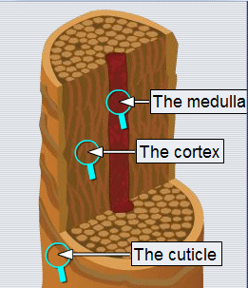
Basic hair structure/layers:

- Cuticle
- Cortex
- Medulla

How to remove colouring products from the hair:

- Brushing
- shampooing
- Clarifying shampoo for build-up of product.
Principles of temporary colours

- On porous hair the colour will be more vibrant and harder to remove.
- Can be used for introducing hair colour to a client
- Gives instant shine
- Used for darkening hair or adding tone
- Removes unwanted tones
- Will not lighten hair
- Refresh colour fade
- Skin test is not required prior to application
- Blends in minimal white hair
- No commitment

Types of temporary colouring products:

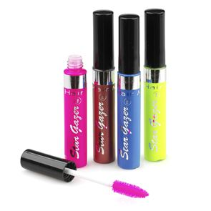
- Colour rinse
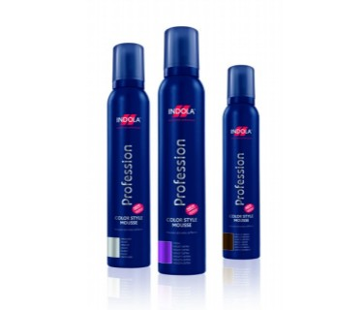
- Hair mascara
- Coloured mousse
- Coloured setting lotions
- Colour creams
- Colour sprays
- Colour shampoos

How to select and apply temporary colour:
Choose the appropriate product for the client and selected service.

Colour rinse/shampoo – applied to shampooed hair directly from the bottle onto the hair using hands.

Hair mascara – applied to clean dry hair directly from the applicator bottle.

Coloured mousse – applied to shampooed hair directly from the can onto the hands.

Coloured setting lotions – applied to shampooed hair directly from the applicator bottle.

Coloured gels – applied to clean dry hair directly from the product using the applicator brush.

Colour creams – applied to both clean dry hair and shampooed hair directly from the bottle.

Colour hairsprays – applied to clean dry hair directly from the can.
What temporary hair colour does not give a sticky end result?
Coloured creams do not leave a sticky end result

