

School of Hairdressing and Applied Therapies

Presenting a Professional Image in a salon
UV10344
Evidence Workbook
Question | √ or X | Competent/Not yet competent
Q1
Q2
Q3
Q4
Q5
Q6
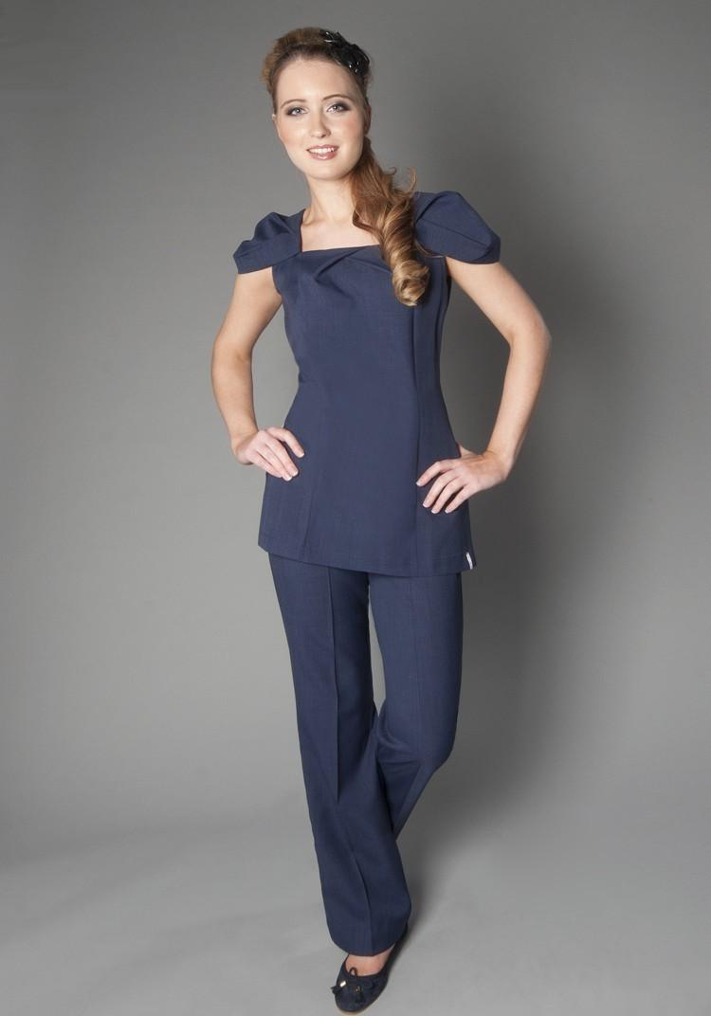

Literacy Alert:

Student Name:
Date issued:
Date handed in for marking:
Date of competence:

Tutor Signature & Comments:

Identify the effects of positive behaviours

Identify the effects of negative behaviours

- Identify how to promote a professional image in a salon

- Identify how to maintain personal hygiene

Develop yourself

Open and closed questions
Below are a number of questions. Some are open and some are closed questions.
5. In each pair of questions, identify which is an open question and which is a closed question, by writing ‘open’ or ‘closed’ in each box.
a Are you OK today?

b How are you today?

c When was the last time you had your hair cut?

d Was it six weeks ago that your hair was last cut?

e What can I do for you today?

f Would you like a shampoo and blow-dry today?

g Would you like your next appointment in six weeks?

h When would you like your next appointment?

6. Why do you think open questions are important in hairdressing consultations?

Please use the grid below to correct any spelling mistakes identified within this workbook

Spelling mistake | Spelling correction

Please use the grid below to correct any grammar issues identified within this workbook

Grammar mistake | Grammar correction

