School of Hairdressing and Applied Therapies

SHAMPOO AND CONDITIONING

UV30336
Evidence Workbook

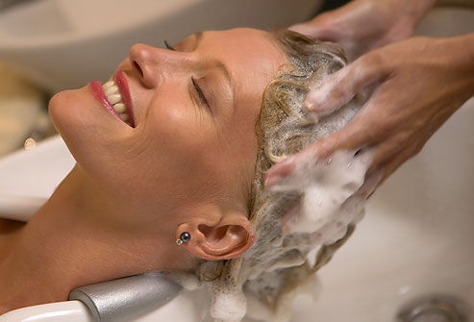

Question | √ or X | Competent/Not yet  competent
Q1.
Q2.
Q3.
Q4.

Student Name:

Literacy Alert:

Tutor Signature & Comments:
Date issued:
Date handed in for marking:
Date of competence:

- State the procedure for client preparation

2. State the effects of shampooing and conditioning on the hair

3. Describe the three layers of the hair shaft

1.
2.
3.

4. The hair shaft

Please label the diagram below

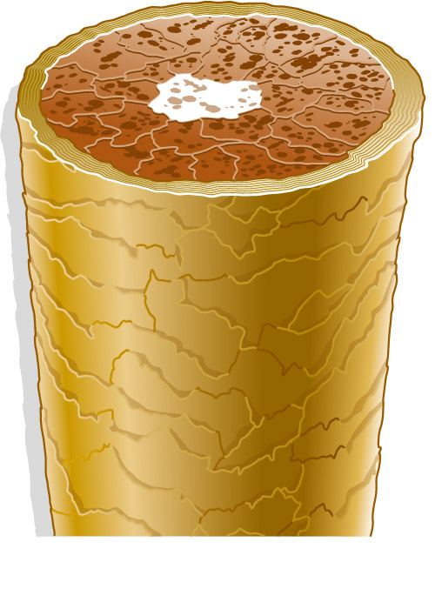

5. Name the three main massage movements that are
used when shampooing the hair -

1.
2.
3.

Please use the grid below to correct any spelling mistakes identified within this workbook

Spelling mistake | Spelling correction

Please use the grid below to correct any grammar issues identified within this workbook

Grammar mistake | Grammar correction

