Leaner Name_____________________________________________________

PH Scale
By understanding the PH scale will help you know how different products affect the hair and skin. Look at the picture below of the PH scale and answer the following questions.
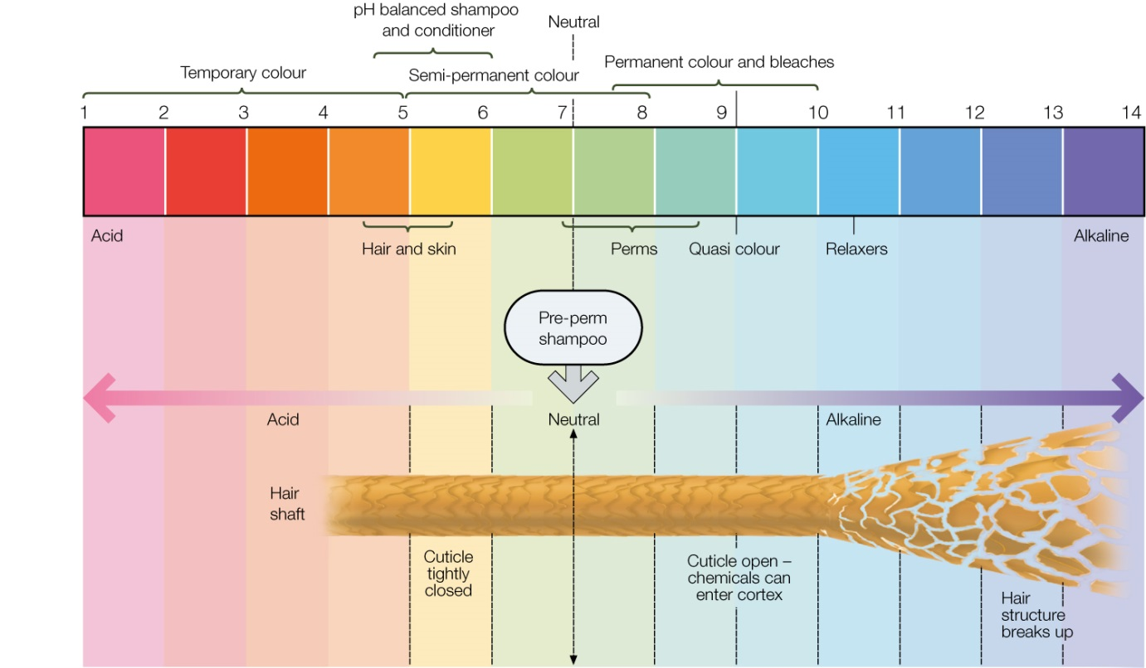

- What does the PH scale measure?
________________________________________________________________________________________________________________________________
- What acid based product will close the cuticle scales making them smooth?
________________________________________________________________________________________________________________________________

- What PH value do shampoos have on the hair?
_____________________________________________________________

- What is the PH value of hair and skin?
______________________________________________________________

- What is kinder on the hair, an acid product or an alkaline product?
________________________________________________________________________________________________________________________________

- On the PH scale was does the number 7 represent?
_______________________________________________________________

