

School of Hairdressing and Applied Therapies

SHAMPOO AND CONDITIONING

Course Notes

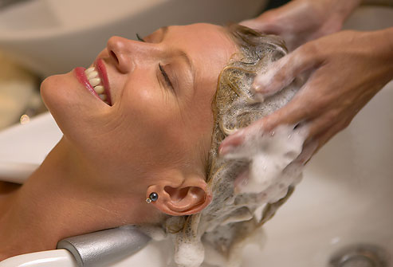

You need to read these notes to enable you to pass your VTCT test

INTRODUCTION

This pack covers all the knowledge and understanding information required to support units in shampooing and Conditioning the Hair and Scalp.

Relevant to:

Those following the Diploma (NVQ) Level 1 & 2 route to Hairdressing.

The process of shampooing and conditioning has an impact on the overall satisfaction of the client’s visit to the salon.

When carried out correctly these services provide a personal, invigorating, stimulating and therapeutic experience. However, if not the client will feel it is an inferior start to the remainder of her treatments.

Greet the client professionally to present a positive impression. Protect the clients clothing by placing a gown on the client, place a plastic cape around the shoulders followed with a towel. (Remember to fold in any collars to prevent the clothing from becoming wet).

Prior to shampooing and conditioning your client’s hair, a full consultation with your client must be carried out in order to establish if there are any contra-indications i.e., a reason why the process may not be carried out. Ask the client to remove any jewellery that may get damaged and ask the client to keep them safe. Check to see if the client is wearing any hearing aids and if so, asked them to remove them until the service has been carried out.

Make sure whilst shampooing, that your client is comfortable at all times.

Shampoos: -
Shampoos vary from – creams, to liquids or gels, some are kinder and gentler than others are. It is essential that you use the correct shampoo to suit the specific hair type.

Always assess the hair during consultation to decide if there is build up of products present, as if these are not removed during shampooing your following treatments will not be effective due to the barrier of these and may cause skin infections. Hair with product build up will appear dull and lifeless.

Remember, there are specially formulated shampoos such as de-lacquering, clarifying shampoos, which are soapless – based and are made to remove these product build ups.

Some contain no additives for use before carrying out any perming or colouring, others will have additives to help remove dirt and grime.

Shampoos will mix (emulsify) with water to release the dirt and grime from the hair and scalp.

If you chose the incorrect shampoo for your client’s hair, it would have an adverse reaction
I.e., the hair may become excessively dry or very greasy, this means the treatment will be ineffective.

Hair types we come across –

1. Normal
2. Dry
3. Greasy/Oily
4. Chemically Damaged
5. Heat Damaged
6. Environmentally Damaged
7. Product build up

Scalp types we come across –

- Dandruff Affected
- Oily
- Dry
- Product build up
- Normal

Shampoo ingredients for different hair types – solution

Shampoo ingredient | Hair type | Benefits
Lemon | Greasy hair | Removes grease
Strawberries | Normal hair | Adds shine and cleanses
Avocado | Dry hair | Adds moisture
Beer | Fine hair | Adds volume
Melon | Normal hair | Adds shine and cleanses
Almonds | Dry hair | Adds moisture
Coconut | Dry hair | Adds moisture
Vinegar | Damaged hair | Adds shine and closes cuticle

Hair and scalp condition – How the hair may look and the solution

Hair and scalp condition | How the hair /scalp may look | How it may feel
Normal | Shiny | Smooth and sleek
Dry | Hair would appear dull. Scalp would have dry white flaky patches | Porous, rough and bumpy
Greasy | Damp and limp. Hair would appear Shiny | Oily
Dandruff | Oily with dry white flakes | Possibly oily
Damaged | Dry and broken | Porous, rough and bumpy
Colour-treated | Coloured, possibly dry | Porous, with swollen, roughened cuticle
Permed | Curly and possibly dry | Porous, with swollen, roughened cuticle

Shampoo ingredients for different hair types – solution

Shampoo ingredient | Hair type | Benefits
Lemon | Greasy hair | Removes grease
Strawberries | Normal hair | Adds shine and cleanses
Avocado | Dry hair | Adds moisture
Beer | Fine hair | Adds volume
Melon | Normal hair | Adds shine and cleanses
Almonds | Dry hair | Adds moisture
Coconut | Dry hair | Adds moisture
Vinegar | Damaged hair | Adds shine and closes cuticle
Medicated | Dandruff affected | Relieves itchiness

Hair Texture

Hair grows in many different textures:

- Very Coarse
- Course
- Average
- Fine
- Very fine

There are three, main massage movements we use to shampoo –

1. Effleurage
2. Rotary
3. Friction

Remember to use the massage technique relevant to the hair length.

Effleurage is a gentle stroking movement. We use this to apply the product and relax the client. This is a stroking movement that helps spread the product evenly using the palm and fingertips. Effleurage is suitable for hair of all lengths; however it is especially suited to long hair. Taking your hands off the head while shampooing long hair will not cause tangles.

Massage movements

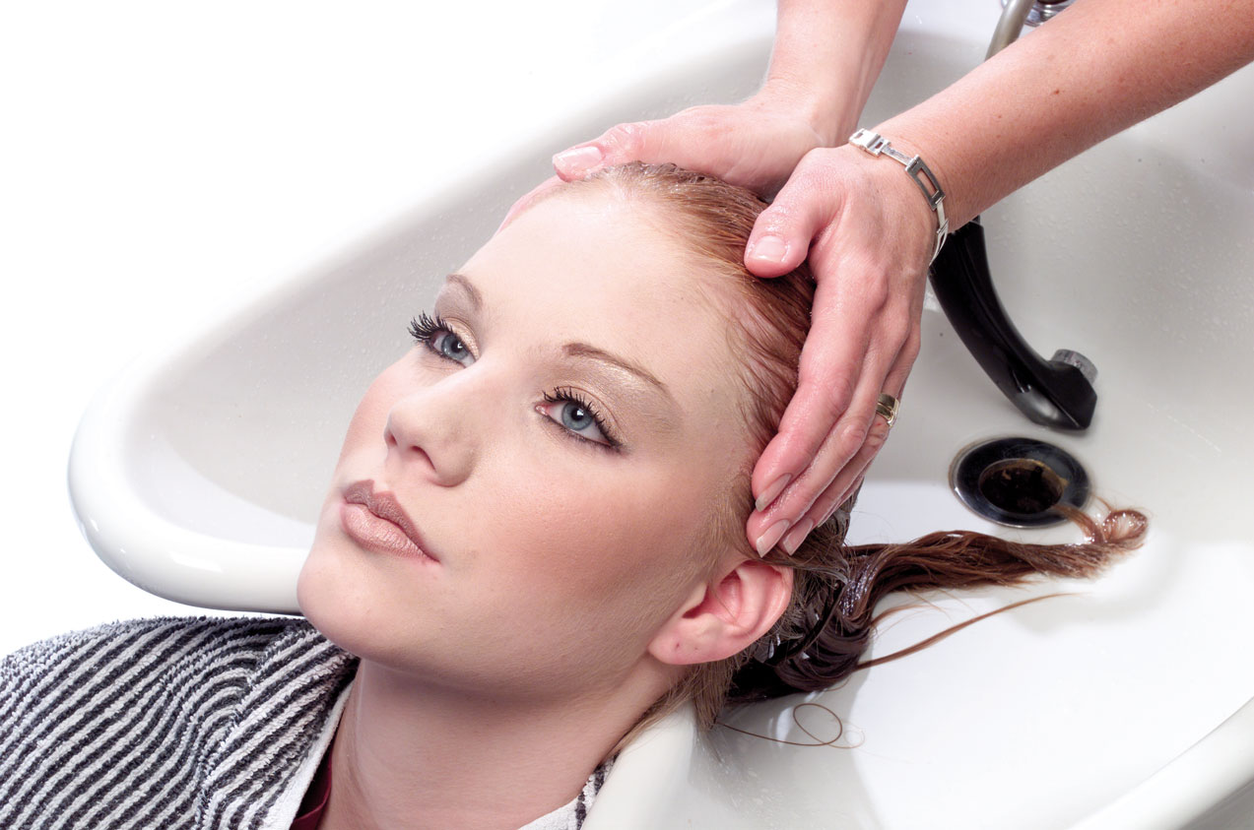

Rotary is circular movements used with the fingertips to cleanse and remove dirt from the hair and scalp. These massage movements are carried out with the fingertips as they glide over the scalp in a circular movement. Rotary is best suited to short hair.

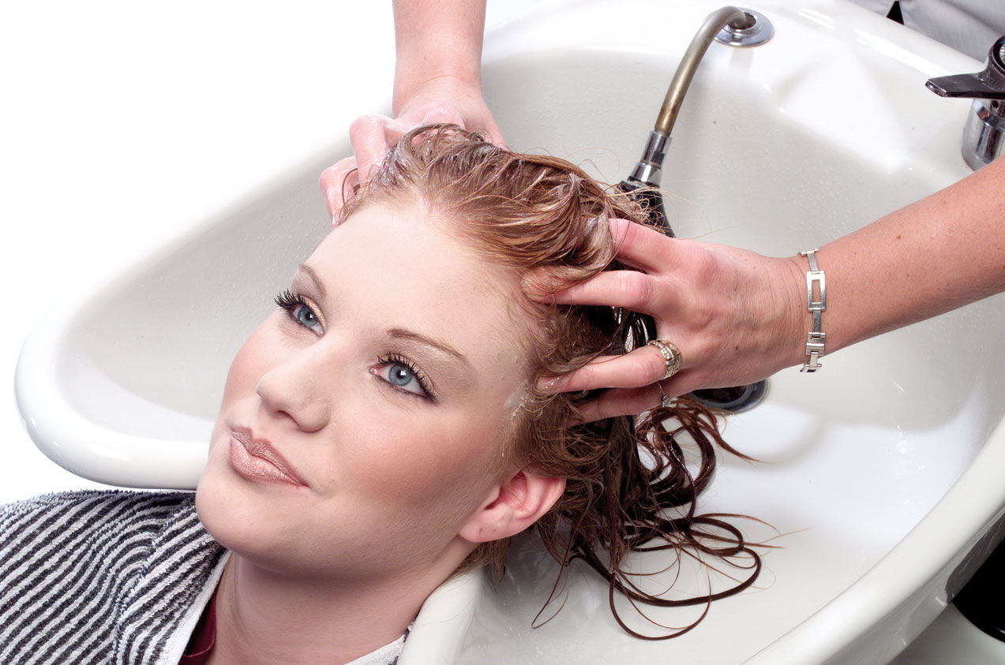

Friction is a quick rubbing technique, used to deep cleanse, and is often used with friction lotions. Occasionally you can use this technique instead of rotary, as a quick rubbing movement to stimulate the scalp. Friction must only be used on short hair and must never be used on greasy hair as this will stimulate the scalp and increase the sebum, therefore have an adverse reaction i.e. become greasier. This massage technique is ideal for very thick hair to loosen dirt and debris.

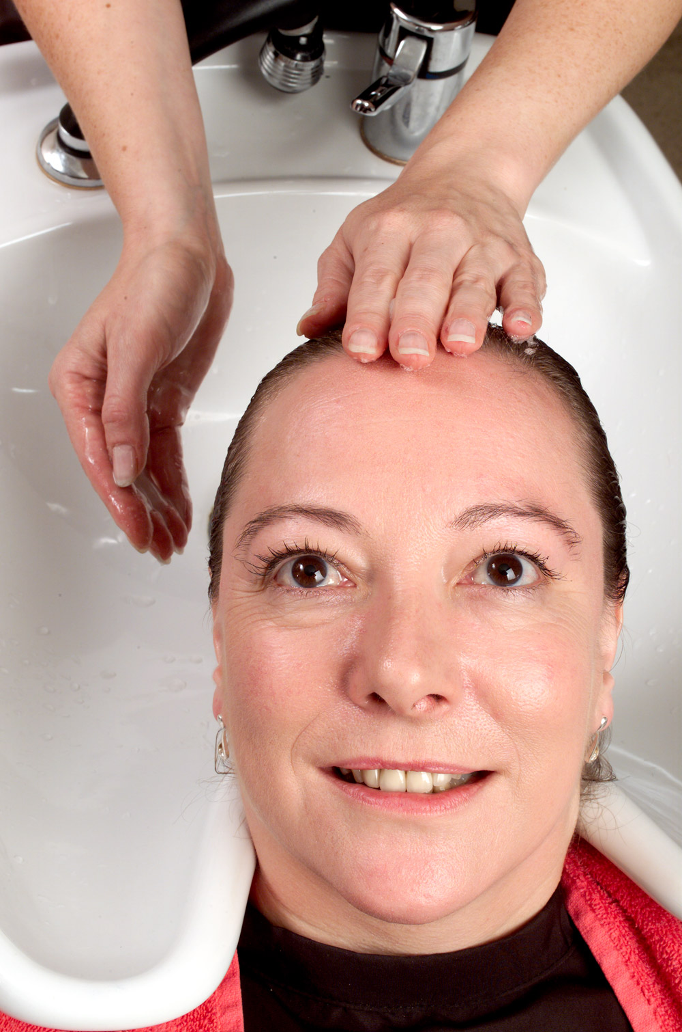

Conditioners:-
Choosing conditioners is of the utmost importance, as we do not want to create excessive greasiness, also we do not want to increase sebum if the scalp is on the greasy side.

Conditioning services often sell themselves, as clients are usually aware if their hair is out of condition. Clients will often ask what they can do to improve the condition of their hair, it is then your job to assess the condition of their hair and decide what conditioning service would be beneficial for them.

There are 3, types of conditioning services we offer –

- Surface Conditioner
- Penetrating Conditioning Treatment
- Scalp Treatment.

Surface Conditioner is the most popular as this is convenient and suits most hair types; it is carried out at the backwash following the shampooing process. When conditioning below shoulder length hair, the product should be distributed to the mid-lengths and ends first and then work through the hair.

Generally, there are two, main massage movements we use when applying a surface conditioner –

Effleurage, Petrissage and tapotement

Conditioning massage movements

Effleurage

Slow, smoothing, stroking massage movements done with the palms of the hands during shampooing. It is used to apply shampoo to the hair and to relax the client.

Petrissage is a deep kneading movement using the pads of the fingers. It stimulates the scalp as well as being extremely relaxing and therapeutic for the client.

Tapotement is a lighter quicker movement than petrissage, applying light tapping movements over the scalp. This also gently stimulates the scalp. This is an invigorating motion using the pads of the fingers in a firm tapping rhythm. It stimulated the scalp and hair follicles and releases muscular tension.

Surface conditioners only coat the cuticles

Conditioning massage movements
Effleurage
Slow, smoothing, stroking massage movements done with the palms of the hands during shampooing. It is used to apply shampoo to the hair and to relax the client.

Petrissage
Large, circular, slow, deep kneading massage movements used to stimulate the scalp when conditioning the hair and scalp. It increases blood flow to the area and stimulates the sebaceous glands to secrete sebum. Ultimately, it relaxes the client.

Penetrating Conditioning Treatment is excellent for extremely dry, damaged, porous, and over processed hair. Conditioner is applied to the hair following the shampooing process, by sectioning the hair into four, taking thin neat meshes of hair, then applying the conditioner from the roots through to the points by use of a tinting brush and bowl. Heat is then applied to the hair by use of a steamer or hot towels. The hair is then rinsed to remove excess conditioner.

Penetrating conditioners penetrate the cuticles and enter the cortex
Scalp Treatment is excellent for a client with a dry scalp. Vegetable oil e.g. olive, palm or coconut is used. The oil must be warmed, prior to application, however it must not be hot or it could burn the client. While the oil is warming, the client should be placed under a warm steamer in order to open the pores to aid penetration of the oil. The oil is applied to dry hair, therefore, prior to the shampooing process. The oil is applied to the scalp area only by sectioning the hair into four, taking thin neat meshes of hair, then applying the oil only to the scalp area by the roots of the hair by use of a tinting brush and bowl. Heat is applied to the hair for 5 minutes by the use of a steamer. The hair must then be shampooed; however you always apply the shampoo to the hair before the water. This emulsifies with the oil and acts as your first shampoo, rinse and re-apply more shampoo.

Pre- perm/colour Conditioners
These conditioners are specially formulated to even out the porosity of the hair prior to chemical treatments

Post – perm/colour conditioners
After chemical treatments have been on the hair it is important that the hair is re-balanced using an acid balance conditioner such as an anti-oxidant conditioner.
Combing of the Hair
Hair cuticles lay from root to point; they are overlapping scales like roof tiles on a house.

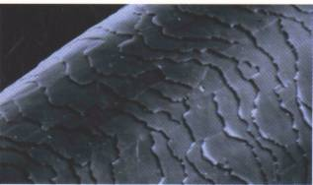

Carefully combing the hair after shampooing is vital, disentangling the ends (points) first, then working back up through the lengths getting closer to the scalp (roots). It is essential to comb the hair correctly, to avoid causing discomfort to your client, tangling of the hair, roughing the layers and even hair breakage.

Water Temperature
The water temperature needs to be neither too hot nor too cold (tepid) and the flow quick enough to rinse so the client is not too long at the basin.

Commercial timings
- Above shoulder length - 10 minutes
- Below shoulder length – 15 minutes

Always remember: -

Hot water opens the cuticle allowing products to enter.
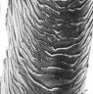

Cold water closes the cuticle preventing products penetrating.
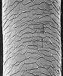

PH of the Hair

In order to understand the chemistry of the hair we must have knowledge of the pH scale and what it represents. The pH scale is a measure of value for potential hydrogen, for which there are two chemical extremes: acid and alkaline.

The pH scale runs from 0-14 with 7 being neutral. Below 7 would be considered acid while above 7 would be alkaline. In normal healthy hair the pH is 4.5-5.5, with the cuticle being considered compact i.e. lying flat and smooth. Products with a pH of above 7 such as perm lotion, tints or bleach will be alkaline; this will result in the cuticle being open and raised i.e. causing dryness and possible breakage with a dull appearance. If the hair is not restored to its original pH by the use of a conditioner or restructurant the hair may become severely broken and damaged.

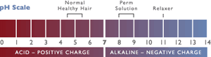

Always remember that clients can get excessive build up of products such as gel, mousse or hair spray. They coat the cuticle, and cause a barrier over the cuticle layers this can prevent successful services such as perming or colouring taking place.

Health and Safety
Health and safety are prime do’s and don’ts. Ensure that the clients clothing is protected throughout the service. Always use fresh clean towels. Make sure you are clean and well presented. Keep water at the correct temperature. Carefully comb the hair afterwards. Be polite and courteous. These are just a few of many.

Contact Dermatitis

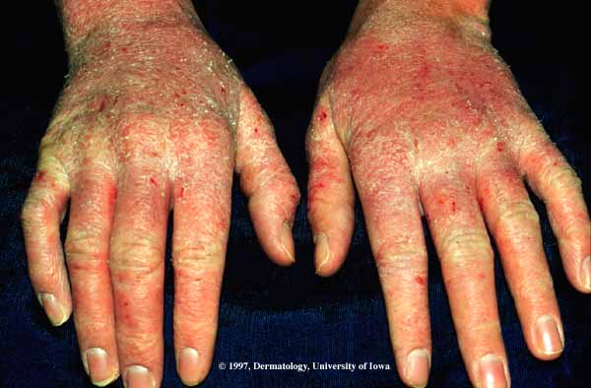

Dermatitis is a painful, itchy condition that affects the skin. Usually it appears sore, sometimes red and predominantly between the fingers. Hands are in contact with chemicals, shampoo, so avoid these products by always wearing gloves and applying cream throughout the day. Some say it is a form of eczema.

Structurally, hair is comprised of three major layers when keratinized:

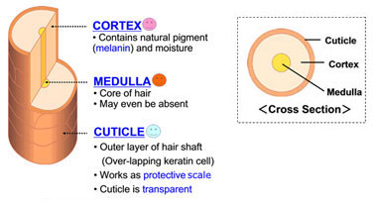

Cuticle- the outer protective covering of the hair shaft made up of overlapping layers of transparent scales. Think of it like a see-through armor or skin of the hair. Also, when we talk shine, we’re talking cuticle.

Cortex- the second layer consisting of unique protein structures. This is where most of the pigment (see hair color) resides and attributes to hair’s strength and flexibility.

Medulla- the central core of the hair shaft, and it is often absent in fine to very fine hair types. The original function of the medulla was to improve the thermal insulation properties of the hair with its structure of cavities. This function can be found in the winter fur of many animals.
Thick, mostly dark, human hair of European and Asian origin often has a medulla. It serves sometimes as a reservoir for pigment. Furthermore, in such types of hair, the additional inner reflection surface of the medulla contributes considerably to the shine.

