School of Hairdressing and Applied Therapies

Styling Women’s Hair

Unit UV30338

Course Notes

Maintain effective and safe methods of working when drying hair

Protecting the Client

You must always ensure that you protect your client and their clothing prior to all hairdressing services. The service could be a non-chemical treatment such as a blow-dry, plait, conditioning treatment or hair cut, you still must make sure that your client’s clothing is effectively protected throughout the service.

Items used to protect client’s clothing

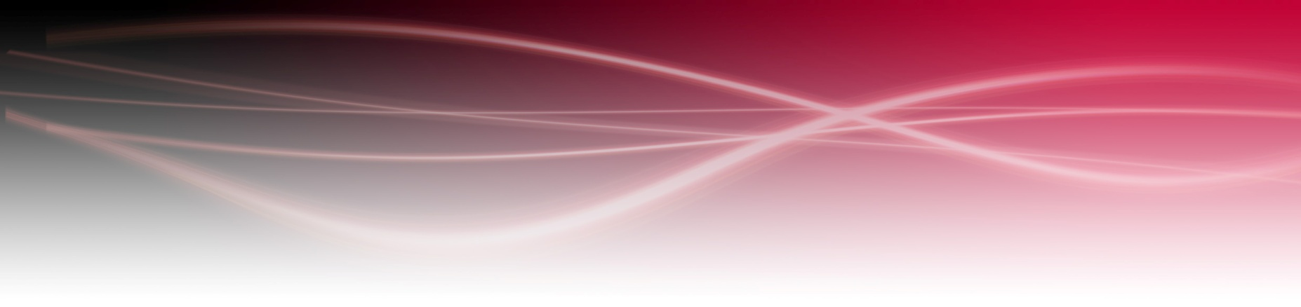
- Gown
- Plastic cape
- Towels

All protective clothing must be clean. The gowns must be washed after each client, as no one wants to smell the odour of the previous client, or the previous treatment on the gown they are wearing.

Positioning your Client

You will need to position your client correctly, ensuring client comfort throughout the service. You should instruct your client to sit upright with their legs uncrossed, as this could cause the end result to be unbalanced.

Your own posture and positioning is also important, to ensure that you are minimising the risk of injury to yourself and others. Avoid stretching over the client and work area distributing your weight evenly over both legs. Having good posture will help you work more efficiently and reduce the risk of becoming tired very quickly, also preventing long term damage to your muscles.

Keep area clean and tidy throughout the service

Keeping the work area clean and tidy at all times will ensure you will be able to access tools and products easily and without delay. You should always make effective use of your time by being organised and always plan ahead ensuring all products and equipment are set up prior to the service. This will show a good impression of professionalism and your client will be happy not to be kept waiting unnecessarily.

Safe working environment

All tools and equipment must be cleaned and sterilised in the correct way to avoid cross-infection and infestation. There are many different ways of sterilising products and you need to be aware of them all.

Sterilisation methods

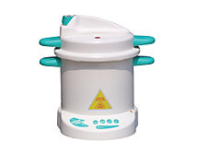
Moist heat (autoclave)

Moist heat is used in an autoclave, the distilled water inside is heated to a temperature of approximately 125º. This model is only used for small pieces of equipment which have been previously been cleaned in hot soapy water. The autoclave will sterilise hard rubber, such as vulcanized rubber combs, and small metal pieces of equipment such as scissors. This method will make your tools sterile, which means they are completely clean from all bacteria and will kill all living organisms.

Barbicide (Form of disinfectant)

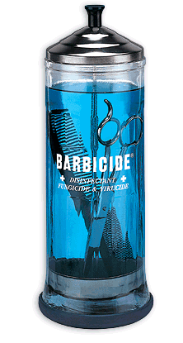

All tools must be cleaned with warm soapy water prior to using barbicide. Tools can then be immersed into the liquid for one hour to ensure that they are sterilized. This method is used to reduce the number of germs that may have built up on your tools.

Ultraviolet Light

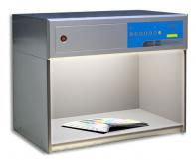

An ultra violet light (UV) cabinet uses UV rays to kill bacteria. This will only be effective if the tools are cleaned with warm soapy water prior to use. The UV light must reach all surfaces, therefore tools must be turned so that all sides are sterilised.

Hot Soapy Water.

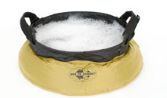
Use hot soapy water prior to immersing your tools into the barbicide. You can also wash your rollers in this after removing any loose hair.

Personal Hygiene

As you are working in close contact with your clients and colleagues, you must ensure that you smell clean and fresh at all times. Because clothing comes in close contact with the skin they must be changed on a daily basis. You should also bath or shower every day to remove any body odour. Always use an effective deodorant on clean skin. Brush your teeth at least twice a day and ensure your breath smells fresh. Hands are your tools and are in constant use and will carry bacteria. Wash them regularly and keep fingernails clean and free from sharp edges. By having good personal standards of health and hygiene you will be minimising the risk of cross infection, as well as giving a professional image and not offending your clients.

Basic styling techniques for women’s hair:
Blow drying (flat, root lift, movement), straightening, smoothing, curling (waves, curls), finger drying (natural look, spiky effect), hair up (plait, pleat, rolls, curls).

Range of tools, techniques, equipment and the effects achieved:

- Round brushes - (various diameters) gives curl ( smaller diameter-tighter curl), body, movement, volume.

- Flat brushes -such as a paddle or denman brush gives smooth straight finishes.

- Bristle brush- (such as an isinis brush) removes roller marks, dresses out hair, smooths the style, and gives shine it is also good for fine hair.

- Vent brush- produces a soft casual broken up effect, which is ideal for short hair.
- Straighteners – smooth’s and flattens the cuticle and straightens the hair.

- Curling Tongs – after blow dry firms curl, produces various sizes of curls, achieves lift and waves

- Finger dry- to dry short textured styles, natural effect.

- Rollers- cohesive or temporary heat moulding, firm/long-lasting effect

- Finger Waving – flat wave effect, produces fixed waves, good on short bob.

- Hair dryer – removes moisture from the hair.

- Diffuser- diffuses the flow of air, allowing hair to dry naturally, used on curly hair, increases curl, and adds volume, movement and body.

- Heated Rollers – always use on dry hair, they come in various sizes achieving lift, curl or bounce.

- Bendy Rollers – used on long hair, to achieve spiral effect curls.

- Velcro Rollers- produces body, curl movement, volume, and bounce. (Do not last long).

- Pin Curl Clips – there are three types of pin curls flat, coil and barrel curls. They produce movement, volume, curl and body.

- Hair Bands – secure long hair

- Pins/grips – secures long hair, criss-cross.
Techniques for dressing out hair:

- Firm brushing – blends, removes partings, softens stiffness caused by product, creates soft waves.
- Comb – used on straight flat styles, polished effect.
- Hands – tease, pull, push, and create.
- Backcombing/back brushing – aids hair up, base to pin, create lift/shape/form to style.

Range of styling products and when to use them:

Gel – wet look, ideal for spiky styles, apply to wet hair.

Mousse – gives hold/body, various hold strengths, apply to wet hair.

Blow dry lotions – protects hair from heat/humidity, apply to wet hair.

Moisturiser/oils – African type hair, conditioning, adds moisture, adds shine, use on dry hair.

Activators – activated by the use of heat, defines curl, adds moisture, shine, hold, ideal for dry sets, can use on wet or dry hair.

Heat protectors – coats hair, protective layer, gives shine/definition, apply prior to the use of all electrical equipment.

Serum – gives shine, adds moisture, ideal on chemically treated hair, can use on wet or dry hair.

The purpose of hair styling and finishing products, tools and equipment: Correct tools/equipment/ styling/finishing products means hair is easier to control, hair protected, style lasts longer, defines style.

Style women’s hair using basic styling techniques:
Straightening – section hair, work methodically, direct airflow away from root, stretch hair, round brush, smooth cuticle, no root lift, fully dry each section, allow to fix in new shape.

Smoothing – section hair, work methodically, direct airflow away from root, smooth cuticle, flat brush, no root lift, fully dry each section.

Curling – section hair, work methodically, round brush to create curl, large diameter = large curl, small diameter = small curl, direct airflow away from root, smooth cuticle, allow to fix in new shape.

Hair up:
Plait – individual, whole head, across front, half head.
Pleat – cone shape in nape of neck.
Rolls – large section of hair, backcombed, wound into roll, pinned.

Factors That Influence Styling

- Previous chemical services, percentage of white hair, client requirements, tools and equipment, presence of added hair, maintenance of styling suitability.

- Hair Condition – dry, greasy, normal, virgin, chemically treated, elasticity ( strength of hair), porosity ( damage to cuticle layer, the ability to absorb moisture)

- Hair cut/style – uniform layer, one length, short graduation, long graduation.

- Temperature – body heat, salon temperature, added heat

- Texture – fine, medium, coarse.

- Length – short, medium, long.

- Density – fine, medium, thick.

- Growth patterns – cowlick, widow’s peak, nape whorl, double crown, male pattern baldness.

- Skin tone – fair, medium, olive, dark.

- Face shape – oval, round, square, oblong, heart, pear.

- Head size – large, medium, small.

- Existing curl – tight, soft, wave.

- Lifestyle – job, family, financial, time.

- Test results – good, bad, caution, positive, negative.
THE BLOW DRY SERVICE

Once the hair has been shampooed, the desired style discussed and chosen, and any application of product applied to aid styling, you can start the blow dry service.

You should always ensure that the client is comfortable throughout the blow drying process and they are aware of how long the service will take. The blow dry service should be completed within a commercial viable time and this is usually 30-40 minutes, depending on the length, type, density and texture of the client’s hair.

- Ensure that that hair has been toweled dried, do not work on dripping wet hair.

- Apply styling aids such as mousse, blow dry lotions.

- Work on clean sections methodically.

- Move around the client, to ensure correct balance is achieved.

- In order to prevent burning your client’s skin and hair, causing the hair to become damaged or discoloured, keep the dryer off the hair and moving in the direction of the hair shaft. This will smooth the cuticle layer, giving a sleek, shiny finish. Always avoid excess heat.

- Don’t drop wet hair onto dry hair as this will make the sections you have dried flop and loose shape.

- Allow the hair to cool before adding finishing products and dressing out, as this fixes the style in place and prolongs the length of time the style will keep its shape.

