School of Hairdressing and Applied Therapies

Styling Women’s Hair
Evidence Workbook
UV30338
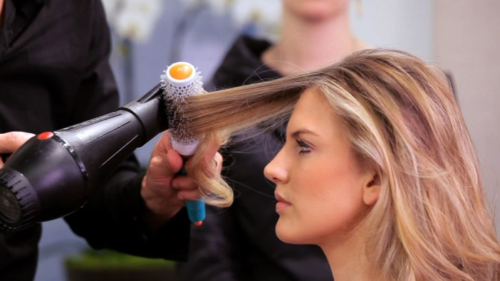
Question | √ or X | Competent/  Not yet  competent
Q1
Q2
Q3a
Q3b
Q3c
Q4
Q5
Literacy Alert:

Student Name:
Date issued:
Date handed in for marking:
Date of competence:

Tutor Signature & Comments:

- Identify the basic styling techniques for women.

- State the factors that may influence the choice of styling techniques for women.

- State the importance of the preparation procedures for styling women’s hair:
- Preparation of self:

- Preparation of client:

- Preparation of work area:

- State the purpose of hair styling and finishing products

Product | How would you use it? | Benefits of using this product
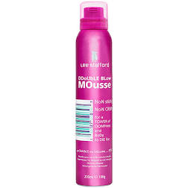

Mousse

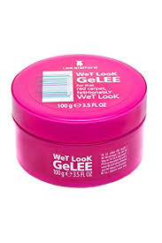 Gel

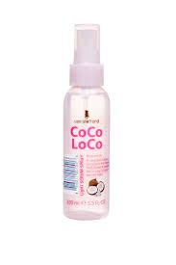

Serum

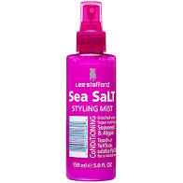 Blow dry lotion

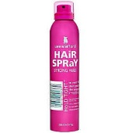Hairspray

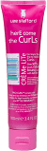 Activator

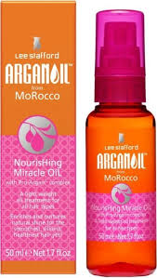

Moisturiser / Oil

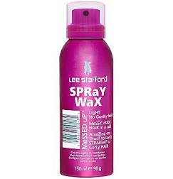
Wax spray

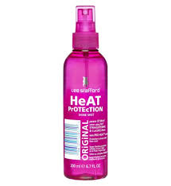

Heat protection spray

Tools and Equipment | Effect achieved when using this
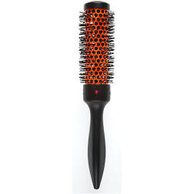

Round brush

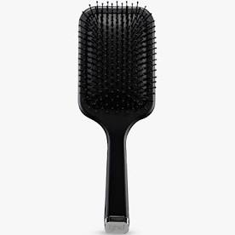

Paddle brush

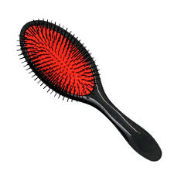

Isnis brush
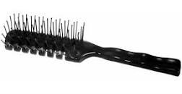Vent brush
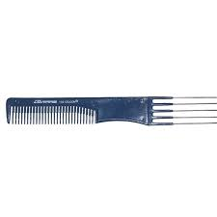 Lifter comb
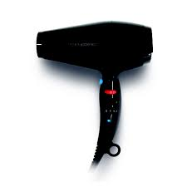 Hairdryer
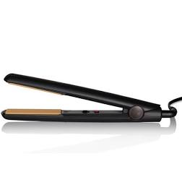
Straightening iron
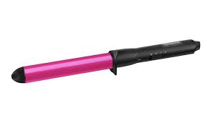Tong
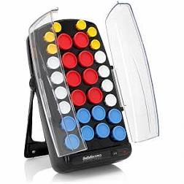 Heated rollers

Please use the grid below to correct any spelling mistakes identified within this workbook

Spelling mistake | Spelling correction

Please use the grid below to correct any grammar issues identified within this workbook

Grammar mistake | Grammar correction

