School of Hairdressing and Applied Therapies

UV10479 Create a Hair and Beauty image
Evidence Workbook
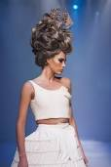
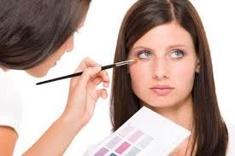
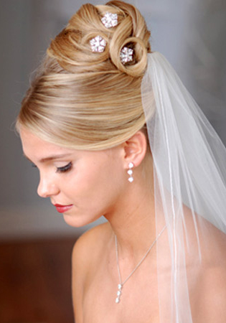

Question | √ or X | Competent/Not yet  competent
Q1
Q2
Q3
Q4
Q5
Q6
Q7
Q8

Student Name:

Tutor Signature & Comments:
Literacy Alert:
Date issued:
Date handed in for marking:
Date of competence:

- State the importance of developing an image

- Describe ways of effectively presenting a created image

- Outline the safety considerations that must be taken into account

- Access sources of information for creating an image

- Identify sources of information for creating an image

- State the importance of researching when developing a plan for creating an image.

- Prepare and develop a plan for creating an image.

- Describe how to develop a plan for creating a range of images

Please use the grid below to correct any spelling mistakes identified within this workbook

Spelling mistakes | Spelling correction

Please use the grid below to correct any grammar issues identified within this workbook

Grammar mistakes | Grammar correction

