

**School of Hairdressing and Applied Therapies**

**Follow Health and Safety Practice in the Salon**

**UV10477**

**Evidence Workbook**

|  |  |
| --- | --- |
| **Question** | **√ or X** |
| **Q1** |  |
| **Q2** |  |
| **Q3** |  |
| **Q4** |  |
| **Q5** |  |
| **Q6** |  |
| **Q7** |  |
| **Q8** |  |
| **Q9** |  |
| **Q10** |  |
| **Q11** |  |
| **Q12** |  |
| **Q13** |  |
| **Q14** |  |
| **Literacy alert** | |

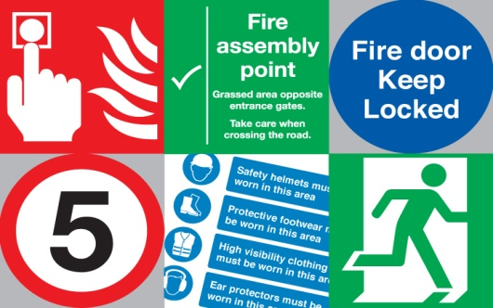

***Student Name:***

***Tutor Signature & Comments:***

**Hazards and Risks**

1. **Explain the meaning of the following:**

|  |
| --- |
| ***Hazard:*** |
| ***Risk:*** |

1. **List the 4 different types of Hazards**

|  |
| --- |
|  |

1. **Look at the list of situations. Decide which are hazardous and non-hazardous and put into the correct box.**

*Broken cuticle hoof stick, Loose tiles on the floor, Therapist wearing a face mask, Blocked fire exit, Electrical lead trailing across the trolley, Dirty cotton wool pads placed on the trolley, Therapist wearing heels, Puddle of water on the floor, Therapist wearing her tunic.*

|  |  |
| --- | --- |
| **Hazardous** | **Non-hazardous** |
|  |  |
|  |  |
|  |  |
|  |  |
|  |  |
|  |  |

1. **Identify the hazards and risks in the picture below**

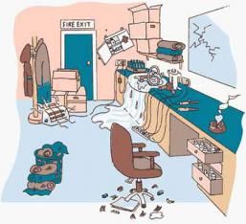

|  |
| --- |
|  |

**Health and Safety at Work**

**5. Health and Safety at Work Act is the main health and safety law. All employers have to make sure the salon is a safe place for you to work.**

**List the different Employers’ responsibilities below**

|  |
| --- |
|  |

1. **Describe how to dispose of different types of salon waste?**

|  |
| --- |
|  |

**COSHH**

1. **Complete the table below by writing in what the hazard symbols mean.**

|  |  |  |
| --- | --- | --- |
|  |  |  |
|  |  |  |
|  |  |  |
|  |  |  |

**Emergency and Accidents**

1. **Where are firefighting equipment kept?**

|  |
| --- |
|  |

1. **What type of fire are the following fire extinguishers used for?**

|  |  |
| --- | --- |
| **Water** |  |
| **Powder** |  |
| **Carbon Dioxide** |  |
| **Foam** |  |

**Add an image of these extinguishers.**

1. **State the procedure for dealing with accident/emergencies when working in a salon?**

|  |
| --- |
|  |

1. **State the colleges’ evacuation procedure in an emergency.**

|  |
| --- |
|  |

**Good Posture and Manual Handling**

1. **How would you recognise good posture and why is this important for salon work?**

|  |
| --- |
|  |

1. **How should you lift a heavy object?**

|  |
| --- |
|  |

1. **Insert a √ or × in the box next to each picture.**

[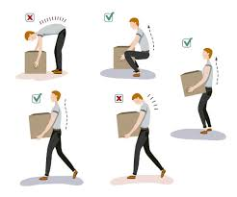](https://www.google.co.uk/url?sa=i&rct=j&q=&esrc=s&source=images&cd=&cad=rja&uact=8&ved=2ahUKEwjFq_PCgqjjAhWwz4UKHV_SBEEQjRx6BAgBEAU&url=https://www.trainingpartners.co.uk/manual-handling&psig=AOvVaw3h2hCsWWK0RZ-RRQunQLxJ&ust=1562767942168455)