School of Hairdressing and Applied Therapies

VTCT Level 2 Award in Preventing Contact Dermatitis

Unit: UV20556
Contact Dermatitis Prevention
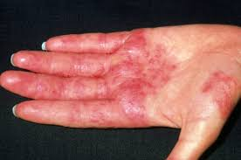
Question | √ or X | Competent/Not yet  competent
Q1
Q2
Q3
Q4
Q5
Q6
Q7
Q8

Student Name:
Date issued:
Date handed in for marking:
Date of competence:

Literacy Alert:
Tutor Signature & Comments

School of Hairdressing and Applied Therapies

- Define contact dermatitis.

- Identify the early and developing signs and symptoms of contact
dermatitis.
Early signs:

Developing signs:

- State the causes of irritant and allergic contact dermatitis.
Irritant contact dermatitis:

Allergic contact dermatitis:

- Describe what is meant by wet work and list the tasks associated
with wet working.

List the tasks associated with wet work:

- State how the skin is exposed to substances.

- Outline the relevant health and safety legislation.

- State employee and employer health and safety responsibilities.
Employee:

Employer:

- Describe the steps to prevent contact dermatitis.

School of Hairdressing and Applied Therapies

Please use the grid below to correct any spelling mistakes identified within this workbook

Spelling mistake | Spelling correction

Please use the grid below to correct any grammar issues identified within this workbook
Grammar mistake | Grammar correction

