School of Hairdressing and Applied Therapies

Introduction to the Hair & Beauty Sector
UV10343
Evidence workbook
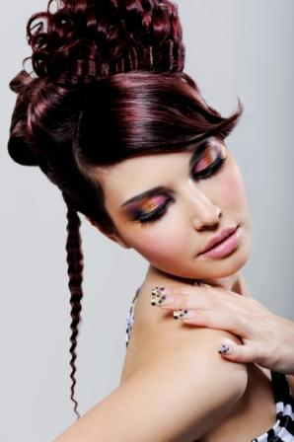
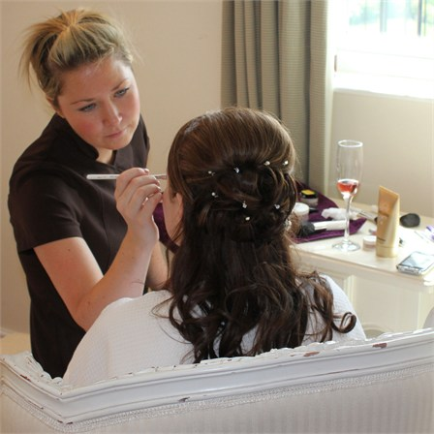

Student Name:
Question | √ or X | Competent/Not yet  competent
Q1a
Q1b
Q1c
Q1d
Q2a
Q2b
Q2c
Date issued:
Date handed in for marking:
Date of competence:

Tutor Signature & Comments:
Literacy Alert:
Know the career opportunities and working patterns within the hair and beauty sector
Outcome 1

Identify the occupational roles in the hair and beauty sector and give a brief description of each.

- Outline working patterns in the hair and beauty sector.

- Identify the main career opportunities available in the hair and beauty sector and related industries.

- List examples of sources of information on training and career opportunities in the sector.

Outcome 2
Know the main hairdressing services and beauty treatments

a. Identify different types of salons and the types of client they attract.

b. Outline the main hairdressing services offered by salons.

c. Outline the main beauty treatments offered by salons.

Please use the grid below to correct any spelling mistakes identified within this workbook

Spelling mistake | Spelling correction

Please use the grid below to correct any grammar issues identified within this workbook

Grammar mistake | Grammar correction

