Date:
Name:

Rate your resilience skills

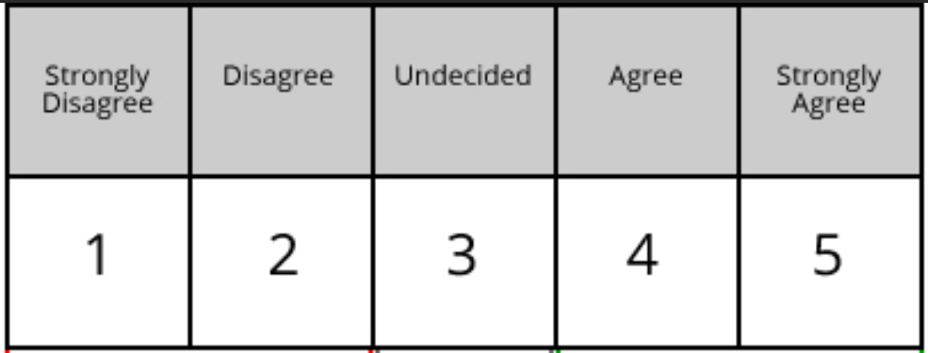

I am a good listener ………………

I am a good problem solver ………………

I am good at managing my emotions ………………

I am good at working with other people ………………

I am good at accessing help ………………

