School of Hairdressing and Applied Therapies

Level 1 Hairdressing and Beauty Therapy

Unit UV10416 – Providing Basic Manicure Treatment
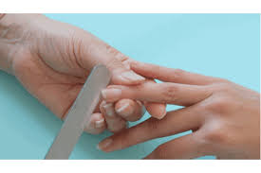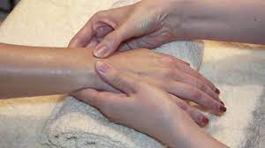

Workbook
Name:

Group:

Tutor Comments:

Date of completion:

Tutor signature:

Question | √ or X
1.
2.
3.
4.
5.
6.
7.
8.
9.
10.
Literacy alert:

1. Label the diagram of the nail.

2. What are the factors that affect nail growth?

Factors affecting the growth of the nail

3. State the salons requirement for preparing yourself, the client and work area for treatment.
Preparing yourself –

Preparing the work area –

Preparing the client –

4. List the contra indications that prevent and restrict a manicure treatment.
Prevent | Restrict

5. State the importance of carrying out a visual study of the hands and nails to identify factors that will influence the treatment.
Importance -

Nail assessment –

Hand assessment –

6. State the reason for the use of the following products.
Product | Reason for Use
Nail enamel remover
Sanitiser/surgical spirit
Cuticle massage cream
Hand soak
Hand cream
Buffing paste
Base coat
Top coat
Coloured nail polish
Nail strengthener

7. State the correct use of the following tools.
Tools | Correct Use Of Tool
Emery board
Spatulas
Hoof stick
Buffer

8. Identify the correct nail shape. Put the correct nail shape in the box.
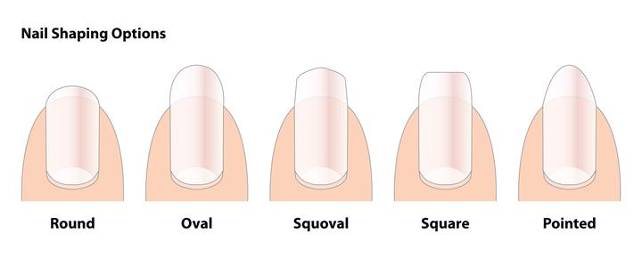
Nail Shape | Description
 | Not usually recommended, as this is a weak shape, prone to breakage. It is most suitable for special occasions.
 | This is one of the most popular manicured shapes. The nail is slightly rounded at the edges and then filed straight across the top.
 | This shape is usually most suitable for manual workers or clients who do a lot of work with their fingertips, for example pianists or typists.
 | This shape is good for clients who work in positions where nails should be short and neat, for example nurses and beauty therapists.
 | This shape can appear to lengthen the fingers for a more elegant appearance. It is usually suitable for small hands.

9. State possible contra-actions to treatment and how should you respond.

10. List the recommended homecare advice.

