The Alternator
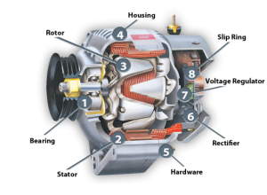

The alternator converts / Mechanical to Electrical Energy
It has 2 main functions
1 Supplies electrical energy to all electrical components when the vehicle is running
2 Charges the battery back up to ensure sufficient voltage is present to start the car from stop.

The alternator generates AC (Alternating Current) when it produces energy and this is converted by numerous diodes found at the back of the alternator into DC or (Direct Current) This process is called rectification.

