Retired On-Screen test – 18 questions

Question 1

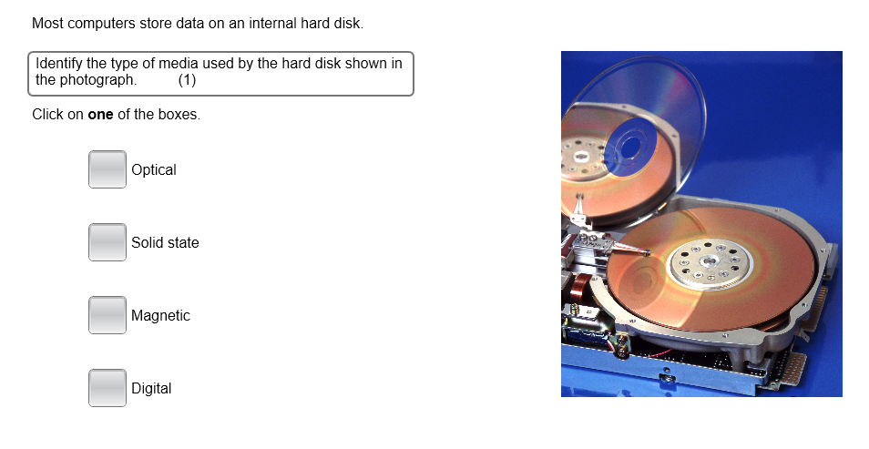
Most computer store data on an internal hard disk.

Identify the type of media used by the hard disk show in the
photograph. (1)

Make the correct answer bold.

Optical

Solid State

Magnetic

Digital

Question 2

Computer data is represented using binary notation.

- Select the binary representation with a value of 9. (1)

Make the correct answer bold.

01010011 00001001 10000001 00110000

- Identify the base 10 number represented by 00000111. (1)

Make the correct answer bold.

1 2 3 4 5 6 7 8 9

Question 3

A geography teacher has decided to create some resources to help her students revise for their exams. She has decided to create a series of podcasts.

- Name the input device that would be essential for the teacher to create the podcasts. (1)

Type your answer in the space below.

- Name the output device students would need to use the podcasts for revision. (1)

Type your answer in the space below.

Question 4

The table shows part of a school’s database.
The database is used to store details of students.

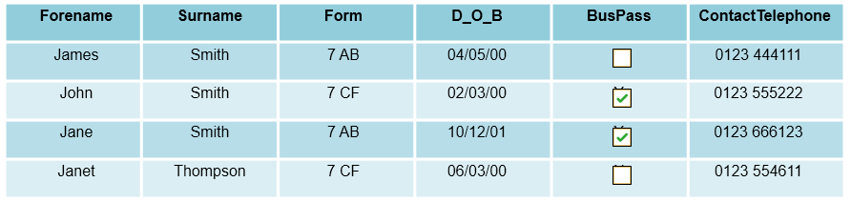

- Identify the correct data type for the BusPass field. (1). Make the correct answer bold.

Boolean String Integer Character

- Identify the correct data type for the ContactTelephone field. (1). Make the correct answer bold.

Boolean String Integer Character

Question 5

Computer software can be custom-made to suit a client’s exact requirements or it can be purchased from retailers ‘off-the-shelf’.

Identify two advantages of purchasing ‘off-the-shelf’ software. (2)
Make the choices bold.

It will provide a competitive advantage

It is available immediately

There will be no licensing costs

It will be updated when user needs change

Product support will be readily available 24/7

Question 6

The diagram illustrates the main internal components of a computer system.
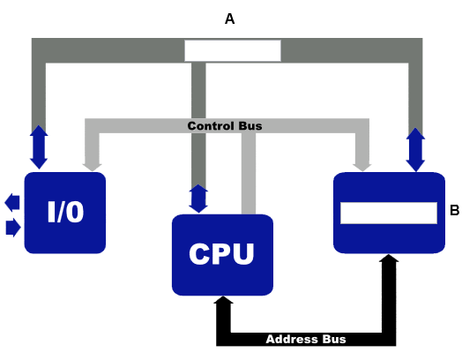
- Identify the missing components (2).

A =

B =

- State the purpose of the Address Bus. (1)

Type your answer in the space below.

Question 7

One role of the operating system is to manage system security.
The animation shows a utility feature of an operating system.

- Identify the utility feature shown in the images below. (1)
Enter your answer in the space below.

- Explain the process carried out by the utility feature shown in the images below. (2)
Enter your answer in the space below.

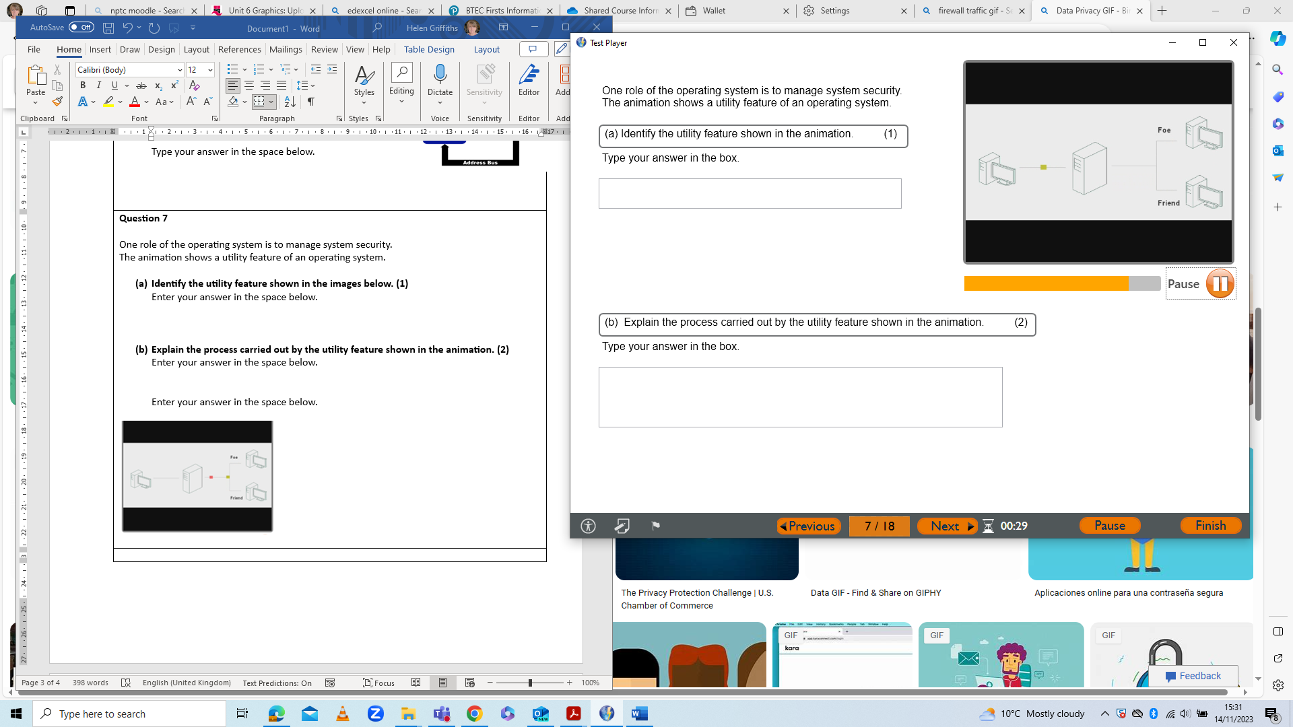
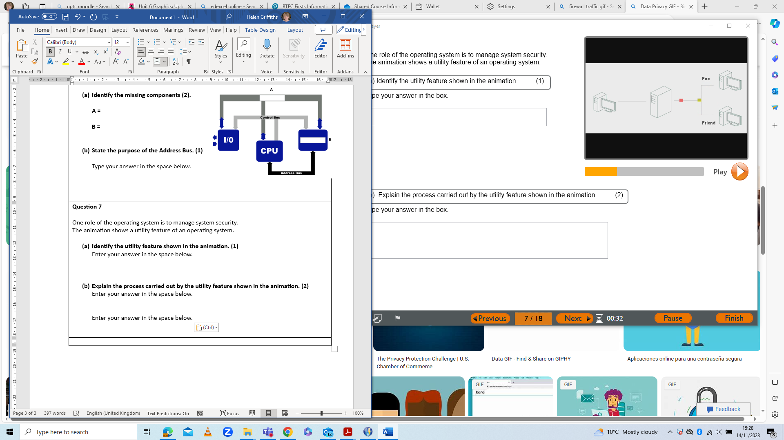

Question 8

All program code must be translated into machine code before it can be run.

- Identify the software that is used to translate source code into machine code. (1)

Make the correct answer bold.

Convertor Loader Compiler Generator

This is an example of annotated source code.
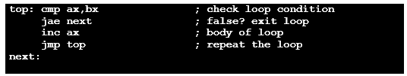
- Identify the type of language that has been used to produce the source code. (1)

Make the correct answer bold.

Procedural language Imperative language

Assembly language Visual language

Question 9

Scott runs an online business and wants to provide his customers with up to date pricing information on his products.

- Identify the software application that Scott would use. (1)

Make the correct answer bold.

Web-authoring software DTP software

Presentation software Graphics software

Scott uses his laptop to calculate sales figures and discounts for special offers.

- Which application should Scott use to carry out calculations? (1)

Make the correct answer bold.

Email software Word processing software

Database software Spreadsheet software

Question 10

Jane is considering buying a new smartphone.
She has narrowed down her options to three phones that are similarly priced.
The table shows an extract from the specifications for each of the smartphones.

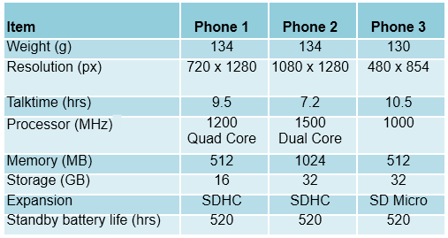

Phone 2 has less talktime than phone 1 or phone 3.

Explain one reason why the specification of phone 2 limits talktime. (2)

Type your answer in the space below.

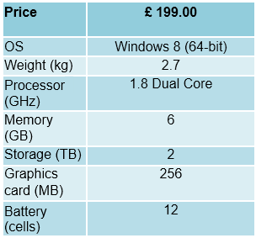
Question 11

Ali is a media studies student and has to create
and work with large image and video files.
She has £200.00 to spend and is looking at a
laptop.
The specification of the laptop is shown.
Ali decides not to buy the laptop.

- Identify two problems with the laptop
specification that led to Ali’s decision. (2)

1.

2.

- State one benefit of a 64-bit operating system. (1)
Type your answer in the space below.

Question 12

The features of computer memory can affect performance and user experience.
The diagram shows the location of different types of memory.

- Complete the diagram with the correct memory types by typing the correct term into the empty boxes.

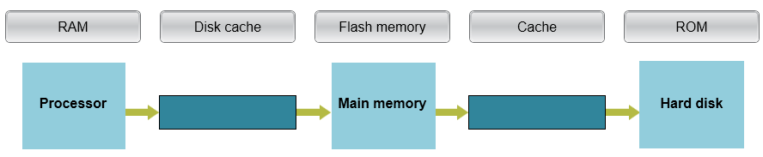

- Identify the type of memory that is non-volatile. (1)

Make the correct answer bold.

Cache RAM ROM Disk cache

Question 13

An operating system is the layer of the software that links the user with the components of a computer.
The operating system must manage the computer’s resources.

- Explain the role of the operating system in managing resources for multi-programming. (2)

- Explain the role of the operating system in memory management. (2)

Question 14

Sian is designing a program for a pupil reward system.
The issue of rewards will be based on positive (P) and negative (N) behaviour points.
The flowchart shows the decisions that need to be made.
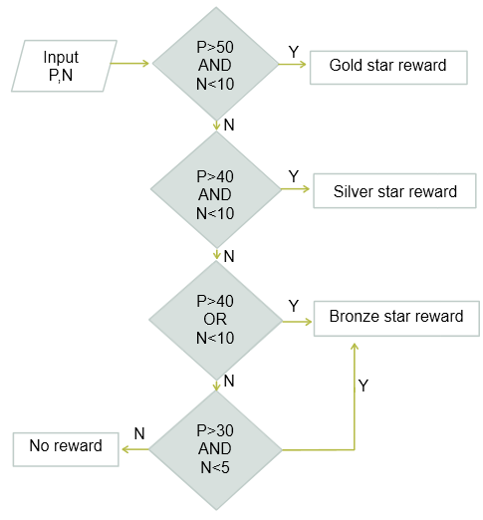
Enter the correct outputs in the table. (2)

 | P | N | Output
1 | 55 | 15
2 | 35 | 10

Question 15

This is a design for a program that sorts two numbers into descending order.
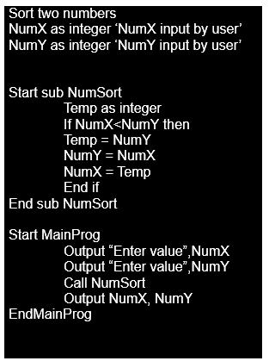
- Explain the process carried out by the
selection statement in the sub-routine. (2)

‘Temp’ is an example of a local variable.

- Explain one reason why it is good practice
to use local variables. (2)

Question 16

In addition to a smartphone, Ella has a laptop computer and a desktop PC at home.
She accesses her calendar on all three devices.

- Name the process used to keep Ella’s calendar up to date on all three devices. (1)

Ella also owns a mobile Wi-Fi device which she uses with her laptop.
- Explain one advantage to Ella of using a mobile Wi-Fi device. (2)

Question 17

Computer programs can be written in different types of high-level language.
Here is an example of program code written in an event-driven language.

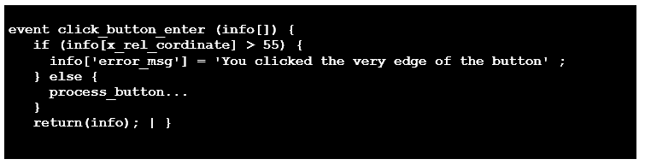

Explain one advantage of using programs written in an event-driven language. (2)

Question 18

An education and training centre is considering extending its computer network.
The extended network needs to support administration, marketing and management functions in addition to training.
The new network facilities could be cabled or wireless.

Discuss whether the centre should install a cabled or wireless extension to its network. (8)

