



Retired Onscreen Test Version 1 Unit 2: Technology Systems

BTEC Firsts Level 1/2 Information and Creative Technology

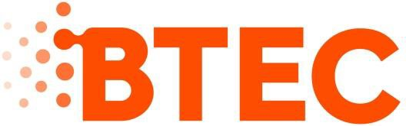**Introduction**

This retired onscreen test has been made available to centres to help you prepare your learners for their BTEC Firsts Level 1/2 external assessments.

We recommend that you use this test as a written assessment

which is then either teacher marked or peer assessed.

This retired test should be used in conjunction with the Mark Scheme and the Lead Examiner’s Report to clearly identify the assessment requirements. These documents are available at:

https://qualifications.pearson.com/en/qualifications/btec- firsts/information-and-creative-technology-2012- nqf.coursematerials.html#filterQuery=Pearson- UK:Category%2FExternal-assessments

**Retired Test Development**

We are currently working towards a simulation test where

mock onscreen tests can be taken in a real environment. However as this is being developed, we have temporarily created these PowerPoint based tests to support you.

**FAQs**

# How can I view the videos in the test?

This document has been produced using screen captures of the retired onscreen test. As such, videos are not available in this PowerPoint document. This document should be used in conjunction with the retired onscreen test which is available on the website:https://qualifications.pearson.com/en/qualifications

/btec-firsts/information-and-creative-technology-2012- nqf.coursematerials.html#filterQuery=Pearson- UK:Category%2FExternal-assessments

# How can I see the drop down menus in the test?

Where a drop down menu may obscure information the learner requires to answer a question, we have instead supplied a text box containing the options from the drop down menu.

To view drop down menus please use the retired onscreen test.

**Question 1/18**

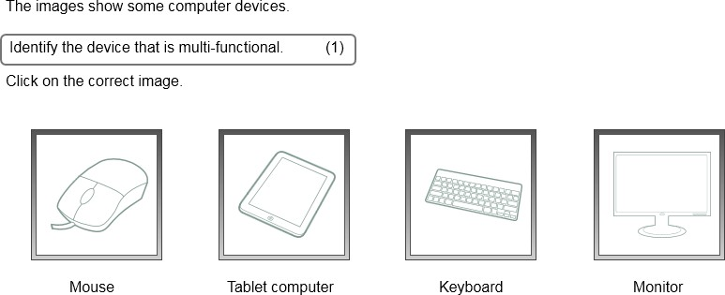

**Question 2/18**

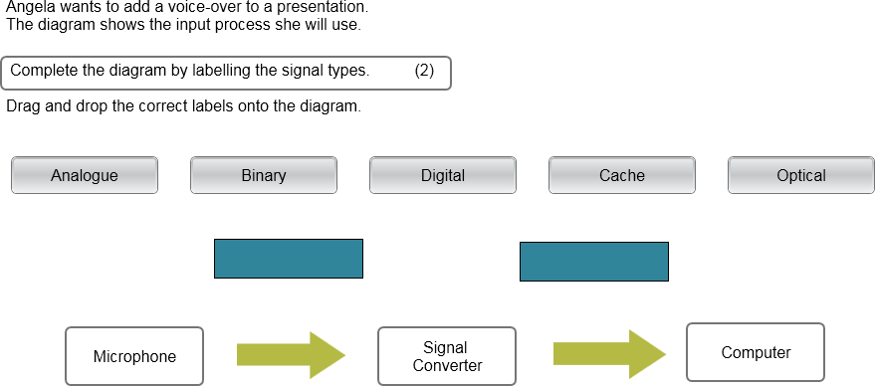

Type here

Type here

**Question 3/18**

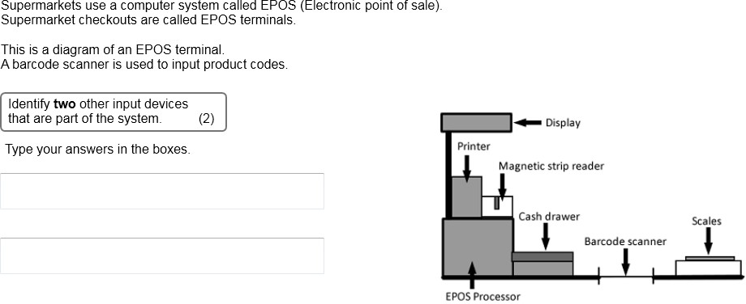

Type here

Type here

**Question 4/18**

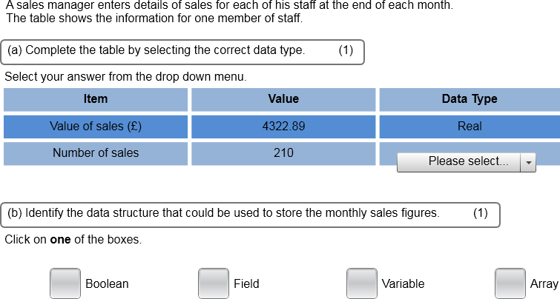

Enter the correct data type.

Put a cross in the correct box.

**Question 5/18**

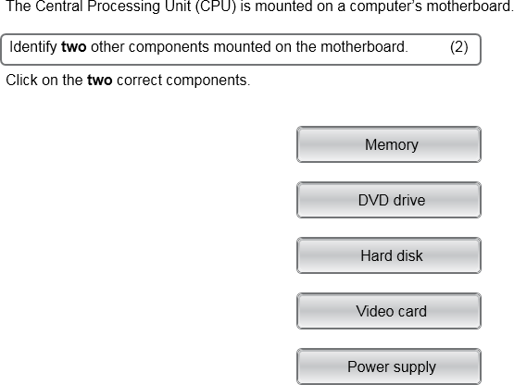

Use the pencil tool (shapes) to select two answers.

**Question 6/18**

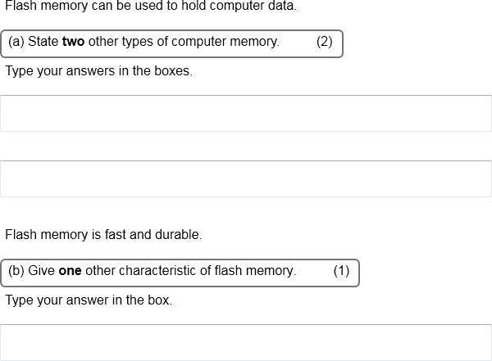

**Question 7/18**

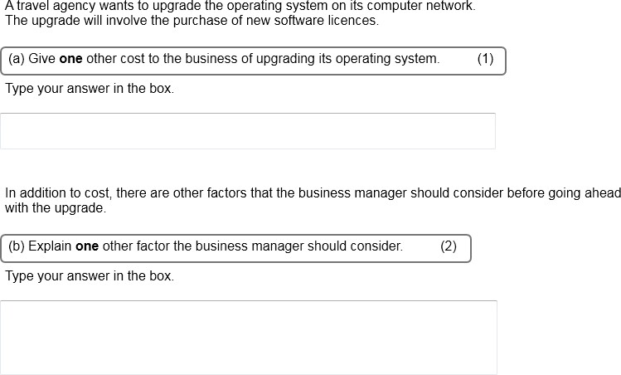

**Question 8/18**

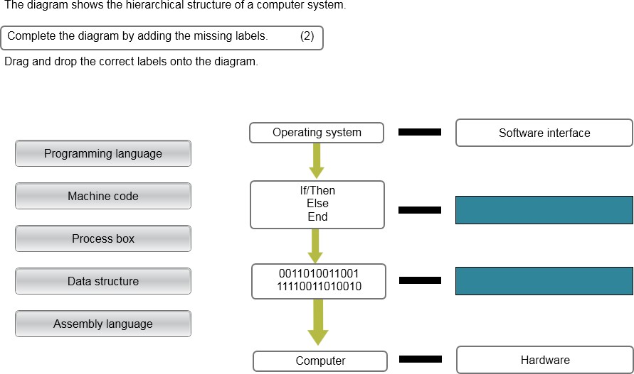

**Question 9/18**

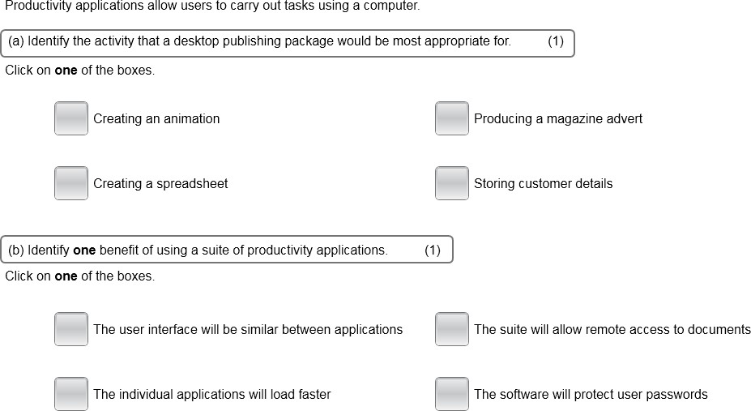

Use the pencil tool to tick a box.

Use the pencil tool to tick a box.

**Question 10/18**

.

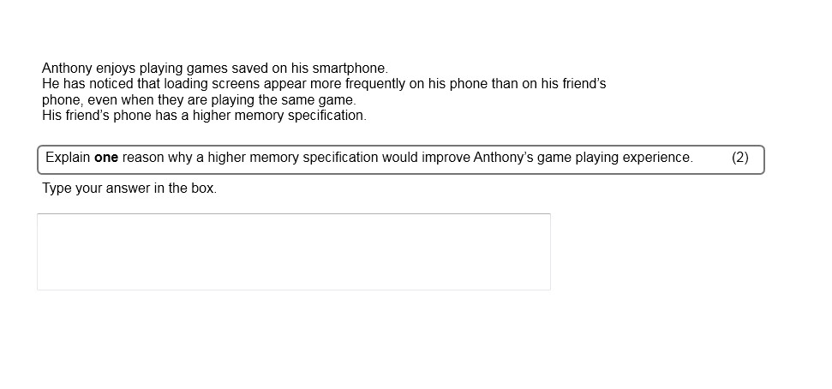

**Question 11/18**

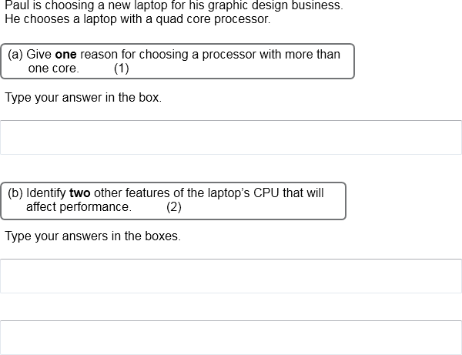

**Question 12/18**

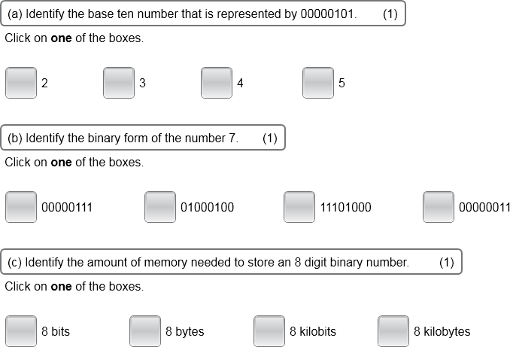

Use the pencil tool to tick a box.

Use the pencil tool to tick a box.

Use the pencil tool to tick a box.

**Question 13/18**

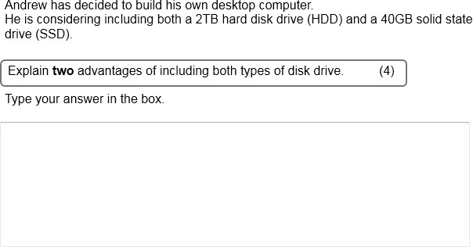

**Question 14/18**

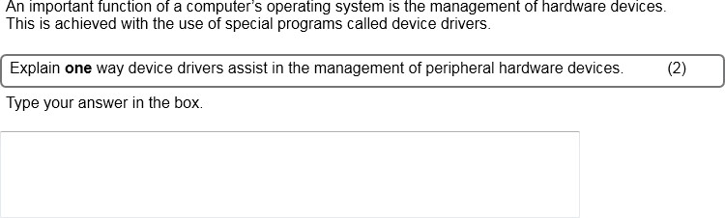

**Question 15/18**

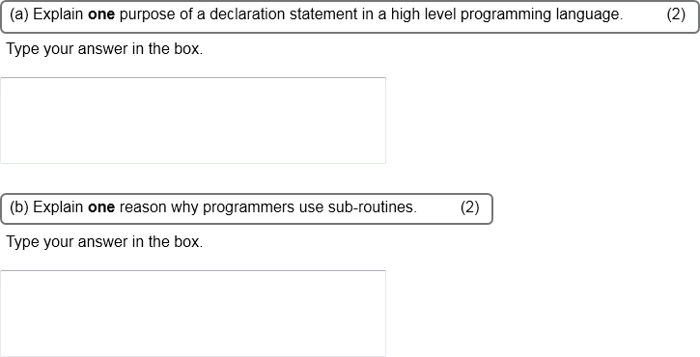

**Question 16/18**

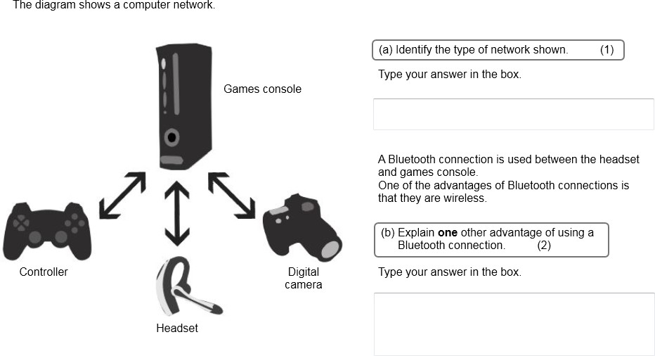

**Question 17/18**

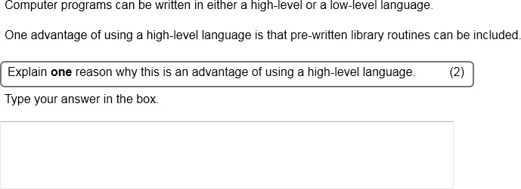

**Question 18/18**

