Electric Cars: All the advice you need to make an informed decision (electriccarhome.co.uk)

What will the learner study as part of this qualification?
The content of this qualification has been designed to give the learners the knowledge required to work safely around electric/hybrid vehicles. It contains one mandatory unit covering:
- the types of electric/hybrid vehicles available
- hazards associated with motor vehicle high energy electrical systems
- working safely around electric/hybrid vehicles including charging
As a result, learners successfully completing this qualification will acquire significant core knowledge of working safely around, but not maintain electric/hybrid vehicles.
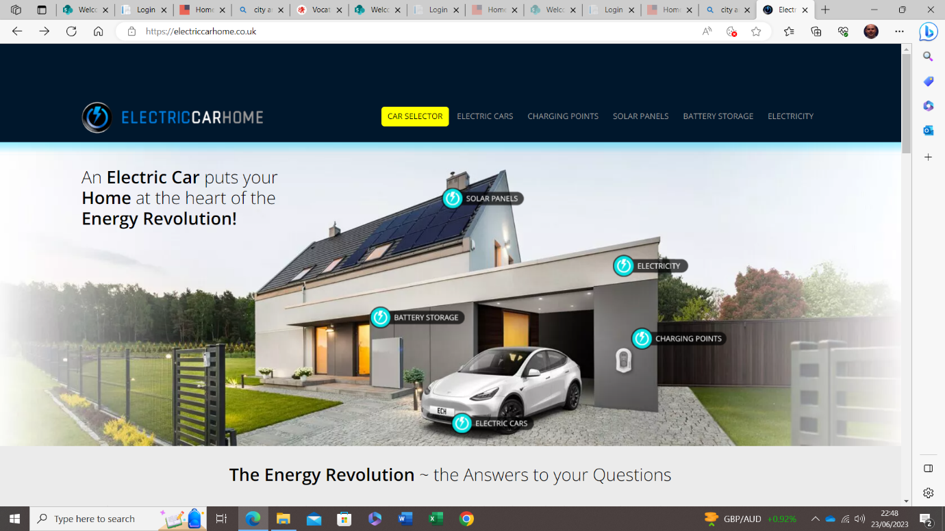

BEV, PHEV, HEV, ICE – what on earth do they mean?
The terms BEV, PHEV, HEV and ICE were created by clever people just to confuse you.
So what is a BEV? What does PHEV stand for? Our job is to explain the terminology in simple terms.
You’ll notice the first three acronyms – BEV, PHEV and HEV – all have ‘EV’ in them. EV stands for ‘Electric Vehicle’. So, BEV, PHEV and HEV are all types of electric vehicle, although some much more than others, as we will discover.
ICE is the odd one out. It’s the ‘Internal Combustion Engine’. Read on…

What they all stand for
EV glossary: All the electric vehicle lingo you need to know | Digital Trends

1 BEV = Battery Electric Vehicle
1.1 Examples of BEVs

2 PHEV = Plug-in Hybrid Electric Vehicle
2.1 Examples of PHEVs

3 HEV = Hybrid Electric Vehicle
3.1 Examples of HEVs

BEV = Battery Electric Vehicle
A BEV is a Battery Electric Vehicle
Here’s the logic:
- Battery = B
- Electric Vehicle = EV
- Battery Electric Vehicle = BEV

So a BEV is an electric vehicle powered by a large battery. If it were powered by milk, it would be a MEV. Got it?
An important additional point:
BEVs are only powered by a battery. There are no other ways of making them go.
For example, they don’t have a little diesel or petrol engine you can fall back on if your battery runs flat.
A BEV is basically a 100% pure electric car. For the true believers.

Examples of BEVs
- Audi Q8 e-tron
- Hyundai Ioniq 5
- Tesla Model 3
- Polestar 2
- Volkswagen ID.3
- Kia EV6
- Mini Electric
- MG ZS EV
- Tesla Model Y
- Renault Zoe
- Hyundai Kona Electric
- Kia Niro EV

Charging An Auxiliary EV / Hybrid 12v Battery

Video examples
https://youtu.be/2RHyTHy1skw?si=p9mvJHXnXKCvd12E

https://youtu.be/wiBi6WneUdI?si=80oLZQLLMuAk4faK

Electric Vehicle Dashboard Warning Lights & Colours

Video https://youtu.be/klJhVXjjcQQ?si=biPsx0ANDgwL7-qT

Want to see the full list of BEVs on offer in the UK? Check out our page on All Electric Cars for Sale.

The Renault Zoe is a BEV
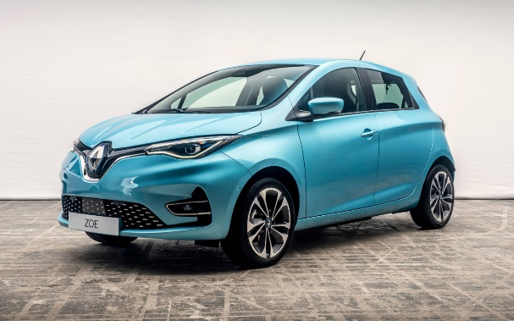

Charging cables
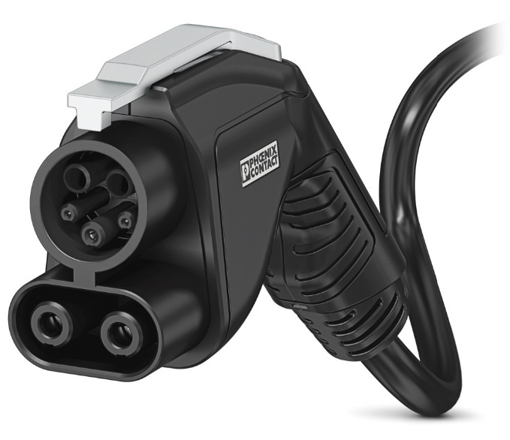
This is a type 2 charging cable. This is by far the most common design on the market.

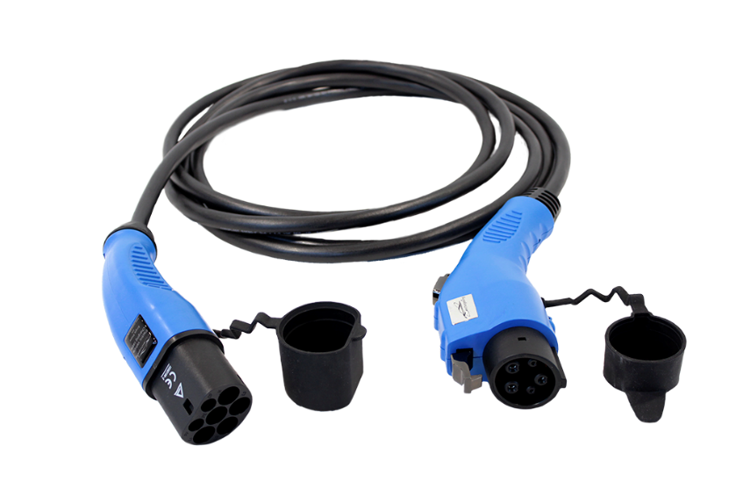
This is the older type 1 charging cable.
In most cases, an adapter can be purchased to convert to a type 2 design.

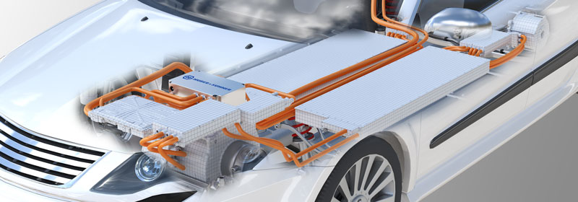
High Voltage Electrical Cables
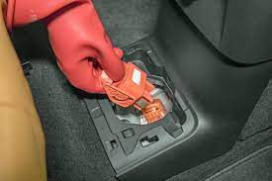
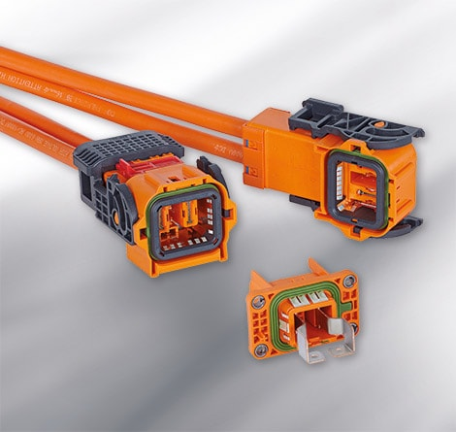

The cables are bright orange in colour, and they are constructed to be very resilient in case of an accident.
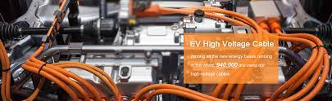

High Voltage Battery Isolator Plugs

These are the connectors Technicians remove correctly to isolate the high voltage from leaving the battery and travelling to the vehicles electric motor.

*** Workshop Demonstration, the correct procedure to isolate an EV or Hybrid vehicle.
Workshop Safety Signs
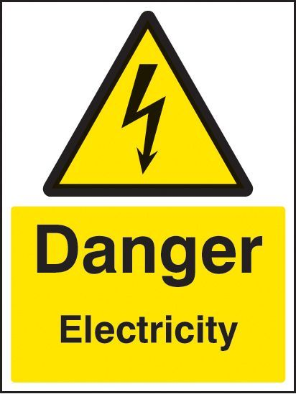
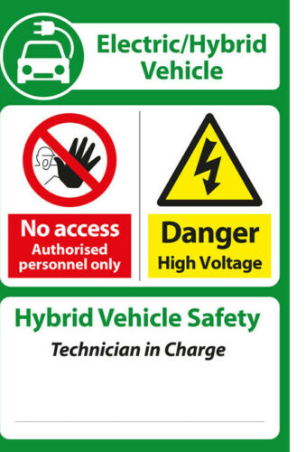

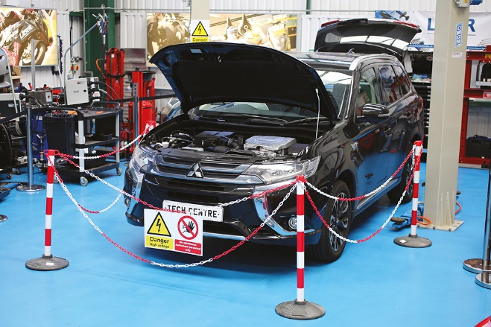

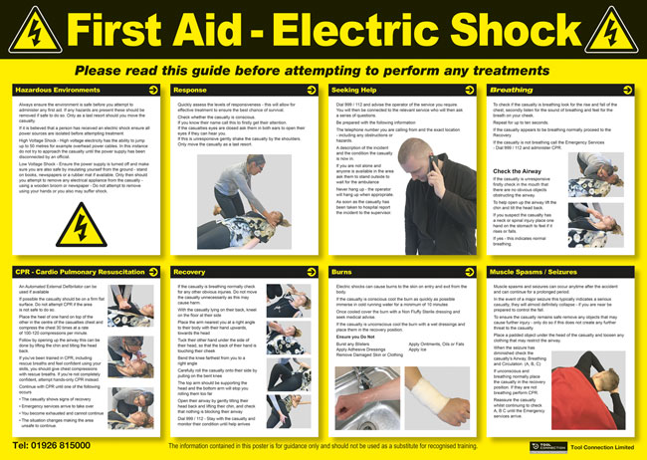

Electric Vehicle Specialist Tools and Equipment
Grade 0 Electrical insulated high voltage safety gloves.
Date opened should be written in on the glove. They need to be tested for conformity every time they are used, and as a rule replaced yearly.

Leather over gloves are worn over the grade 0 rubber gloves to give the rubber gloves protection from sharp objects when working on a vehicle.

Tools used to work on EV systems

Multi Meter cat 3 1000v min

The Hybrid / Electric Car Amprobe is a CAT III safety rated, auto ranging digital multimeter designed for automotive diagnostics and electrical troubleshooting. Whether your shop services automotive, fleet, motorcycle, marine or small engine, the Amprobe 37XR-A has the capability to keep up with your business.
Hybrid electric vehicles have high-voltage components. Use this tool on hybrid vehicles only if:
You are trained in high-voltage electrical system repair on hybrid electric vehicles.
You have read and follow the OEM manufacturers approved hybrid electric vehicle service procedures due to the high voltages in hybrid vehicles
You are using the CAT III / 1000V rated leads included with this kit.
You are wearing proper protective gear, including Class 0 Type 1 electric service gloves that are free from defects/faults and that meet ASTM D120 standards and protect up to 1000 Volts AC / 1500 Volts DC.

EV Socket set and hand tools
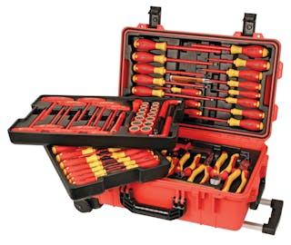
All tools have a high level of insulation. Correct gloves and isolation procedures must be followed at all times.

If in doubt regarding the isolation of the high voltage battery, manufacture instructions should be followed at all times.
When testing for voltage at the inverter, no work should be carried out until 0 volts is present.

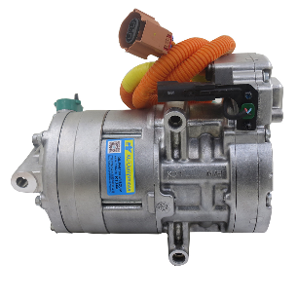
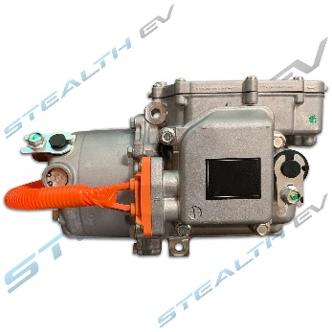
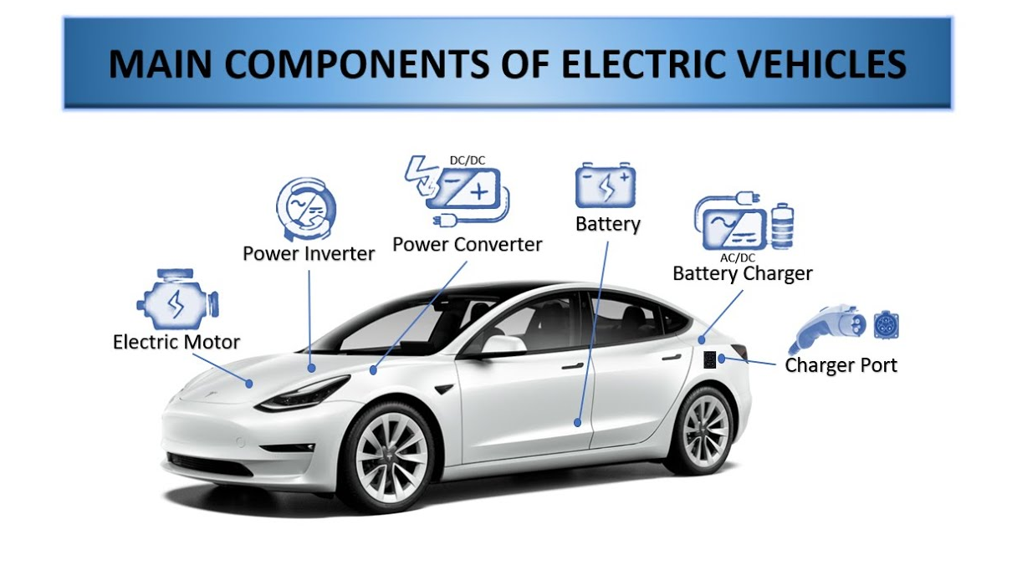
Air Conditioning Compressor
On EV the Air conditioning runs of the high voltage system. When working on this AC system, you must follow manufacturers guidelines to isolate the high voltage the system is followed and the car safe to work on.

Electric vehicles consists of an electric motor that is powered by a battery pack. The main advantage of electric vehicle components is that they emit zero emissions and are eco-friendly. They also do not consume any fossil fuels, hence use a sustainable form of energy for powering the car. The main components of electric vehicles are :
- Traction battery pack
- DC-DC Converter
- Electric motor
- Power inverter
- Charge Port
- Onboard charger
- Controller
- Auxiliary batteries
- Thermal system (cooling)
- Transmission

1. Traction battery pack – Lithium Ion Battery https://youtu.be/00eEj_EgMas
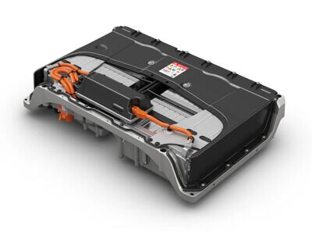
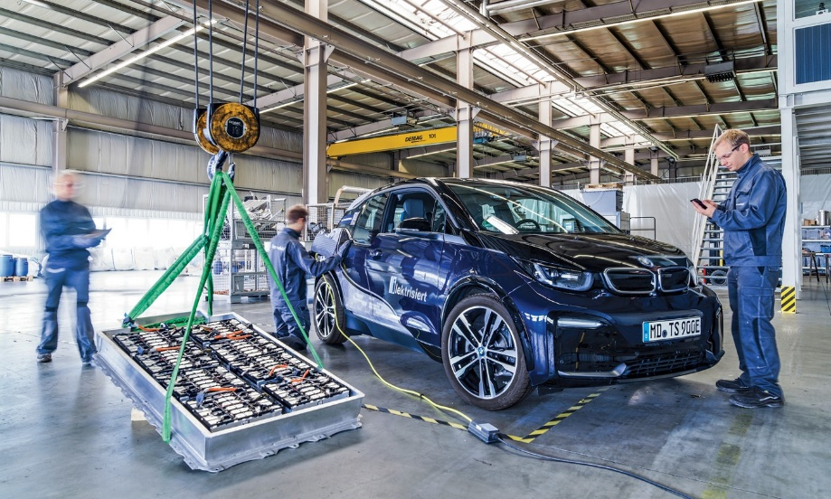
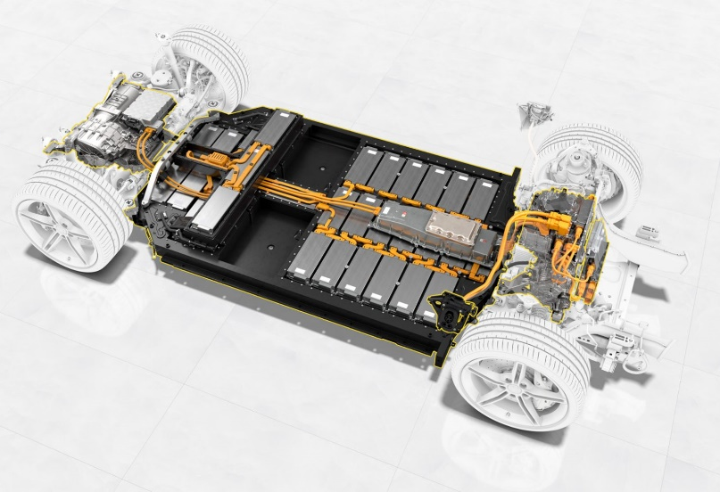
Traction battery pack is also known as Electric vehicle battery (EVB). It powers the electric motors of an electric vehicle. The battery acts as an electrical storage system. It stores energy in the form DC current. The range will be higher with increasing kW of the battery. The life and operation of the battery depends on its design. The lifetime of a traction battery pack is estimated to be 200,000 miles.

2. DC-DC Converter
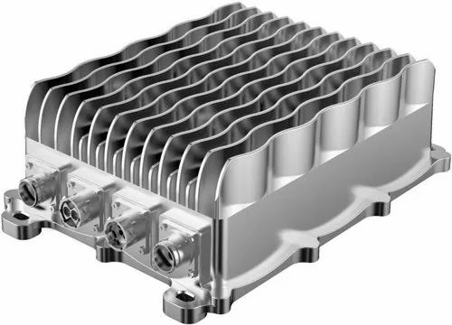
The traction battery pack delivers a constant voltage. But different components of electric vehicle has different requirements. The DC-DC convertor distributes the output power that is coming from the battery to a required level. It also provides the reduced lower voltage required to charge the auxiliary battery.

3. Electric motor
Electric traction motor is the main components of electric vehicles. The motor converts the electrical energy into kinetic energy. This energy rotates the wheels. Electric motor is the main components of electric vehicle that differentiates an electric car from conventional cars. An important feature of an electric motor is the regenerative braking mechanism. This mechanism slows down the vehicle by converting its kinetic energy into another form, and storing it for future use. There are basically two types of motors DC and AC motors.
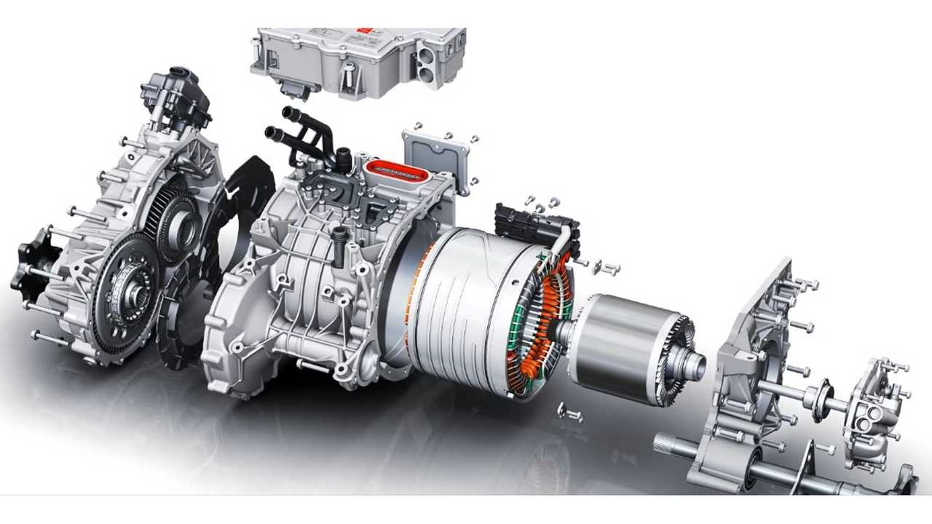
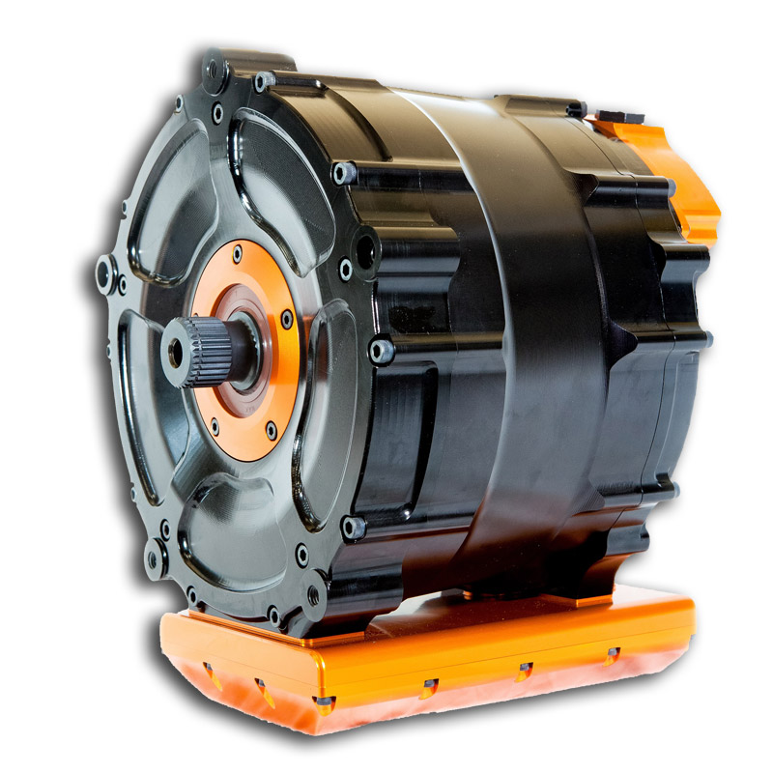
Related article Video
Detailed working of an electric motor

Power Inverter

The EV inverter plays a vital role in the EV powertrain. It’s responsible for converting the DC voltage from the battery pack to the AC voltage required to power the electric motor. The inverter also controls the speed and torque of the motor, which affects the vehicle’s acceleration, top speed, and overall driving performance.
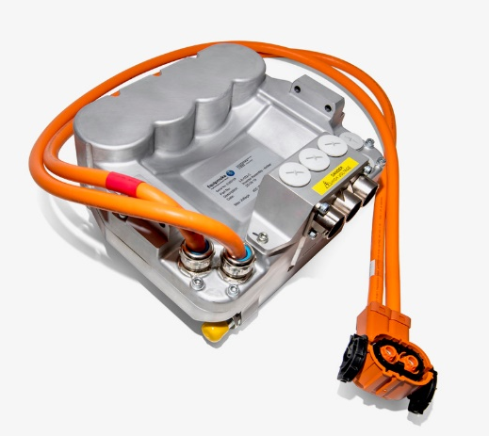
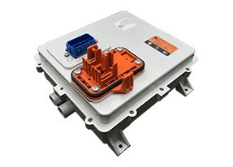

5. Charge Port
The charge port connects the electric vehicle to an external supply. It charges the battery pack. The charge port is sometimes located in the front or rear part of electric vehicle components.
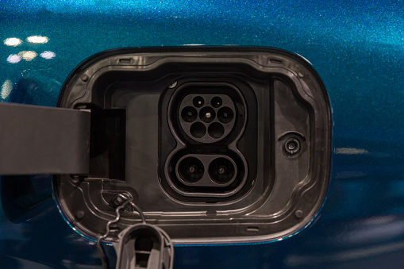

Q - What type of charging socket is this

Ans - It is a Type 2 charging socket

Onboard charger
Onboard charger is used to convert the AC supply received from the charge port to DC supply / Charging of the main EV high voltage battery. The on board charger is located and installed inside the car. It monitors various battery characteristics and controls the current flowing inside the battery pack.

What is an onboard charger ? - Detailed working and components (yocharge.com)
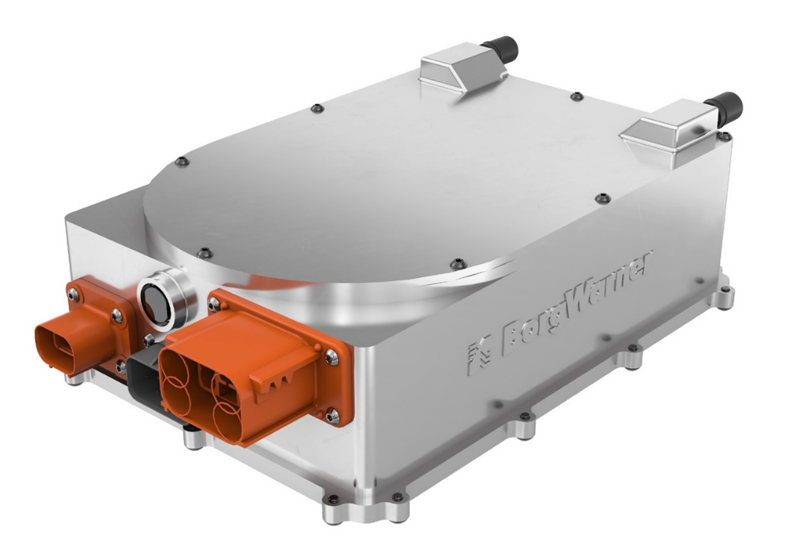

Controller
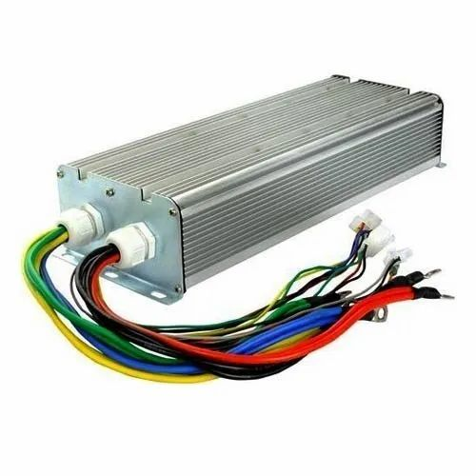
Power electronics controller determines the working of an electric car. It performs the regulation of electrical energy from the batteries to the electric motors. The pedal set by the driver determines the speed of the car and frequency of variation of voltage that is input to the motor. It also controls the torque produced.

8. Auxiliary batteries
Auxiliary batteries are the source of electrical energy for the accessories in electric vehicles. In the absence of the main battery, the auxiliary batteries will continue to charge the car. It prevents the voltage drop, produced during engine start from affecting the electrical system.
Image credits : leab.eu

9. Thermal system(cooling)
The thermal management system is responsible for maintaining an operating temperature for the main components of electric vehicle (EV) such as, electric motor, controller etc. It functions during charging as well to obtain maximum performance. It uses a combination of thermoelectric cooling, forced air cooling, and liquid cooling.

10. Transmission
The gearbox transfers the mechanical power from the electric motor to the wheels. The advantage of electric cars is that they do not require multi-speed transmissions. The transmission efficiency should be high to avoid power loss.

