What are EV tyres?
EV tyres are specifically designed and engineered for electric vehicles and electric vehicles only! These tyres are tailored to provide optimal performance, efficiency, and safety for electric cars.
Are EV tyres different?
EV tyres are different from regular tyres found on petrol cars, these are some of the main differences between them:
1. Rolling resistance EV tyres are designed to have lower rolling resistance compared to regular tyres. This reduced resistance helps to maximize the vehicle’s range by minimizing energy loss as the tyres move around. This really helps with the overall efficiency of the electric car.
2. Weight-bearing Electric vehicles are typically heavier due to the weight of the battery pack. EV tyres are engineered to handle the increased weight without compromising performance and safety.
3. Noise reduction Electric vehicles tend to be quieter than normal vehicles. To enhance the overall driving experience, EV tyres often feature special tread patterns and innovative materials that help reduce road noise, resulting in a quieter ride.
4. Regenerative braking Many electric vehicles have regenerative braking systems, which recover and convert kinetic energy into electrical energy during braking. EV tyres are designed to help this regenerative braking process, by providing better grip and traction to maximize energy recovery.
5. Range considerations EV tyres are designed to extend the range. They are engineered to reduce rolling resistance, aerodynamic drag, and overall energy loss to improve efficiency

Michelin e.Primacy
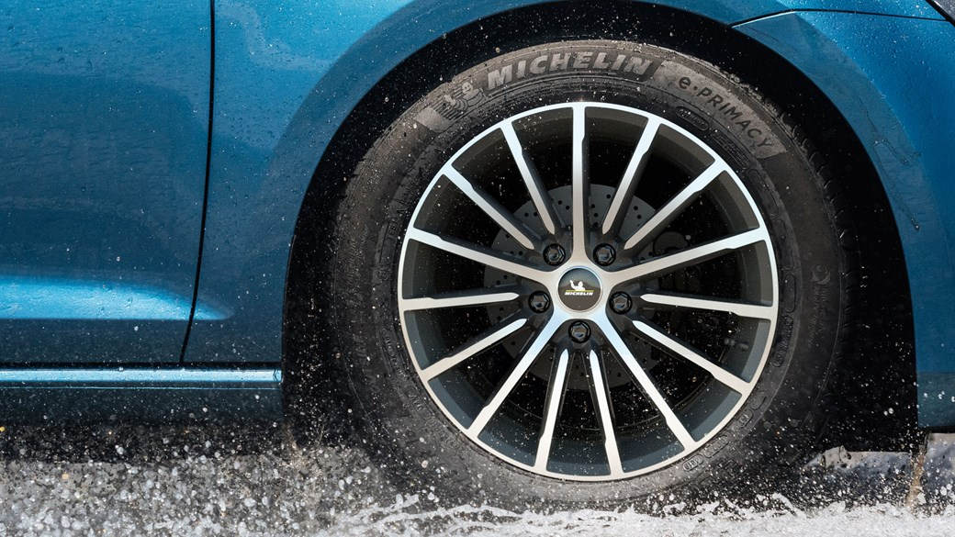

Pirelli P Zero Elect
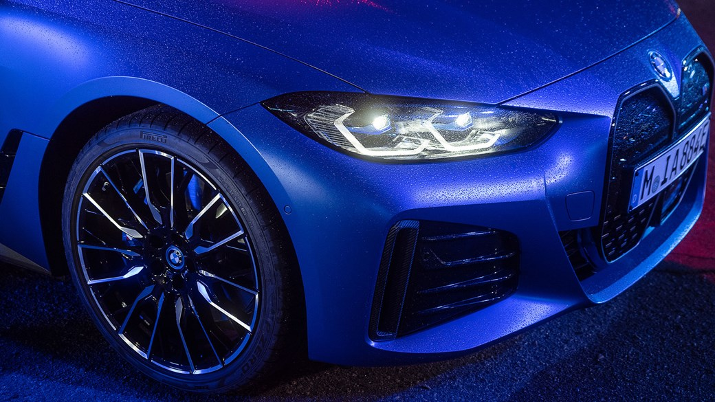

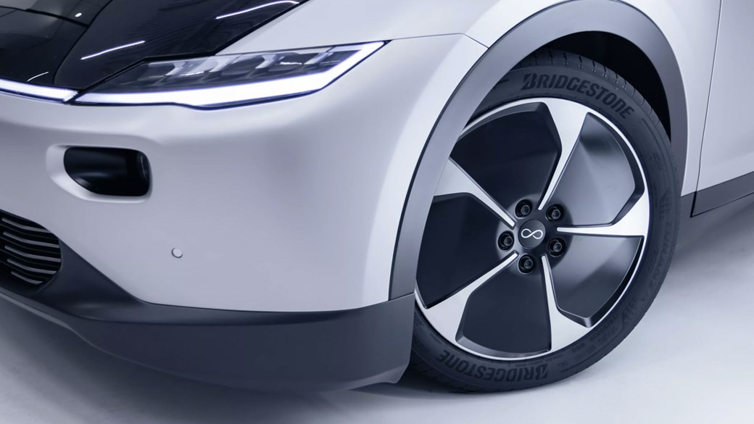
Bridgestone Turanza Eco

Continental EcoContact 6
