**[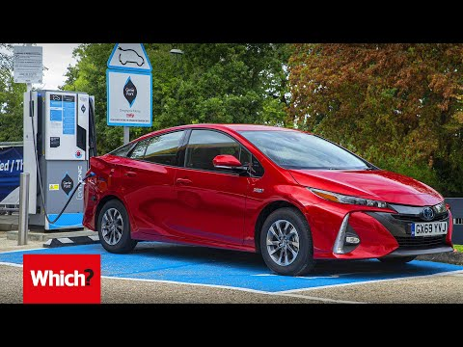](https://www.youtube.com/embed/zMYx3UWdGoE?feature=oembed)Hybrid Cars Explained**