

**School of Hairdressing and Applied Therapies**

**Follow Health and Safety Practice in the Salon**

**Unit: UV10477**

**Course Notes**



**HEALTH AND SAFETY LEGISLATION**.

Legislation is a general term consisting of the Acts of Parliament, European Law and Local Government bye-laws.

**The Health and Safety at Work Act 1974: (H.A.S.A.W.A)**

Most Health and Safety Law is derived from the Health and Safety at Work Act 1974.

This Act requires employers to:

* Provide and maintain a safe working environment
* Provide adequate welfare facilities
* Provide safe systems of work
* Provide information, training and supervision
* Ensure the safe handling, storage and transportation of goods and materials
* Provide and maintain safe equipment

As an employee, you also have duties under this Act, you must:

* Not endanger yourself or others by your acts or omissions
* Assist the employer to meet the requirements of the Act in a safe and responsible way
* Not misuse anything provided in the interests of health and safety
* Report all accidents, incidents and unsafe conditions or practices
* Staff, public and clients are all responsible for health and safety within the salon.

**The Electricity at Work Regulations 1989**

These regulations are concerned with ensuring safety when using electrical equipment. All employees must ensure:

* All electrical equipment is properly maintained and in good working order.
* Regular tests are made by a qualified electrician on each piece of equipment, P.A.T tested annually.
* Records are kept regarding the testing of all electrical equipment and may be provided for inspection purposes if required.

As an employee, it is your responsibility to remove and label any faulty equipment and then report it to the relevant person. You must also cooperate with your employer to comply with these regulations.

**Personal Protective Equipment at Work Regulations 1992**

These regulations require an employer (salon owner) to provide their employees with protective equipment if they may be exposed to any risk to health or injury during their working hours. The risks will have to be assessed during the risk assessment your employer has to carry out under related regulations all employers have the responsibility to:

* Assess the need for the use of personal protective equipment
* Supply protective clothing or equipment free of charge
* Train staff on the correct use of the personal protective equipment
* Ensure that the equipment is properly maintained and clean
* Ensure that it is fit for the purpose

**RIDDOR – Reporting of Injuries, Diseases and Dangerous Occurrences Regulations (2013)**

This act means that all employers must notify the local enforcement officer/HSE of any **work-related** accidents, deaths, specified injuries, occupational diseases and dangerous occurrences. Work related means that they have happened in the workplace. Employees must inform employers of any situations which must be logged into an accident book.

**Manual Handling Operations Regulations 1992**

These regulations are concerned with the manual handling of loads, for example, equipment or stock. This includes the way we lift things and move them from place to place. Employers have specific duties under these regulations which involve assessing the risks when manually handling loads. To do this, the employer must look at:

* The task to be undertaken
* The capabilities and limitations of the staff (e.g. pregnant women or staff who have recently returned to work after an illness may not be back to full strength)
* Type of load to be handled
* The working environment (if the atmosphere is damp, your hands may be wet and the load may slip)

e.g. the correct way to lift a heavy box of stock from the floor would be by keeping your back straight, bend knees, grasp box and lift.

**The Data Protection Act 1998**

The Data Protection Act is in place to protect the personal information you hold on individuals. You are required to ensure appropriate security measures are in place to prevent any unlawful or unauthorised access to data, although it’s also worth remembering that your clients must have access to their own information if and when requested. If your salon is holding personal data, you must be registered with the Information Commissioner. It is worth checking to find out if you should be registered, as failure to do so may result in prosecution.

All information held must be accurate, up to date and relevant.

**The Control of Substances Hazardous to Health Regulations (COSHH) 2002**

In the salon you will be using many substances that may put your health at risk. The COSHH regulations require that all employers assess the health risks that arise from the use of hazardous substances within the workplace and to provide controls that will be most effective in protecting staff and members of the public. The regulations apply to substances that have been classified as corrosive, explosive, harmful, highly flammable, irritant, oxidising or toxic.

All employers are required to:

* Assess the risk to health from the use of hazardous substances at work and what precautions are needed
* Design and introduce appropriate measures to prevent or control your exposure to hazardous substances
* Ensure that control measures and safety procedures are followed and protective equipment is used when appropriate
* Monitor the exposure to hazardous substances and carry out appropriate forms of surveillance to ensure everyone maintains good health
* Inform and instruct all staff about the risks and precautions that need to be taken and to carryout training, so everyone is able to work in a safe way when dealing with hazardous chemicals
* Ensure all employees are aware of how to use and store chemicals safely

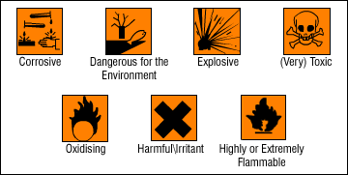

All employees should also be made aware of how to dispose of hazardous substances, these may cause harm to the environment and other people if they are not disposed of correctly. Always read the manufacturer’s instructions regarding the safe disposal of these substances. If you have any doubts, you can phone the manufacturers, and they will advise you on safe methods of disposal. Your salon may have its own policy for disposing of salon waste.

e.g. Sharps used in the salon should be disposed of in a sealed yellow sharps bin and chemical waste (colouring products) should be diluted with water and washed down the sink.

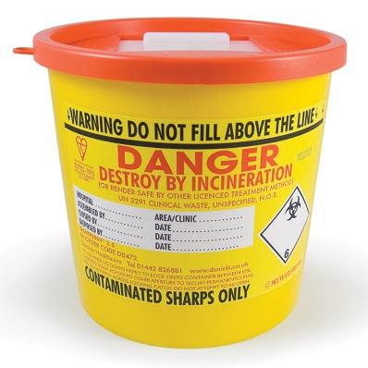 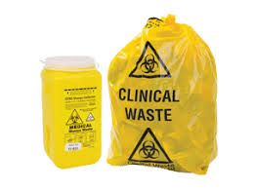

Salon work place policies set rules and procedures that everyone must follow.

Codes of practice are set by industry lead practitioners and government appointed standards agencies.

**Risk Assessment**

Risk assessments should be carried out at regular intervals. A risk assessment is a careful examination of the areas of your work that could cause harm to people in the salon. All workers (and others that enter the place of business) have a right to be protected from harm. No one can pre-empt every eventuality; however, so long as people are protected as far as is ‘reasonably practicable’, business owners have fulfilled their responsibility.

Five steps to risk assessment:

1. Identify the hazards
2. Decide who might be harmed
3. Evaluate the risks and decide on precautions
4. Record the results and ensure they are implemented
5. Review risk assessments and update them if and when necessary.

Although it may not be our responsibility to carry out risk assessments, you should ensure that you monitor the workplace at regular intervals (this should be agreed between yourself and your employer) following workplace instructions. All staff should be adequately trained in Health and Safety but you need to ensure they are compliant and any training needs are identified and acted upon. This will ensure the salon environment is run in a safe and effective manner.

**Hazards and Risks.**

What is a hazard?

A hazard is something that may cause harm to someone.

What is a risk?

A risk is the likelihood of a hazard being possible.

An example of a salon hazard could be water on the floor (spillage), or a trailing wire in the salon.

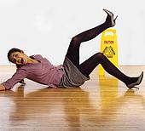 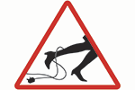

However, if you found that the electrical equipment that you had to work with was of poor quality then this is a hazard that should be reported to a senior staff member, also if you noticed that the lighting in the toilet is not as bright as usual you should tell a senior staff member as this hazard could easily become a risk.

**Salon Hygiene.**

**Health and Safety**

The salon is legally responsible for the care and protection of their clients whilst they are in the salon having treatments.

If the client is not protected/gowned up correctly and any product comes into contact with their clothing or belongings then the salon is liable for damages.

All equipment in the salon should be sterilised to prevent the risk of cross-infection/ cross-contamination.

Cross-infection and cross-contamination:

when bacteria or germs are passed from one person to another.

To prevent the possibility of cross-infection/cross-contamination taking place within the salon and prevent contact dermatitis, we have to make sure:

* All services are kept clean and disinfected at all times.
* All towels, gowns, tools and equipment are properly cleaned and sterilised.
* You use clean towels and gowns for every client.
* Hair and scalp checks are properly carried out before the commencement of each service.
* Gloves are worn by stylists when handling chemicals, and stylists dry their hands thoroughly.

**Sterilisation**

It is vital that you look after your equipment by keeping it clean and well maintained. One way of doing this is to ensure that all equipment is sterilised this is a cleaning method that kills all germs and bacteria. Sterilisation is the complete destruction of living organisms to prevent cross-infection. All tools should be cleaned before sterilising to remove traces of hair, dirt and dust. Brushes, combs and rollers should be cleaned with soapy water. Scissors and razors should be wiped with alcohol or spirit.

An effective method of sterilisation uses a radiation system.

* **Ultra-violet light (UV) cabinets**

These are suitable for all tools if you remove dirt and debris and apply the solution thoroughly.

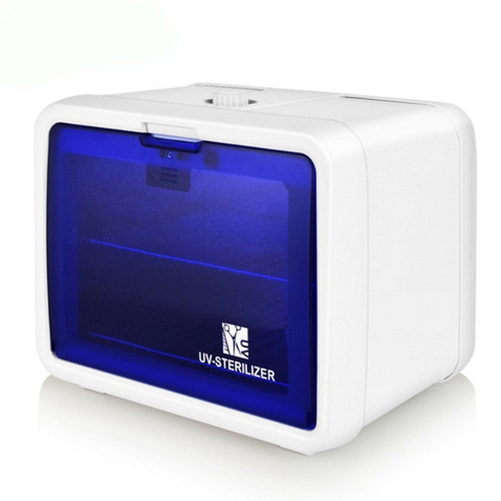

* **Autoclaves**

These are a particularly effective means of sterilisation, however care should be taken with some plastics and you avoid using them if the tools have wooden handles. The principle is the same as a pressure cooker. Sterilisation takes place as the water inside the autoclave is heated to 121°C (due to the build up of pressure).

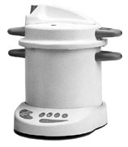

* **Chemical sterilisers**

Many salons use chemical sterilisers to sterilise tools. The disinfectant we use for this is barbicide. The barbicide must be prepared according to the manufacturer’s instructions, using PPE if stated. Tools must be completely immersed in the barbicide for the specified length of time for sterilisation to take place.

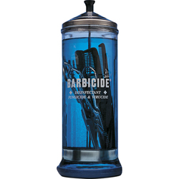

Check with the manufacturer that fluid is suitable for metal tools, otherwise they must rust. Remember that the fluid will need to be changed periodically to ensure it is of the correct strength.

**Personal Protective Equipment - PPE**

The Personal Protective Equipment at Work Regulations 1992 details that all employees provide their staff with the correct training, cleanliness and use of protective clothing.

The Personal Protective Equipment (PPE) is essential to hairdressers to minimise the risk of contact dermatitis, so gloves should be worn when handling chemicals and an apron should be worn to minimum the risk of products making contact with the skin.

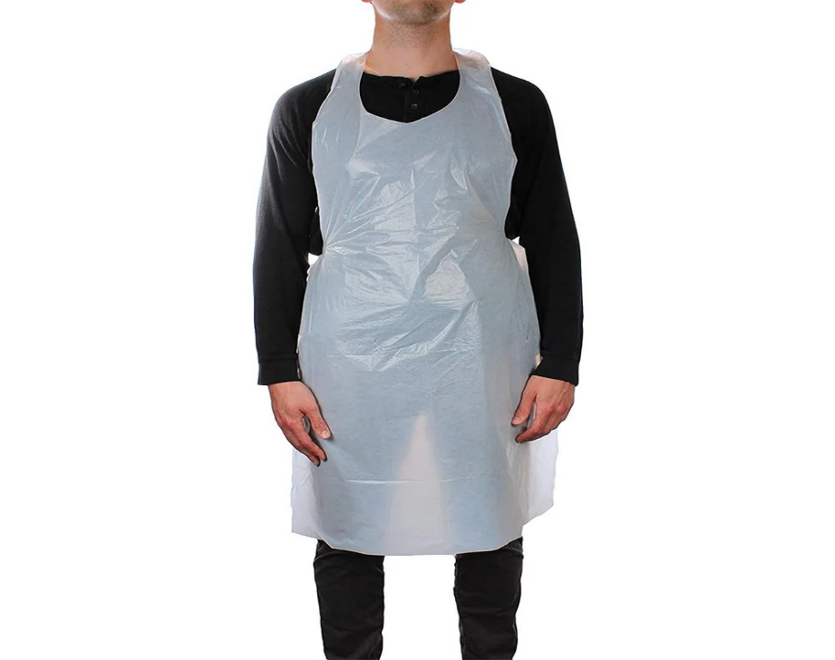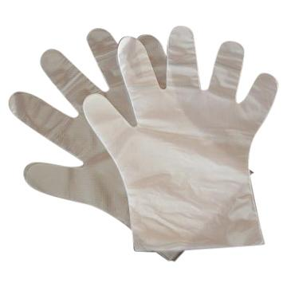

**Fire Evacuation Procedures**

It is important to have an organised evacuation procedure in place so there are less accidents and all staff and visitors can get out of the building quickly and safely without chaos. All staff must be up to date with evacuation drills and procedures so they will know where to escort the clients.

On discovering a fire you would immediately operate the nearest fire alarm call point. The clients should be escorted quickly to the nearest fire exit and out of the building. If the fire is a small a fire extinguisher or glass fibre blanket could be used to smother the fire. If the fire is too big to tackle, leave the premises quickly by closing the doors behind to help stop the fire from spreading. Call the fire services if they haven’t already been called.

Salons should have various types of firefighting equipment these should be as follows:

**Fire blankets**

These are particularly useful for wrapping around a person whose clothes are on fire.

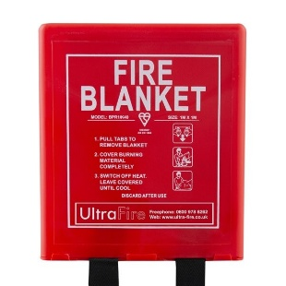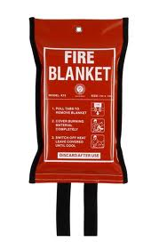

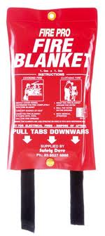

**Buckets of sand**

Fire exits which have green boxes above the doors to show staff and clients a safe and fast way out.

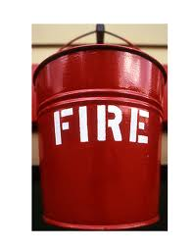

Fire boards are placed on doors at eye level so staff and client’s can be made aware of the fire procedures and their designated assembly points in case of fire.

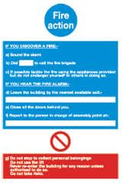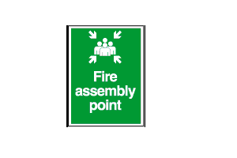

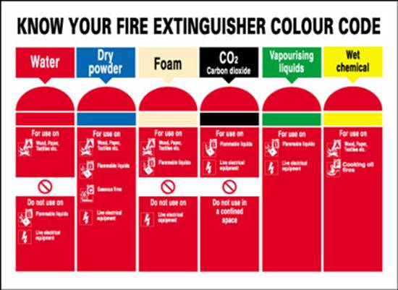

Colour coded fire extinguishers to ensure that the right extinguisher is used for that type of fire.

Red extinguisher with red label contains water for use on flammable solid materials, like paper, wood, textiles etc.

Red extinguisher with black label contains Co2 (carbon Dioxide) for use on electric risk and flammable liquids.

Red extinguisher with blue label contains powder multiple purpose suitable for most fires.

Red extinguisher with cream label contains foam for use on flammable solids, flammable liquids like surgical spirit, paint etc.

Failure to identify the correct type of fire fighting equipment to be used on a fire will result in escalating the fire quickly and endangering lives.

**Accidents or Illness**

In the event of an accident or illness, you should report to the person responsible for first aid. Their responsibility is to take charge of the situation, assess the need for medical intervention and act accordingly. The appointed person should not give first aid unless they have been trained and hold a current first aid certificate. They may call for an ambulance if they feel it is necessary.

**[](http://www.safetyscene.co.uk/wp-content/uploads/2009/01/first-aid.png)**

Should anyone have an accident in the salon then this should be reported promptly as we can identify accident trends and can put into place patterns to improve working practices, also an accident report form has to be completed to record the information for investigation and insurance purposes.

[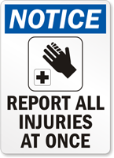](http://www.mysafetysign.com/img/lg/s/report-all-injuries-notice-sign-s-4012.gif)