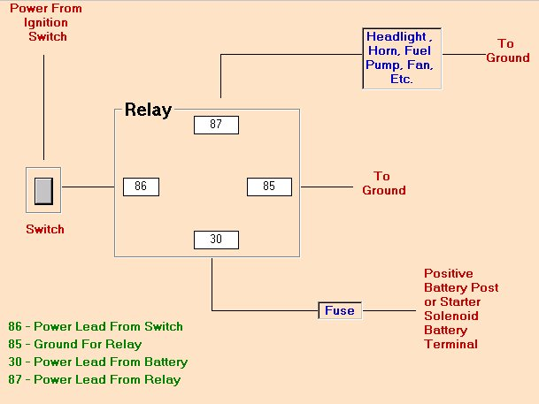Fitting 2 Spotlights Using a Relay

Fit an inline fuse of the correct amperage between pin 30 on the relay and the permanent live source.

To calculate the correct size of the fuse, we use Ohms law

Ohms law states:- Watts = Current x Volts

If the wattage of the lamps is 28 watts and the battery is 12volts we can use this formula to calculate the fuse size required.

I = W I = 28 I = 2.33 amps

V 12

Fit a 2 pin switch to the dashboard of the vehicle

If using a 3 spade connector,

1 Earth / ground

2 Live

3 To spotlight

This will allow the switch to light up when on

The 30 pin on the relay is connected to a permanent live. This means that it is live at all times unlike an ignition live that is only live when the ignition is switched on

The 85 connector must be connected to a good ground or earth point.

If possible, use the negative side of the battery

Fit 2 spot lights on to the front of the car. Ensure both lights have their own ground or earth connection

This feed to the switch must be an ignition live. This means it will only be live when the ignition is switched on

Live to spot lights

Feed from Ing live

live in car Each Lamp is earthed

