**School of Hairdressing and Applied Therapies**

**Follow Health and Safety Practice in the Salon**

**UV10477**

**Evidence Workbook**

|  |  |
| --- | --- |
| **Question** | **√ or X** |
| **Q1** |  |
| **Q2** |  |
| **Q3** |  |
| **Q4** |  |
| **Q5** |  |
| **Q6** |  |
| **Q7** |  |
| **Q8** |  |
| **Q9** |  |
| **Q10** |  |
| **Q11** |  |
| **Q12** |  |
| **Q13** |  |
| **Q14** |  |
| **Literacy alert:** | |

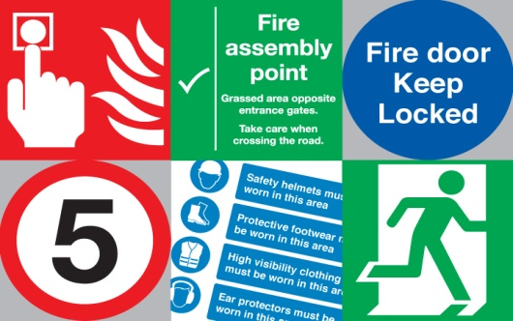

**Student *Name:***

**Tutor Feedback/Feedforward:**

**Section 1- Hazards & Risks**

1. **Explain the meaning of the following in the Salon:**

**Hazards:**

**Risks:**

1. **List the 4 different types of Hazards.**
2. **Look at the list of situations. Decide which are hazardous and non-hazardous and put into the correct box.**

* *Broken hoof stick*
* *Loose tiles on the floor*
* *Therapist wearing a face mask*
* *Blocked fire exit*
* *Electrical lead trailing across the trolley*
* *Dirty cotton wool pads placed on the trolley*
* *Therapist wearing heels*
* *Puddle of water on the floor*
* *Therapist wearing her tunic.*

|  |  |
| --- | --- |
| **Hazardous** | **Non-hazardous** |
|  |  |
|  |  |
|  |  |
|  |  |
|  |  |

1. **Identify the hazards and risks in the picture below.**

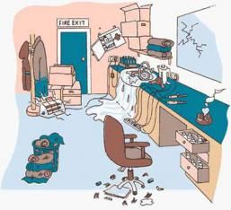

**Hazards:**

**Risks:**

**Health and Safety at Work**

1. **The Health and Safety at Work Act is the main health and safety law.**

**All employers must make sure the salon is a safe place for you to work.**

Research the Health and Safety at Work Act and explain the different Employers’ responsibilities below:

Describe how to correctly dispose of different types of salon waste?

**COSHH- Control of Substances Hazardous to Health**

**Complete the table below by writing in what the hazard symbols mean.**

|  |  |  |
| --- | --- | --- |
|  |  |  |
|  |  |  |
|  |  |  |
|  |  |  |

**Emergency and Accidents**

1. **Where is firefighting equipment kept in the Salon?**
2. **What type of fires are the following fire extinguishers used for?**

|  |  |
| --- | --- |
| **Water** |  |
| **Powder** |  |
| **Carbon Dioxide** |  |
| **Foam** |  |

**Add an image of these extinguishers below:**

1. **State the procedure for dealing with accident/emergencies when working in a salon?**
2. **State the colleges’ evacuation procedure in an emergency.**

**Good Posture and Manual Handling**

1. **How would you recognise good posture and why is this important for salon work?**
2. **How should you lift a heavy object?**
3. **Insert a √ or × in the box next to each picture.**

[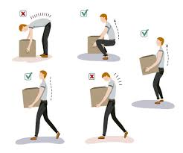](https://www.google.co.uk/url?sa=i&rct=j&q=&esrc=s&source=images&cd=&cad=rja&uact=8&ved=2ahUKEwjFq_PCgqjjAhWwz4UKHV_SBEEQjRx6BAgBEAU&url=https://www.trainingpartners.co.uk/manual-handling&psig=AOvVaw3h2hCsWWK0RZ-RRQunQLxJ&ust=1562767942168455)